Uploading Images to the CyVerse Data Store
Last updated by Katie Pearson on 14 June 2021
  - Goal: These directions describe how to upload images into our CyVerse community data folder, where they will then be publicly accessible and linked to CCH2.
- Navigate to the following URL https://de.cyverse.org/ and log in to your CyVerse account. (This is the same CyVerse account that you may have previously used to set up Cyberduck).
- Click the Data icon from the toolbar on the far left:
- Next to the home icon, you will see your username. Click on your username and then select Community Data from the dropdown menu.
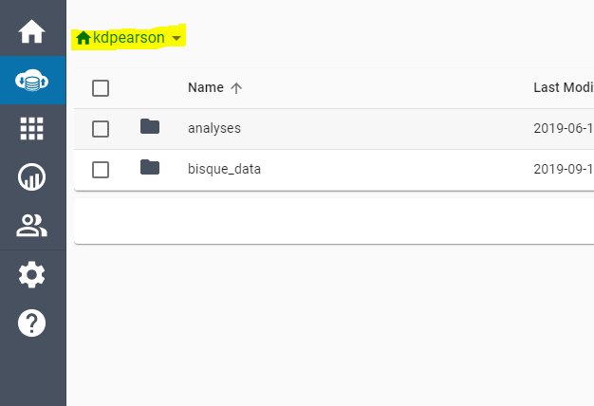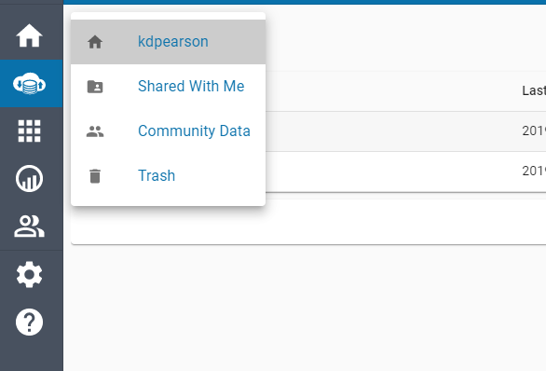
- Open the CAP_TCN folder from the resulting list.
- Open the folder belonging to your institution.
- Create a new folder inside your institution’s folder. We recommend naming this folder with today’s date or the date when the specimens were processed.
- Once the folder is created, open the new (empty) folder. This is essential to make sure that the images you upload end up in the correct place.
- On your computer, open the folder that contains the images that you want to transfer to CyVerse.
- Select all the images in the folder on your computer by pressing Ctrl and A (or Cmd and A, if using an Apple computer).
- Drag and drop the selected images from your computer into the new folder that you have created in CyVerse.
- A message will pop up that will show you the number of files being uploaded. Click the View Upload Queue button to view the list of uploading files.
- Once the files are uploaded, check the queue for any images that did not upload properly. They will be marked with a red circle with an exclamation mark. Successfully uploaded images will be marked with a green circle with a check mark.
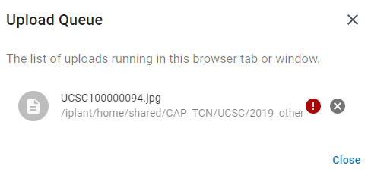
- Resolve any image uploading issues. Images may not have uploaded properly because:
  - The image already exists in your institution’s folder (potentially in a different subfolder). If this is the case, contact your portal manager for help deleting the duplicate images.
  - Your internet connection was unstable or was temporarily disconnected.
  - Your image is corrupted.

Loading JPEGs into CCH2
**The user conducting this protocol must have administrator permissions in CCH2.***
Notes:
- After uploading your images to CyVerse as described above, wait 24 hours before doing the next step.
- Note that the servers often undergo maintenance on Tuesdays, which can cause a delay in processing or unexpected errors.

- Log in to your account in CCH2 and navigate to the collection management page (My Profile > Specimen Management tab > name of collection).
- In the administration control panel, click Processing Toolbox.
- Select the Image Loading tab and select iPlant Image Processing from the Saved Image Processing Profiles box.
- Ensure that the Processing start date is the same as the Last Run Date. This means that the API will search and load your folder for all the images that were uploaded since you last loaded JPEGs into CCH2.
- Click the Process Images button. Examine the resulting log file to ensure the expected number of images was loaded into CCH2.
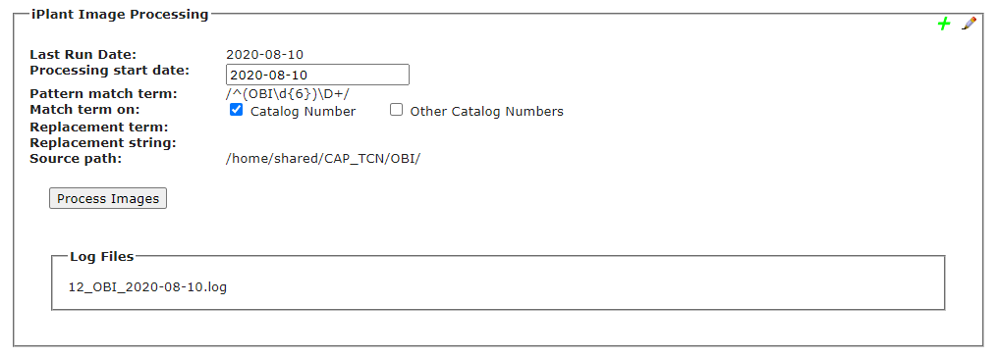
Date that you want to start processing from (should likely be the same as the Last Run Date)
Previous imaging logs

Understanding the Log File
The image linking algorithm will work chronologically to load all the images uploaded each day since the last day you ran the algorithm. For each day, the log will list how many images were recognized and linked (see screenshot below).
Images will be recognized and linked only if they have been (1) uploaded to the appropriate folder in CyVerse and (2) processed by BisQue. Processing in BisQue happens automatically once you have uploaded the images; however, the BisQue server can get busy at times, which can delay the processing of your images. This is why we recommend waiting 30 minutes or longer after uploading images to CyVerse before conducting steps 1-5 above.
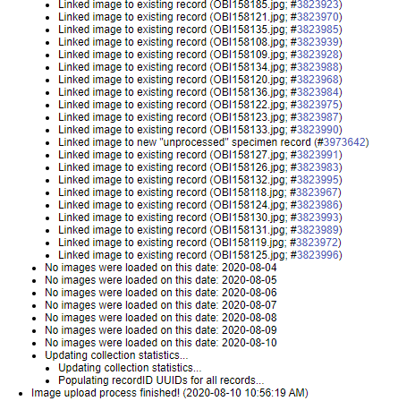
The log shows you what happened to each image we uploaded. You will see one of the following messages for each image that was recognized and loaded:
- Linked image to new "unprocessed" specimen record - this means that CCH2 did not find an existing record for this image, so it created a skeletal record (i.e., record with just the barcode number and image) for that image. The Processing Status of this specimen will be "unprocessed," and you can use this fact to search for these skeletal records in the future.
- Linked image to existing record - this means that CCH2 found an existing record for the image and added the image to it. This happens when you have already entered barcode numbers into CCH2 or when you upload multiple images for a single record at one time (i.e., a skeletal record was created for the first image for that record, then CCH2 linked the second image to that skeletal record as well).
- Replacing previously mapped image with new input; Linked image to existing record - this means that an image with the same name already existed in the portal, so CCH2 is replacing the old image with the most recently uploaded one.
- NOTICE: Imaging mapping skipped; image identifier already in system – the means that an image already exists for the specimen for which you were uploading an image; CCH2 does not replace images if they already exist on the server. To replace an image, you will need to delete the previous image from the CCH2 occurrence record first. See the Section 9.1 of the Symbiota Guide (https://www.capturingcaliforniasflowers.org/symbiota.html) for instructions on deleting previous images.
Note that the number following each line of the log is the SymbiotaID number, rather than the catalog number of the specimen. The first time you view the log, you can click the SymbiotaID number to navigate to that record. When you download the log later, these links do not exist. Instead, you can look up a specimen by copying the SymbiotaID number and pasting it after occid= in the following URL:
http://cch2.org/portal/collections/editor/occurrenceeditor.php?occid=

