Barcode Recommendations
Last updated 21 September 2018 by Katelin Pearson

Formatting
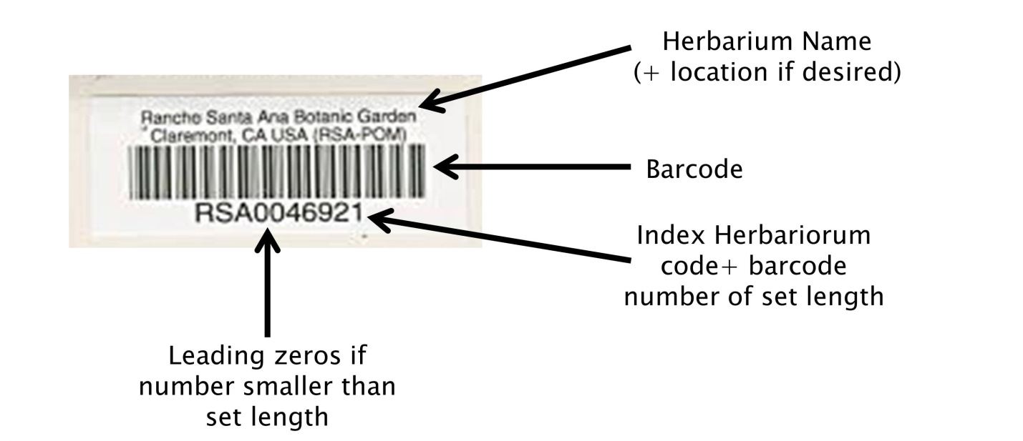
- Above barcode: name of institution (optional: location of institution)
- Barcode: “code 39” format, which includes letters and numbers
- Below barcode: barcode number, consisting of your Index Herbariorum (http://sweetgum.nybg.org/science/ih/) herbarium abbreviation followed by a unique number of a set number of digits.
  - Decide ahead of time how many digits will be in your barcode. Any numbers shorter than the set length of your barcode should be left-padded by zeros. For example, if your barcodes will include 9 digits (which means your institution can have a maximum of 999,999,999 specimens), and you have barcode number 38, your barcode should read: INST000000038. We recommend following this format so that the records can be sorted appropriately in Symbiota, Excel , or other management softwares.
  - We recommend including the IH abbreviation of your institution prior to the barcode number to maximize the “uniqueness” of this barcode number relative to other institutions’.

Sourcing
Cal Poly investigated purchasing barcodes from Reliance Barcode Solutions, Computype Inc, and Watson Label Solutions. Reliance Barcode Solutions was the most cost-effective at 2-4¢ per barcode, however, this printer is now out of business.
A recent quote from Watson Label Solutions can be found here:
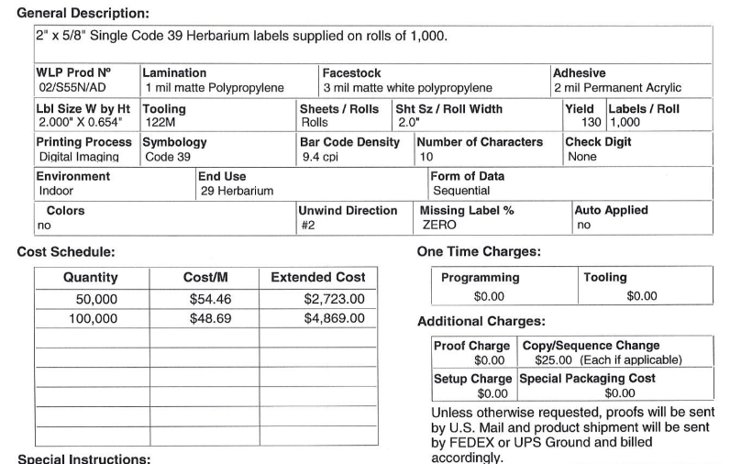

Other sources include:
- Electronic Imaging Materials, Inc. https://barcode-labels.com/use-case/museum-archival-library/
  - Used by Harvard University Herbaria and Museum of Vertebrate Zoology
The quotes from Computype, Inc. and Watson Label Solutions are shown below, for your reference:
Computype, Inc.
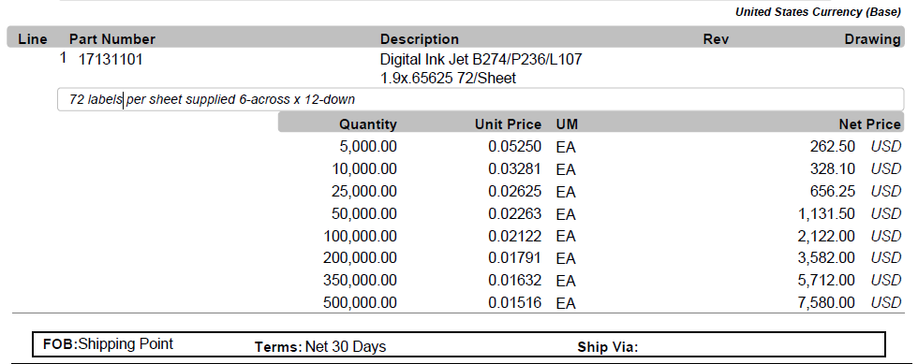
Watson Label Solutions
