Protocol for Georeferencing with GeoLocate
Last updated by Katie Pearson on September 30, 2020

Goals: This document describes how to georeference specimen records using the GeoLocate instance on the CCH2 portal.

For a video introduction to GeoLocate, see: https://vimeo.com/showcase/2163673/video/65222791

- Log in to your account in the CCH2 portal, click “My Profile,” navigate to the “Specimen Management” tab, and click the name of the institution for which you will be georeferencing.
- In the Data Editor Control Panel, click “Batch Georeference Specimens.”
- In the Query Form box, select the country, state, and county that you wish to focus on and click the “Generate List” button. You will then see a list of results in the box below the Query Form (see screenshot below).
  - If no results are returned, select a new county or state in the Query Form.

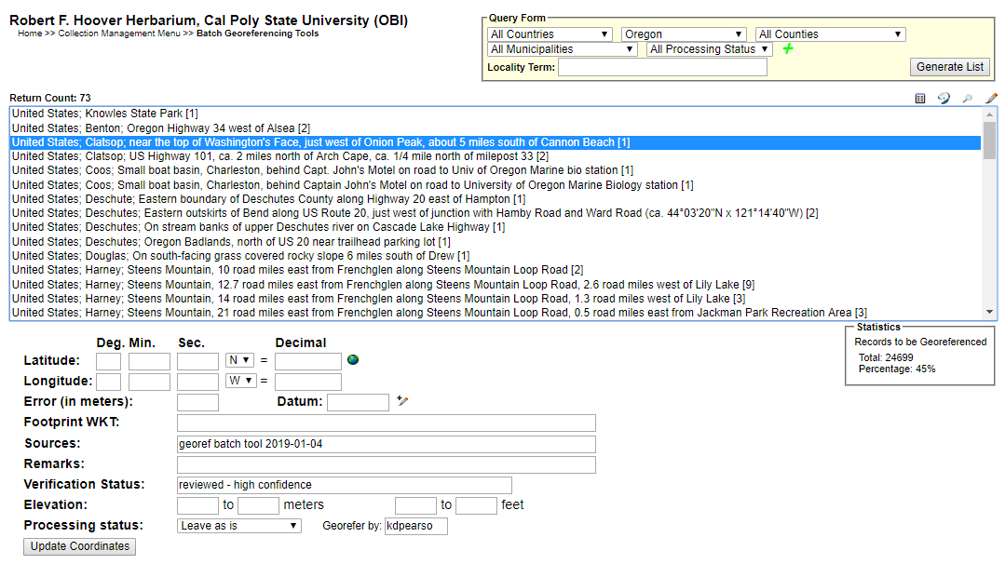
- Select the entry that you want to work on and click the Geolocate () icon at the top right of the search results. This will open a new GeoLocate window (see screenshot on next page) displaying a map and, in some cases, possible location(s) for the specimen that GeoLocate inferred from the text.
  - The green dot is GeoLocate’s best guess for the locality of the specimen. You may also see red dots, which are alternative guesses.
  - To view the reasons why GeoLocate selected these dots, click the “# possible locations found” tab to the right of the Workbench tab. The words in all caps are those that GeoLocate used to infer a location.
- Click the “Options” button on the bottom left of the GeoLocate window and ensure the “Do Uncertainty” box is checked. Close the Georeferencing options window.
- Make sure that all of the boxes (latitude, longitude, uncertainty, and error polygon) near the bottom right of the window are checked.
- If there are dots on the map, investigate whether any of them could be a good starting point for your georeferencing by comparing the dots’ locations on the map to the text in the Locality String (see dashed box in screenshot above). It is possible that none of the dots indicate the correct locality. If this is the case, you can ignore the dots or remove them by clicking the “# possible locations found” tab and clicking the circled ‘x’ to the left of each rejected entry (see below).
  - When deciding whether to use one of the GeoLocate dots, make sure to check that the state and county where the dot has been placed matches the state and county indicated by the record.
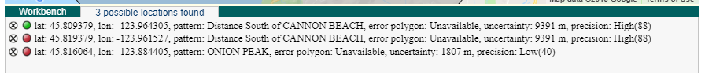
- Either starting with a GeoLocate dot, if appropriate, or from scratch, use the Locality String to determine an approximate location for the specimen. This will likely require searching other references (e.g., Google maps) for location and feature names.
  - You can change the base layer (i.e., the type of map shown in the GeoLocate window) by clicking the plus symbol in the upper right corner of the window (see screenshot on next page).
  - To measure a distance on the map, click the button next to “Measure” and click on a starting point on the map. You can then move your cursor anywhere on the map and a line will be measured between those two points. The length of the line will be shown in green next to the line. To measure between more than one point, click again to anchor another point. To stop measuring, double click on the ending point of your measurement.
  - If there is not enough information in the Locality String to assign an approximate point, view the specimen record by returning to the search results page (see screenshot on first page) and clicking the pencil icon () on the top right of the search results box. This will bring up the specimen record, where you can see whether there is more locality information in another data field (e.g., habitat) or on the specimen image (if available).
    - If you are still not able to assign an approximate point from this information, return to the batch georeferencing window (see screenshot on first page). If you think someone else may be able to georeference this record in the future, just move to another record. If you think the specimen data are insufficient for anyone (even an expert) to georeference the specimen, add a note in the Remarks field that begins with “cannot georeference.”
      - If only a county is provided, enter “locality imprecise; cannot georeference” in the Remarks field.
- Once you have found an approximate location for the specimen record, click the button next to “Place Marker” and click on the map where you want to place the GeoLocate dot. Follow the guidelines provided in Table 1 when deciding where to place the dot.
- Set the error radius and/or create an error polygon to indicate the uncertainty of the specimen’s locality. Follow the guidelines provided in Table 1 when deciding how large of an error radius to use for a given point and whether you should use an error polygon.
  - To edit the size of the error radius, click the green dot on the map and select “Edit Uncertainty” in the pop-up box. Click and drag the grey arrowhead that will appear on the outer rim of the error circle to resize the error radius.
  - To create an error polygon, click the button next to “Create polygon” and click on the map where you want to begin drawing the polygon. A corner of the polygon will be created time you click on the map. To finish the polygon, double click. Once you have completed the polygon, click the green dot again and select “Resize uncertainty to polygon.”
    - To redo a polygon, click the “Clear Polygon” button to the right of the “Options” button.
  - Make sure to note any uncertainty you experienced when setting the error radius. For example, if you were georeferencing a named place that did not have clear boundaries, explain how you determined a suitable error radius by putting a note in the Remarks field on the search results page where you first selected your specimen record (indicated by the arrow below).
- When you are confident in your GeoLocate point and error radius, click the “Save To Your Application” button at the bottom of the GeoLocate window. You will be taken back to the search results page where you first selected your specimen record (see screenshot on first page).
  - The coordinates and error will now show up below the search results in the appropriate Latitude, Longitude, and Error fields. If you created an error polygon, its coordinates will be listed in the Footprint WKT field.
- Click the “Update Coordinates” button at the bottom of the page.
- Select a new record or set of records to georeference from the search results list and repeat steps 7-13.

Helpful resources:

For georeferencing videos:
https://vimeo.com/showcase/2163673

For georeferencing township, range, section (TRS) coordinates
https://www.randymajors.com/p/township-range-on-google-maps.html
Table 1: Guidelines for georeferencing from different types of locality information. Adapted from Wieczorek et al. 2012 “Georeferencing Quick Reference Guide” (https://www.idigbio.org/wiki/images/1/1e/GeoreferencingQuickReferenceGuide.pdf) and Zermoglio et al. 2020 Georeference Quick Reference Guie [Community review draft] version b5a20n5
Locality type | Example | How to place coordinates | How to measure error radius/polygon
Bounded area: locality refers to a geographic feature with discernible spatial boundaries | “Las Vegas”  “Puerto Madryn”  “San Fernando” | Estimate the geographic center of the boundaries of the area. If the center of the area does not fall within the boundaries of the area (e.g., the area is moon-shaped or otherwise curved) find the smallest enclosing circle that contains the entire feature, but has its center on the boundary of the feature. | Measure the distance from the center of the area to the border of the area furthest from the center.
Undefined area: locality refers to a geographic feature that does not have a clear spatial boundary | “Hoosier Pass”  “Hills south of Los Osos” | Determine the coordinates for the geographic center of the area as well as possible using visual evidence (e.g., appearance of houses, changes in elevation, mountains) near the label for the area on the map. | Use half the measured distance from the selected coordinates to the center of the nearest feature (e.g., next town or geologic feature). Selecting the nearest feature can be tricky, and you should select a feature that is at a distance that indicates an appropriate level of uncertainty for your point (e.g., far away if you are uncertain, fairly close if you are rather certain in your geolocated point).  Make note of the feature that you measured to in the “Remarks” field on the search results page.
Street address | “1 Orchard Lane, Berkeley, CA”  “319 Stadium Dr., Tallahassee, FL” | Locate the address on, e.g., Google maps, and find this location on the map in GeoLocate. | Use half the measured distance from the selected coordinates to the location of an address on either side of the given address. If the next address is too difficult to determine, use half the distance from the coordinates of the address to the further end of the block on which it sits.
Locality type | Example | How to place coordinates | How to measure error radius/polygon
Junction, intersection, crossing | “junction of Coora Rd. and E Siparia Rd.”, “bridge over Willamette River”, “interscn of CA 166 and 399” | Use the coordinates of the center of the intersection. | Use satellite or aerial images to find the extent of the intersection by measuring the distance from the center to the furthest part of it. If this is not possible, use the number of lanes of the larger of the two roads and multiply by 4 meters.
River, stream, road, path | “Sacramento River”, “Los Osos Valley Road”, “Rio Parana” | Make a straight line between the two points on the geographic feature that are most removed from each other, yet still within the administrative boundaries (e.g., county) specified in the locality description. Choose the point on the feature nearest to the midpoint of the line. | Use one half of the straight line that you made between the two points on the geographic feature that are most removed from each other, yet still within the specified administrative boundaries.
Mouth or headwaters of a river, confluence of waterways, trailhead | “headwaters of the Missouri River”, “Triangle Lake trailhead” | For a river mouth or confluence of waterways, select the midpoint of the line connecting the opposite shores where the waterways meet. For a river source, select the point of highest elevation on the river or create a boundary around the multiple streams contributing to the river and find the geographic center of that bounded area. For a trailhead, select the point where the trail begins. | For a river mouth or confluence of waterways, use the distance from the chosen point to the shore. For a single river source or trailhead, use 10 m.
Near a named place | “vicinity of Mt. Hood”, “near the Hoover Dam” | Determine the coordinates as either a Bounded area or Undefined area, as appropriate. | Determine the distance as either a Bounded area or Undefined area, as appropriate, and add additional uncertainty if you can do so without encompassing another major feature (e.g., another prominent town).
Between two places | “between Atascadero and San Luis Obispo” | Use the midpoint between the centers of the two named places. | Use half the distance between the centers of both named places.
Locality type | Example | How to place coordinates | How to measure error radius/polygon
Direction only, no distance | “N of Berkeley”, “SW of Gainesville” | Use the midpoint between the centers of the specified named place and the nearest feature (e.g., town or mountain range), where the nearest feature to use is in the specified direction. The nearest feature should be, for the first example, the nearest named place somewhere between NW and NE of Berkeley. | Use half the distance between the centers of both named places.
Specified distance in unnamed direction | “5 km outside Calgary”, “2 miles from Morro Bay” | Determine the coordinates as either a Bounded Area or Undefined Area, as appropriate. | The length of the radius should be the same as the distance given in the locality description.
Specified distance in a direction, no path given | “50 miles W of Las Vegas”, “30 km E of Sacramento” | Find the center of the feature (e.g., town) and measure the provided distance in the direction provided in the locality description. | Use half the measured distance from the selected coordinates to the center of the nearest feature.  Make note of the feature to which you measured in the “Remarks” field on the search results page.
Specified distance in a direction, path given | “7.9 mi N Beatty, on US 95”, “7 mi. W Santa Barbara on 101”, “left bank of Mississippi River, 16 mi downstream from Paris” | Find the geographic center of the named place as either a Bounded area or Undefined area, as appropriate. Use the measuring tool to follow the specified route for the given distance. Use the end point as the coordinates. | Use half the measured distance from the selected coordinates to the center of the nearest feature.  Make note of the feature that you measured to in the “Remarks” field on the search results page.

