Protocol for Printing Batch Annotations on CCH2
Created by Jennifer Poore 2020
OK to update as necessary

This protocol is for the task of printing batch annotations from CCH2 and then removing them from the print queue. Once the annotations are created, they will need to be cut and glued to the specimens. The time for this task varies depending on the number of specimens there are to annotate.

After signing into your CCH2 account,
- Select My Profile to the right of the “Welcome/ Your Name!” salutation.
- On the tabs page that comes up next, select Specimen Management.
- From the menu under that tab, select your herbarium, e.g. DAV – UC Davis Herbarium (DAV)
- In the Data Editor Control Panel, choose “Print Annotation Labels”
- Select the occurrences you wish to print annotation labels for.

In the Annotation Printing Box,
- Footer: your herbarium title, e.g. UC Davis Center for Plant Diversity (DAV)
- Select: Print species authors for infraspecific taxa
- Border width: 0
- Rows per page: 2
- Spacing between labels: 5
- Click: Export to DOCX

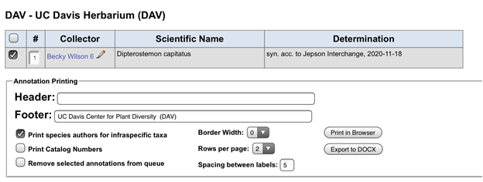

CCH2 will thereby create a word document filled with your annotations, which will look like this:

Dipterostemon capitatus (Benth.) Rydb.
Det: syn. acc. to Jepson Interchange 2020-11-18
UC Davis Center for Plant Diversity (DAV)

After the following finessing, the annotations will be ready to print and cut.

- Center the text by selecting all annotations on the page and center all of the text.
- Remove “Det: “ by using the Find/Replace tool to
Find: Det: (with one space after the semicolon) Replace: (with nothing)

3. Move the date left by again using the Find/Replace tool”
Find: (Type in 6 spaces with the space bar)
Replace: (Type in 2 spaces)

Dipterostemon capitatus (Benth.) Rydb.
syn. acc. to Jepson Interchange 2020-11-18
UC Davis Center for Plant Diversity (DAV)

Save the file, name it Scientific_Name_Date_initials
Print to archival quality paper on a laser printer and carefully cut them on a paper cutter.

Before you move on, please clear your annotations from the print annotations list (see below)

To clear the completed annotations from the print list,
Re-select your selections as previously described.
Check “Remove selected annotations” from the queue.
Click Export to DocX again.
Annotations are now cleared from the list!

