Barcoding & Imaging Protocol
Last updated by Katie Pearson on 5 August 2020

Goals: This example protocol describes how to barcode and image specimens using the Ortery lightbox setup and Smart Shooter. For specimens that already have data in the database, the assigned barcode numbers are added to their respective specimen records in CCH2.

- Turn on the lightbox using the switch labeled “Front & Rear.” Do not turn on the “Back” switch.
- Ensure that the camera is correctly plugged in to a power source and the computer. The cord that connects to the computer is plugged in to the left side of the camera, and the cord that connects to the power source is plugged in to the right side of the camera, where the battery pack usually is (see image below).

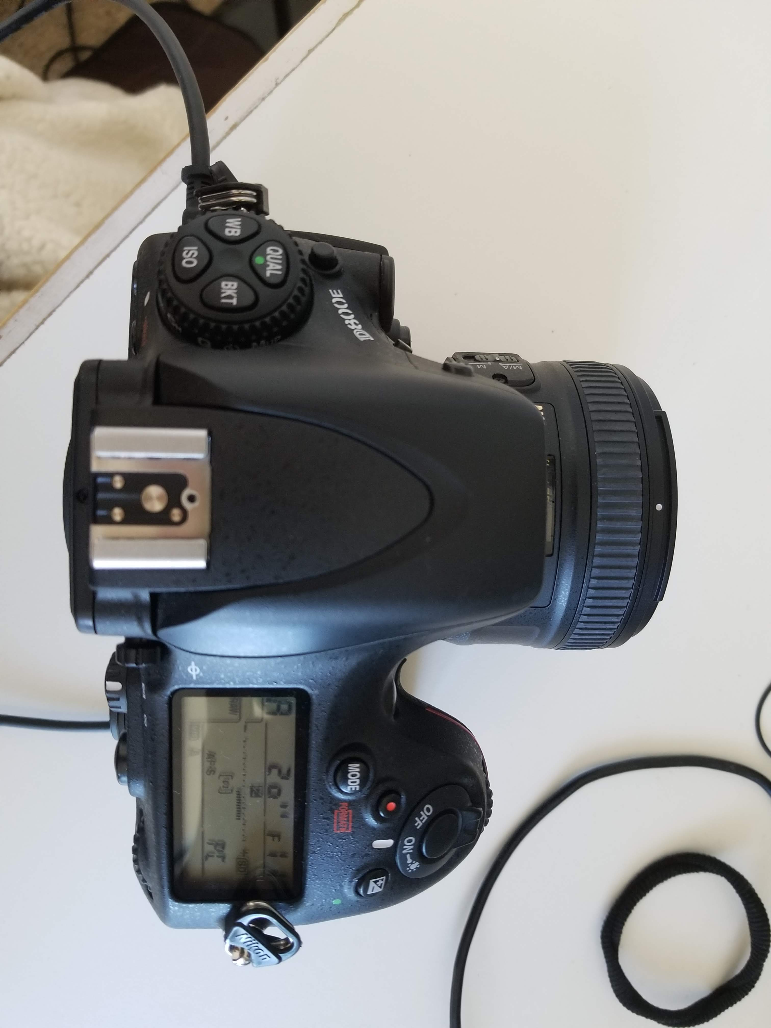
on/off switch
cord to power source
cord to computer

- Turn on the computer (if necessary) and camera, in that order. The camera’s “on” switch is located to the right of the lens on the top of the camera (circled in photo above).
- Remove the camera lens cap.
- Ensure that the dial on the left side of the camera body, below the lens, to AF and the switch on the lens, if present, is set to M/A (see photo below).

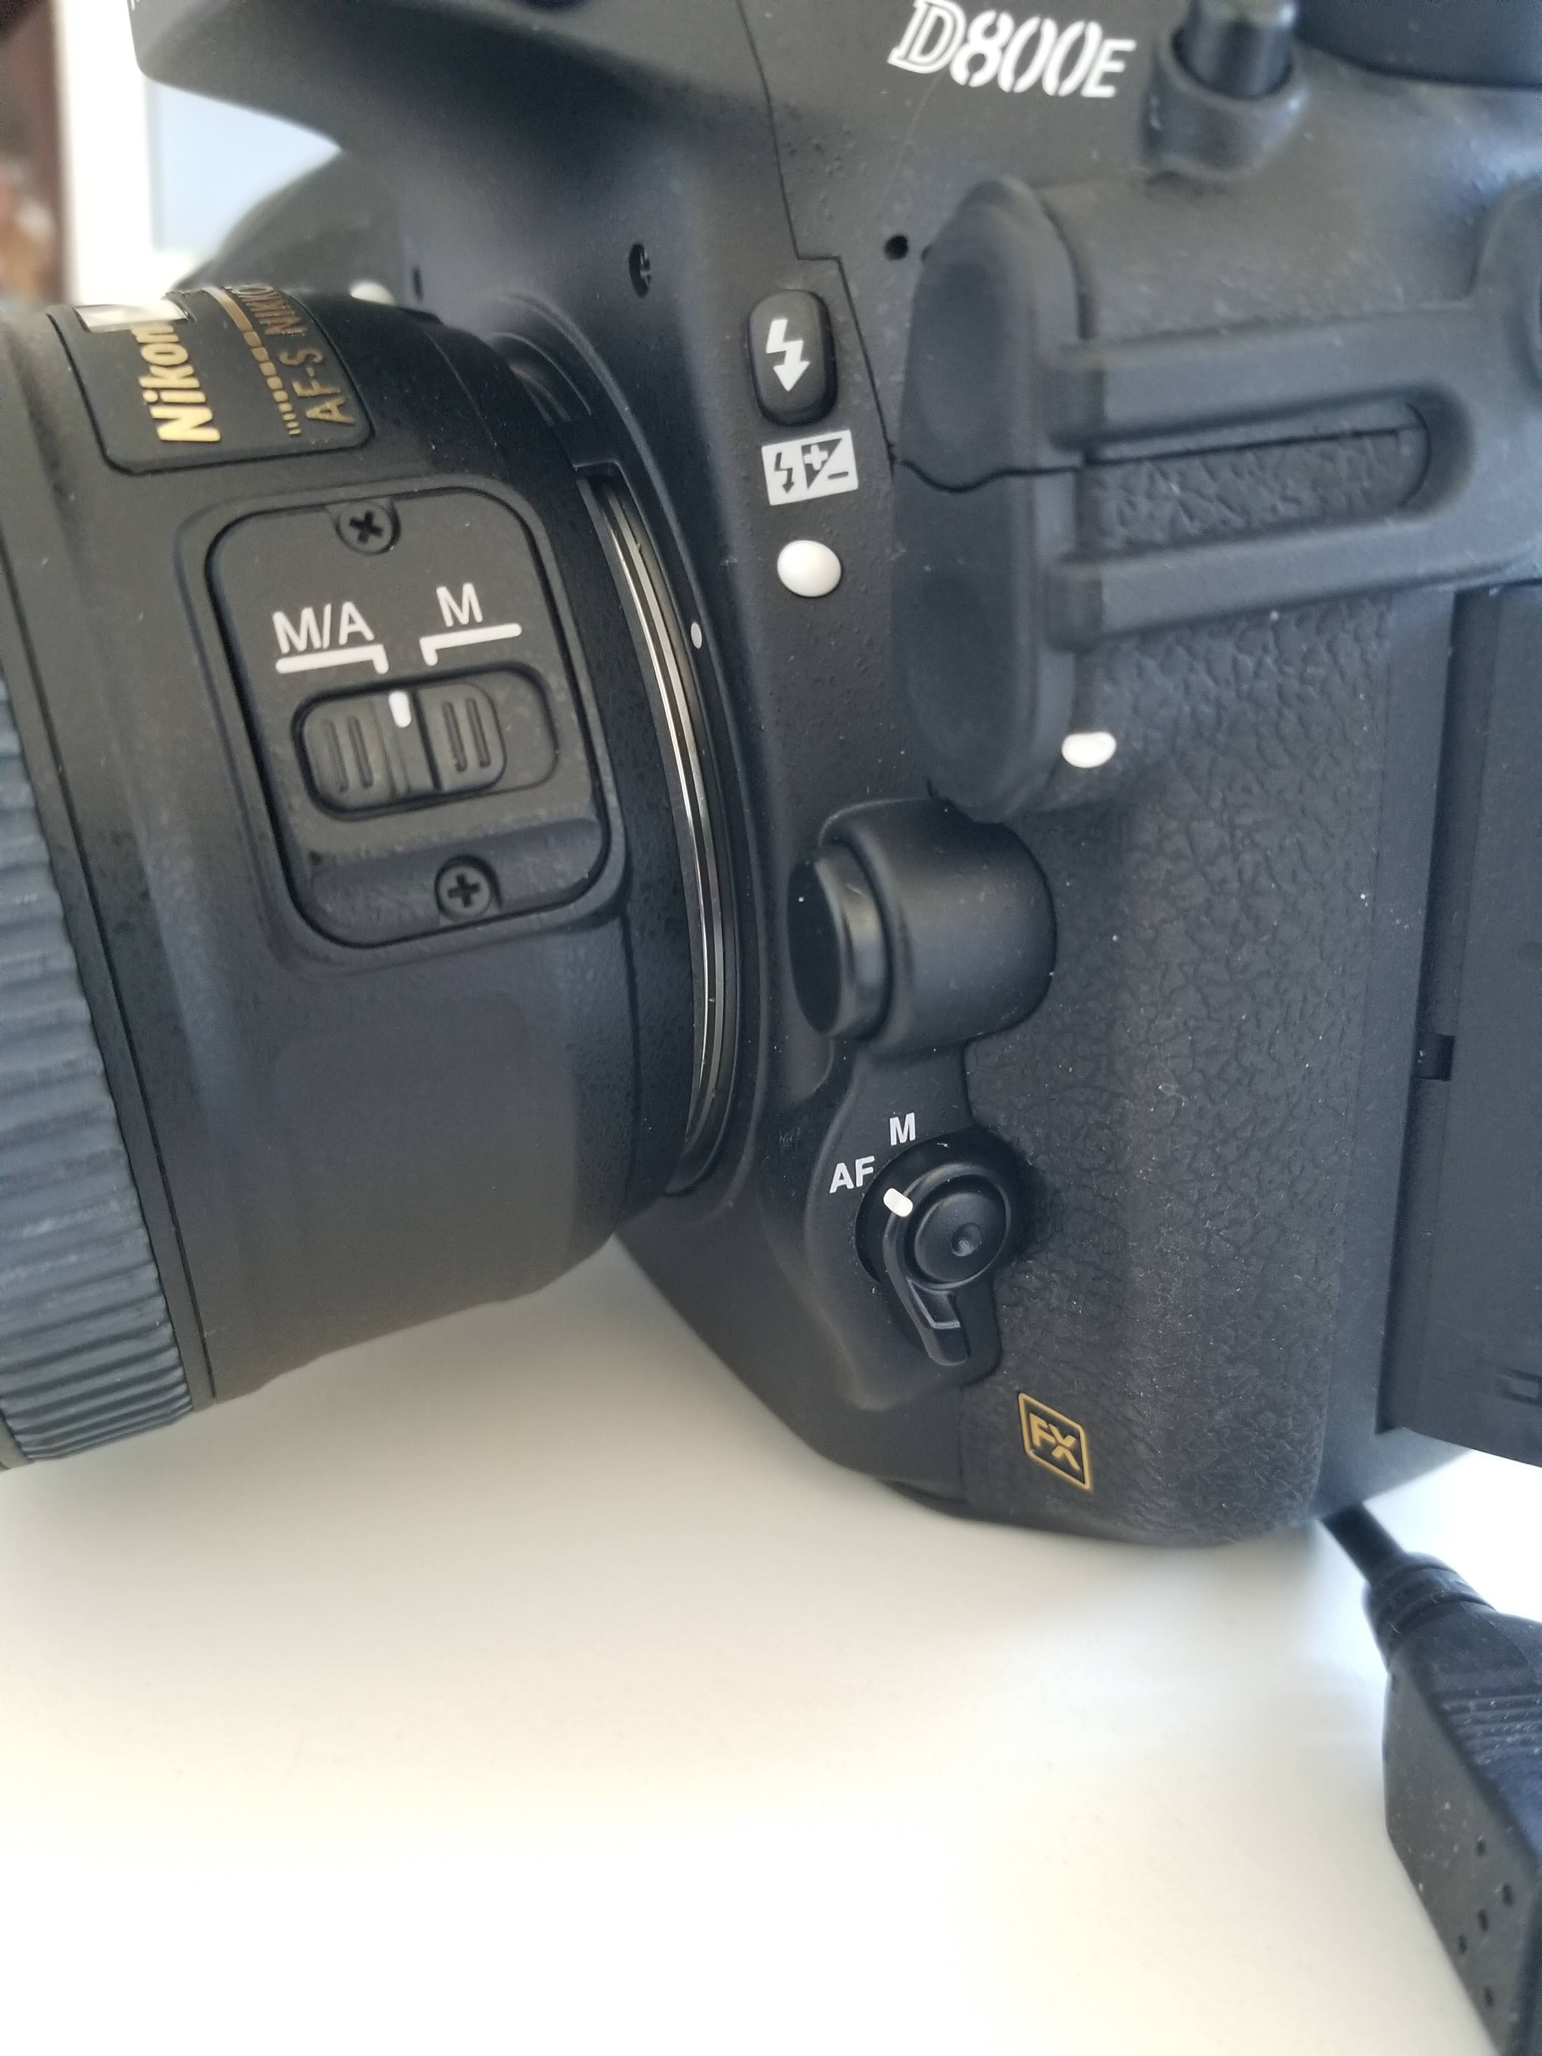

- Start an Imaging Log entry by writing the date, your name, and the starting cabinet/cubby numbers in the appropriate fields on the Imaging Log (see page 5).
- Create a folder on the desktop with the date (YYYYMMDD) and your last name separated by an underscore. Include a zero before single-digit days or months (e.g., if Katie Pearson made a file on October 1st, 2020, the filename should be 20201001_Pearson).
- Open the application Smart Shooter 4. If you have already turned on the camera, it should automatically be connected (the “Connect” button will be greyed out, as shown below). If not, click the “Detect” button, then the “Connect” button.

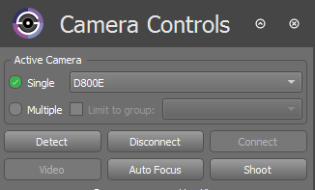

If the Camera Controls toolbar is not visible, click “Display” in the menu bar at the top of your screen and click “Camera Controls” in the dropdown menu.

If the camera does not connect, close Smart Shooter 4, turn off the camera, and unplug the camera from the computer. Then plug the camera in to the computer, turn on the camera, and re-open Smart Shooter 4.

- Press the Cmd and comma keys simultaneously (PC: Ctrl and comma) or, in the menu bar at the top of your screen, click “Smart Shooter 4” followed by “Preferences” (PC: “File” followed by “Options”).
- In the Preferences (PC: Options) window, open the General tab, if it isn’t already open.
- In the box labeled Photo Download Directory, click “Browse” and navigate to the folder that you created in step 7. Click “Open.”
- Open the “Name Policy” tab. Ensure that the text in the “Filename Expression field” is “[Z]” with no quotation marks and no spaces before or after.

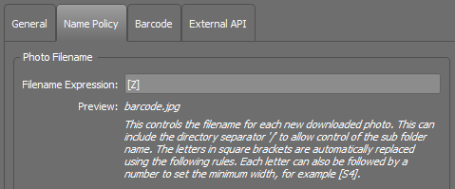

- Open the “Barcode” tab. Ensure that the “Autoscan for Barcodes” box is checked.

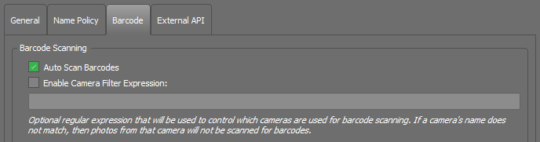
- Click “OK” to close the Preferences (PC: Options) window.
- Ensure that all the camera settings match those shown in the example below (but see first time set up note). Select the correct values from the dropdown menus as necessary. Don’t worry about changing the greyed-out fields. You will not be able to change these values.

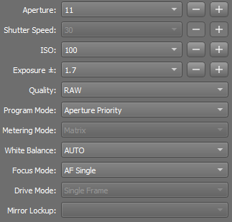

First time set up note:
  - Appropriate values of ISO and Exposure may differ depending on your ambient lighting conditions. You will want to experiment with what settings make clear and relatively bright (but not overexposed) images.
    - Lower values of ISO means that the camera will be less sensitive to light. If you find that your images are overexposed (i.e., too bright), decrease this value. If you find that your images are underexposed (i.e., too dark), increase this value.
    - Lower values of exposure means that the shutter is open for a shorter amount of time, letting in less light. If you find that your images are overexposed (i.e., too bright), decrease this value. If you find that your images are underexposed (i.e., too dark), increase this value.
  - You can also experiment with Shutter Speed. The longer the shutter speed, the brighter the image will be. We have found that it can be helpful to try changing the Program Mode to Manual and selecting 1/13 for Shutter Speed, especially when imaging small or thin specimens, like grasses.
- Click the checkbox next to “Enable” in the Live View portion of the Camera Control toolbar (indicated in the photo below). You should now be able to see camera’s view in the viewscreen. Increase the size of the Preview window by dragging the left edge of the Preview box left. The image will look grainy on the screen, but don’t worry, the pictures will not!

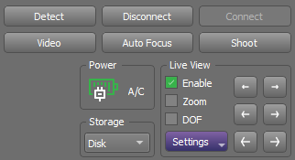
- Open a browser window and navigate to the CCH2 portal (http://www.cch2.org).
- Log in to your account and click My Profile followed by the Specimen Management tab, then the Robert F. Hoover herbarium link.
- Select “Edit Existing Occurrence Records” from the Data Editor Control Panel. This will open the CCH2 Record Search Form (see screenshot below).

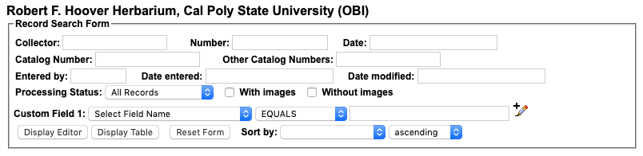

- Arrange the windows on your computer screen so that the Smart Shooter window and browser window are side-by-side.
- Determine where imaging was most recently left off by looking at the Cabinet Logs attached to the herbarium cabinet doors (examples on pages 11-12).
  - The last imaged cubby will be indicated by initials and a date under the word “Imaged,” while the cubbies that follow on the diagram will not have initials or a date.
- Remove all the specimens from the next cubby to be imaged and bring them to your workstation, taking care to initial and date on the corresponding cubby of the cabinet log.
- Place the first/next specimen on a level surface by itself.
- Apply a barcode 1/8 inch (NO CLOSER) from the bottom left corner of the first specimen (see following image).
  - DO NOT apply a barcode sticker on top of anything else (e.g., herbarium stamp, piece of the specimen, or a label).
  - If there is not space in the bottom left corner, place the barcode somewhere else along the bottom of the specimen. If there is not space at the bottom of the specimen, you may use the top edge of the specimen.
  - If a sheet has an indication that there are two different species on a single sheet, set this sheet aside and notify a supervisor, making sure to record the folder in which the specimen had been filed.
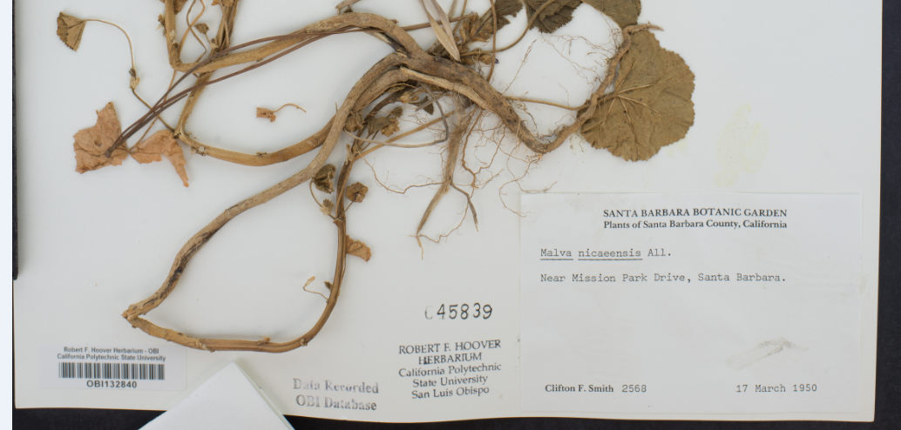

- Look for a stamped number (“accession number”) on the specimen. This is sometimes (but not always) located near the Robert F. Hoover Herbarium stamp. Some examples are shown below.
  - If a stamped number exists, continue to step 26.
  - If a stamped number does not exist, proceed to step 28.

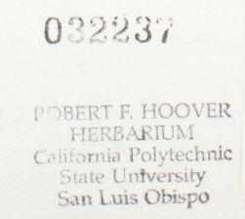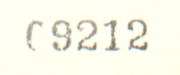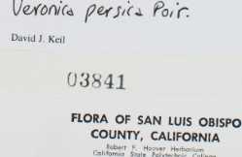

- Look for a stamp on the specimen that says “Data Recorded OBI Database.”
  - If there is such a stamp on the specimen, continue to step 27.
  - If you do not find this stamp on the specimen, proceed to step 29.

TIP: You can zoom in to the image by pressing Command (Mac) or Control (Windows) and clicking on the image where you want to zoom in. Alternatively, you can hold Shift, click on the area where you want to zoom in, and move the mouse up (to zoom in) or down (to zoom out).

- Enter the stamped number into the Other Catalog Numbers field. Do not include leading zeros (e.g., if the stamp is 01499, enter 1499). Click Display Editor.
  - If no record is returned, double check that you entered the accession number correctly into the Other Catalog Numbers field and that there are no extra spaces before or after the numbers you typed. If the number is correct, proceed to step 28.
  - If a record is returned, check that the data on the specimen record match the data on the label of the specimen in front of you, particularly collector, collector number, and date.
    - If these data match, place your cursor in the Catalog Number field (top left) and scan the barcode of the specimen in front of you. The barcode number will then appear in this field. Press Tab on your keyboard, followed by Enter. Proceed to step 29.
    - If these data do NOT match, notify your supervisor, change the processing status of the problematic record to “Expert required”, and proceed to step 28.

TIP: To re-open the Record Search Form after you have performed a search, click the magnifying glass icon at the top right side of the specimen record.

- In the CCH2 Record Search Form, enter the last name of the collector preceded by a percent sign (%), the collector number, and the date (in YYYY-MM-DD format) into the top three fields (see example below) and click Display Editor.

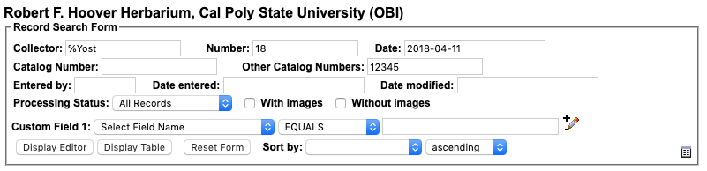

  - If no record is returned, double check that you entered data correctly into the appropriate fields. If everything looks correct, continue to step 29.
  - If a record is returned, check that the data on the specimen record match the data on the label of the specimen in front of you, particularly collector, collector number, and date.
    - If these data match, place your cursor in the Catalog Number field (top right) and scan the barcode of the specimen in front of you. The barcode number will then appear in this field. Press Tab on your keyboard, followed by Enter. Proceed to step 29.
    - If these data do NOT match, notify your supervisor, change the processing status of the problematic record to “Expert required”, and proceed to step 29.
- Place the specimen inside the lightbox, aligning the top left corner of the specimen to the inside corner of the raised pieces of foamboard.
  - The ruler and color guide should be at the top of the specimen. If the label is on the bottom right corner of the specimen, like most are, the label should be closest to you and on your right side.
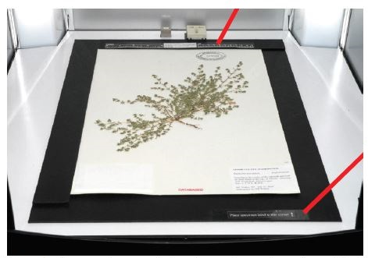
Image credit: Ben Legler, Consortium of Pacific Northwest Herbaria

- Make sure the entire specimen, ruler, and color guide are visible in the viewscreen and that the specimen does not appear crooked.
  - If the specimen does not appear aligned, the specimen platform or camera may have been jostled or shifted. Adjust the camera and/or specimen platform if necessary. Do NOT untape the specimen platform or unscrew the camera from its mount. Contact a supervisor if you cannot fix the problem without doing so.
- Adjust the focal point by clicking and dragging the blue square in the Preview window (indicated by the arrow below). The best focus can be achieved by selecting a focal point that is relatively flat and contains mostly vegetation and/or text with little white space. Some examples of good focal points are shown below the screenshot.

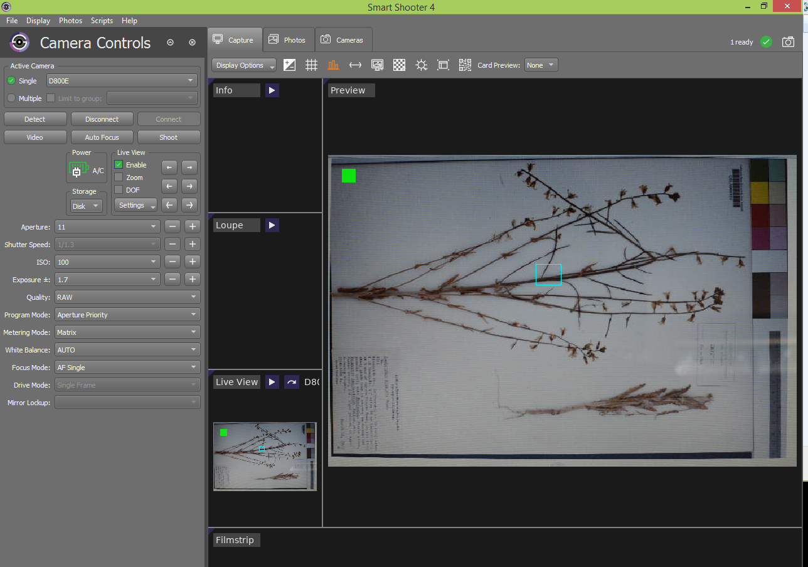

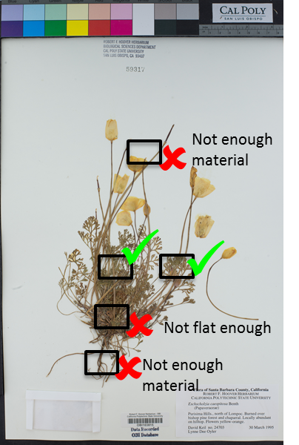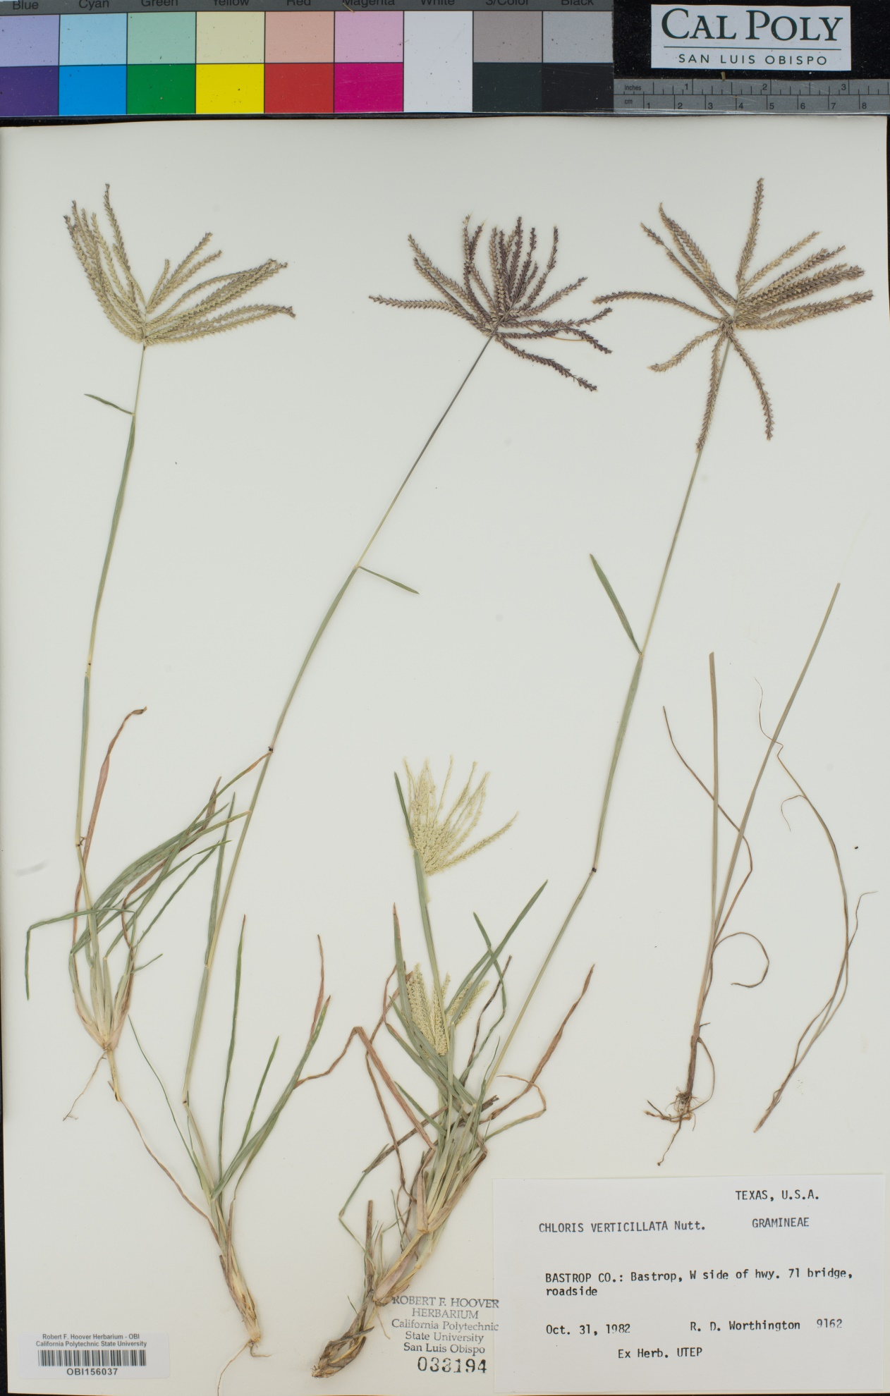

- Click the “Auto Focus” button once you are satisfied with your choice of focal point.
- Click the “Shoot” button in Smart Shooter 4.
- Uncheck the box next to “Enable.”
- View the image you just captured. It should have appeared on the screen after you unchecked “Enable.” If not, click the appropriate image in the Filmstrip window at the bottom.
- Check the quality of the image you just took.
  - Is the whole label and barcode visible?
  - Is the specimen straight and aligned with the edges of the specimen platform?
  - Is the focus sharp? Place your mouse over several parts on the specimen to zoom in and check the focus.
    - If there are any problems with focus:
      - Return to the Display tab.
      - Re-focus the camera by repeating steps 31-32.
      - Instead of clicking “Shoot”, click the Photos tab (circled below) and right click the name of the problematic image.

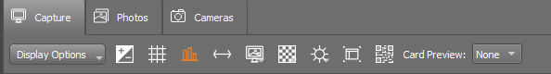

      - Select “Reshoot with same name” from the dropdown menu and repeat steps 35-36 with this new photo.

- If you are happy with the focus, switch the camera from Autofocus (AF) mode to Manual (M) mode by flipping the switch left side of the camera body. Do NOT touch the M/A / M switch on the lens.
- Carefully remove the specimen from the lightbox and place it in your "imaged" pile or to the right of the imaging station.
- Get a new specimen and place it in the lightbox like you did in step 29.
  - For the remaining specimens in this stack, you do NOT need to refocus and check for quality! (i.e., you can skip steps 31-37)
- Image the remaining specimens in your stack by placing each specimen in the lightbox individually and clicking “Shoot.” Make sure to quickly check each image for alignment and focus.
- When you have finished imaging your stack, ensure that it is in the correct order (i.e., alphabetical according to genus, then species. Rearrange if necessary.
- Return the stack of imaged specimens to its cubby.
- Switch the camera back to Autofocus (AF) by flipping the switch on the camera body.
- Repeat steps 23-43, switching to Autofocus at the beginning of each cubby and checking the quality of the first specimen of each cubby as instructed.

At the end of your shift:

- Navigate to the Photos tab.
- Check that all the images have names in the expected format: the institution code of your collection followed by a set number of digits (e.g., OBI100259).
  - If any images are not named correctly:
    - View the image by right clicking on it and selecting “Open in editor” in the dropdown menu. If no editor opens, click “View”.
    - Rename the image according to the barcode by right clicking on the record in the Smart Shooter 4 table, selecting “Rename” in the dropdown menu, and manually entering the barcode number. Make sure to keep the .NEF file extension.
    - Double check that you have entered the entire barcode correctly, including the institution abbreviation (e.g., OBI) at the beginning.
- In the Photos tab, randomly select one of the images in the table. Double click to open it in the Display tab.
- Check that the barcode number in the image matches the image name.
- Repeat steps 47-48 for at least four additional specimens.
- Turn off the camera and lightbox and replace the lens cap on the camera.
- Complete your Imaging Log entry by indicating your ending cabinet/cubby and the number of specimens you imaged. You can find the number of images you created by right clicking on the folder into which you imaged the specimens, clicking Get Info (PC: Properties), and looking for the number of files.

Supervisor Notes:
Specimens with multiple specimens on a single sheet should be barcoded once for every specimen on that sheet. Then, when imaging, one image will be taken for each barcode on that sheet (i.e., 3 barcodes = 3 identical images, each with a different image name corresponding to one of the barcodes on the sheet).

Note that the program we are using to rename images at the time of imaging, Smart Shooter will not be able to automatically name specimens with multiple barcodes on the sheet! Therefore, during imaging, the technicians should make a note of which barcodes belong to this anomalous specimen, they will have to manually rename the images accordingly.

Specimens that consist of multiple sheets or items should be treated as a set of botanical duplicates, with each sheet or item receiving its own barcode. Each sheet or item should then have a corresponding record in the database.

Cabinet Log
For collections that barcode and image specimens in the same step
  - A copy of this document (or the half-cabinet version on the next page) should be printed and attached to the outside of each cabinet in the collection.

Cabinet Number: ___________
1. Imaged | 14. Imaged
2. Imaged | 15. Imaged
3. Imaged | 16. Imaged
4. Imaged | 17. Imaged
5. Imaged | 18. Imaged
6. Imaged | 19. Imaged
7. Imaged | 20. Imaged
8. Imaged | 21. Imaged
9. Imaged | 22. Imaged
10. Imaged | 23. Imaged
11. Imaged | 24. Imaged
12. Imaged | 25. Imaged
13. Imaged | 26. Imaged

Completely imaged and frozen: _________________________Date:_____________

Cabinet Log (half-cabinet version)
For collections that barcode and image specimens in the same step
Cabinet Number: ___________
1. Imaged | 8. Imaged
2. Imaged | 9. Imaged
3. Imaged | 10. Imaged
4. Imaged | 11. Imaged
5. Imaged | 12. Imaged
6. Imaged | 13. Imaged
7. Imaged | 14. Imaged

Completely imaged and frozen: _________________________Date:_____________

