Barcoding & Imaging Protocol (Windows OS)
Last updated by Katie Pearson and Jenn Yost on January 2, 2019

Goals: This protocol describes how to barcode and image specimens using the Ortery lightbox setup and Smart Shooter 3.

- Turn on the lightbox using the switch labeled “Front & Rear.” Do not turn on the “Back” switch.
- Ensure that the camera is correctly plugged in to a power source and the computer.
- Turn on the computer and camera, in that order.
- Remove the camera lens cap.
- Start an Imaging Log entry by writing the date, your name, and the starting cabinet/cubby numbers in the appropriate fields on the Imaging Log (see page 6).
- Create a folder on the desktop with the date (YYYYMMDD) and your last name separated by an underscore. Include a zero before single-digit days or months (e.g., if Katie Pearson made a file on October 1st, 2018, the filename should be 20181001_Pearson).
- Open the application Smart Shooter 3. In the Camera Controls toolbar (shown below), click the “Detect” button and look toward the bottom right of the screen.

If the Camera Controls toolbar is not visible, click “Display” in the menu bar at the top of your screen and click “Camera Controls” in the dropdown menu.

You should see the following message:
If you do not see this message, close Smart Shooter 3, turn off the camera, and unplug the camera from the computer. Then plug the camera in to the computer, turn on the camera, and re-open Smart Shooter 3.

- Click the “Connect” button in the Camera Controls toolbar.
- Press the Control (Ctrl) and “O” keys simultaneously. (Or, in the menu bar at the top of your screen, click “File” and select “Options”).
- In the Photo Download Directory box of the Options menu, click “Browse” and navigate to the file that you created in step 6. Click “Open.”
- Navigate to the “Name Policy” tab in the Options window. Replace the text in the “Filename Expression” field with “[S]” with no quotation marks and no spaces before or after. Click “OK.”
- Ensure that all the camera settings match those shown in the example below. Select the correct values from the dropdown menus as necessary.
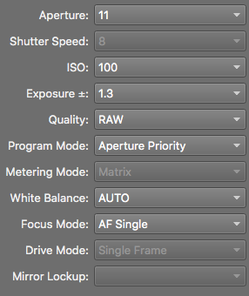
- Click the checkbox next to “Enable” in the Liveview portion of the Camera Control toolbar. You should now be able to see camera’s view in the viewscreen. Click the picture icon ( ) to the right of the Options button (top of the viewscreen) to fit the viewscreen to the window. The image will look grainy on the screen, but don’t worry, the pictures will not!
- Determine where imaging was most recently left off by looking at the Cabinet Logs attached to the herbarium cabinet doors (examples on pages 7-8).
  - The last imaged cubby will be indicated by initials and a date under the word “Imaged” on that cubby, while the following cubbies in the diagram will not have initials or a date under “Imaged.”
- Remove all the specimens from the next cubby to be imaged and bring them to your workstation, making sure to initial and date under the word “Imaged” on the corresponding cubby of the cabinet log.
- Place the first/next specimen on a level surface by itself.
- Apply a barcode 1/8 inch (NO CLOSER) from the upper left corner of the first specimen (see image below).
  - DO NOT apply a barcode sticker on top of anything else (e.g., herbarium stamp, piece of the specimen, or a label).
  - If there is not space in the upper left corner, place the barcode somewhere else along the top of the specimen. If there is not space at the top of the specimen, you may use the bottom edge of the specimen.
  - If a sheet has an indication that there are two different species on a single sheet, set this sheet aside and notify a supervisor, making sure to record the folder in which the specimen had been filed.
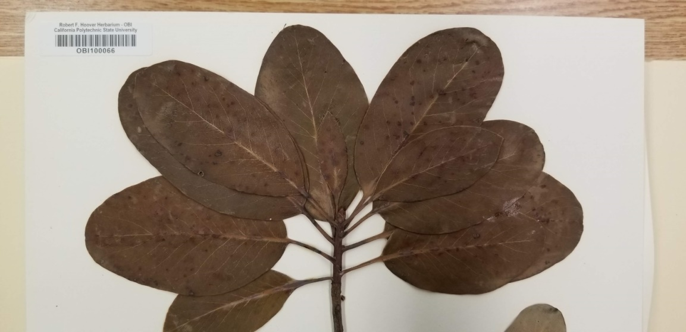
- Place the specimen inside the lightbox, aligning the top left corner of the specimen to the inside corner of the raised pieces of foamboard.
  - The ruler and color guide should be at the top of the specimen. If the label is on the bottom right corner of the specimen, like most are, the label should be closest to you and on your right side.
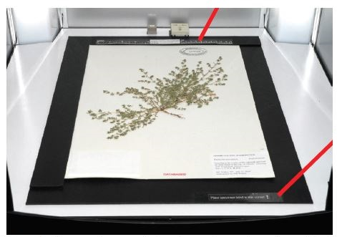
Image credit: Ben Legler, Consortium of Pacific Northwest Herbaria

- Make sure the entire specimen, ruler, and color guide are visible in the viewscreen and that the specimen does not appear crooked.
  - If the specimen does not appear aligned, the specimen platform or camera may have been jostled or shifted. Adjust the camera and/or specimen platform if necessary. Do NOT untape the specimen platform or unscrew the camera from its mount. Contact a supervisor if you cannot fix the problem without doing so.
- Find a representative part of the specimen that has a good amount of vegetation and make a mental note of where it is on the screen. This will be where you will focus the camera initially.
- Check the box next to “Zoom” in the Liveview portion of the Camera Controls toolbar. A small rectangle will appear on the viewscreen surrounded either by black or the most recently created image.
  - NOTE: There is a glitch in the program, and the most recently created image will be displayed after you click “Zoom.” This image does NOT show the specimen that is in the lightbox currently. You will have to ignore this image as you move the zoom rectangle in step 22.
- Drag the zoom rectangle to the approximate location of the representative part of the specimen you previously identified (see below).
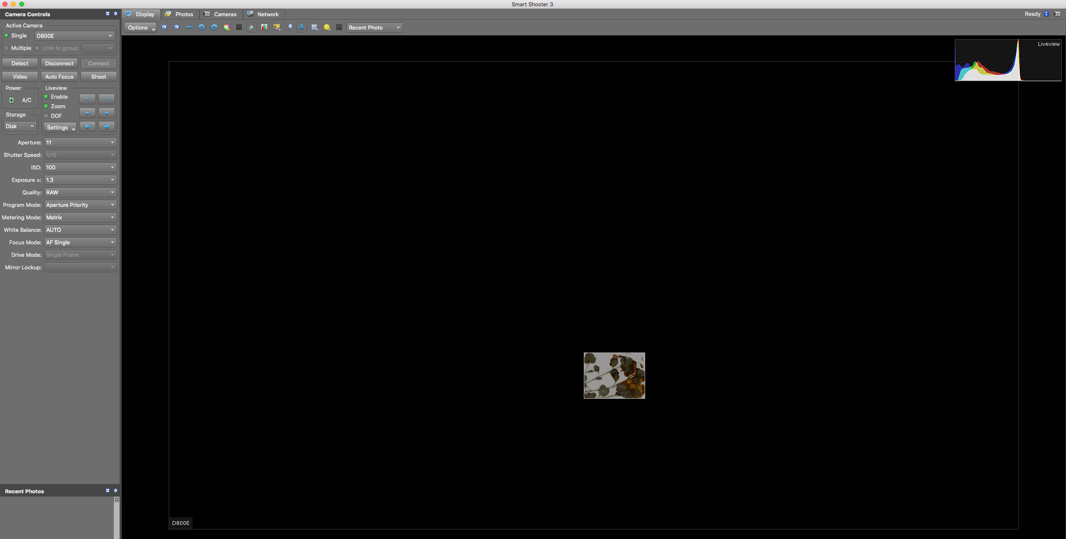
- Uncheck the box next to “Zoom” when you are satisfied with your choice.
- Click the “Auto Focus” button.
- On the camera, switch the camera from Autofocus (AF) mode to Manual (M) mode by flipping the switch to the left of the lens (near the cord that connects the camera to the computer).
- Uncheck the “Enable” box and click “Shoot.”
- Navigate to the Photos tab (circled below).
- Right click on the name of the image you just took and select “Open in editor” in the dropdown menu.
Set-up note: To change the default photo editing program, go to Options > General tab > External Editor and select the desired photo editing program.
- Check the quality of the image you just took.
  - Is the whole label and barcode visible?
  - Is the specimen straight and aligned with the edges of the specimen platform?
- Zoom in and check the focus in multiple places on the specimen.
  - If there are any problems with focus:
    - Return to the Display tab.
    - Switch the camera back to Autofocus (AF) mode.
    - Re-focus the camera by repeating steps 20-25.
    - Uncheck the “Enable” box, but instead of clicking “Shoot” for step 26, return to the Photos tab and right click the name of the problematic image.
    - Select “Reshoot with same name” from the dropdown menu and repeat steps 28-30 with this new photo.
- Close the image and return to the Display tab.
- Carefully remove the specimen from the lightbox and place it in your "imaged" pile or to the right of the imaging station.
- Get a new specimen and place it in the lightbox like you did in step 18.
  - For the remaining specimens in this stack, you do NOT need to refocus and check for quality!
- Image the remaining specimens in your stack by placing each specimen in the lightbox individually and clicking “Shoot.”
- When you have finished imaging your stack, put it in the gray cabinet in front of the imaging station. Write the numbers of the cabinet and cubby from which you obtained this stack of specimens on the whiteboard cabinet diagram on the outside of the gray cabinet.
- Switch the camera back to Autofocus (AF) by flipping the switch on the camera body.
- Repeat steps 14-36, switching to Autofocus at the beginning of each cubby and checking the quality of the first specimen of each cubby as instructed.
- At the end of your shift, open the Options window (Control + O keys) and navigate to the “Name Policy” tab.
- Replace the text in the “Filename Expression” field with “[Z]” with no quotation marks and no spaces before or after. This tells the program to rename the images according to the barcode. Click “OK.”
- Navigate to the Photos tab. Select all of the images in the table by clicking the first image and then pressing Control and “A” simultaneously.
- Right click on the selected images and select “Scan for barcode” in the dropdown menu.
  - If the names do not immediately change, just be patient! The program may take a little while, depending on how many images you have taken.
- Check that all the images have names in the expected format: the institution code of your collection followed by a set number of digits (e.g., OBI100259).
  - If any images are not named correctly:
    - View the image by right clicking on it and selecting “Open in editor” in the dropdown menu.
    - Rename the image according to the barcode by right clicking on the record in the Smart Shooter 3 table, selecting “Rename” in the dropdown menu, and manually entering the barcode number.
    - Double check that you have entered the entire barcode correctly, including the institution abbreviation (e.g., OBI) at the beginning.
- Return to the Smart Shooter 3 Photos tab.
- Randomly select one of the images in the table.
- Left click to select just this image, then right click on it.
- Select “Open in editor” in the dropdown menu.
- Check that the barcode number in the image matches the image name.
- Repeat steps 44-47 for at least four additional specimens.
- Turn off the camera and lightbox and replace the lens cap on the camera.
- Complete your Imaging Log entry by indicating your ending cabinet/cubby and the number of specimens you imaged. The number of images you created should be listed underneath the name of the folder you created on the desktop. If this is not the case, right click on the folder into which you imaged the specimens, click Get Info, click the triangle next to “General”, and find the number of items next to Size (if you use this method, you will need to subtract 1 from this number to account for the file itself).

Example Imaging Log
  - This document should be printed and kept next to the imaging station. Alternatively, a digital version (e.g., Google sheets document) could be curated on the imaging/processing computer.

Date | Imager(s) | Starting Cabinet + Cubby | Ending Cabinet + Cubby | Number of images | Processed (date/initials) | Uploaded to iDigBio | Linked to CCH2 | DNGs stored

Cabinet Log
For collections that barcode and image specimens in separate steps

A copy of this document (or the half-cabinet version on the next page) should be printed and attached to the outside of each cabinet in the collection.

Cabinet Number: ___________
1. Barcoded | Imaged | 14. Barcoded | Imaged
2. Barcoded | Imaged | 15. Barcoded | Imaged
3. Barcoded | Imaged | 16. Barcoded | Imaged
4. Barcoded | Imaged | 17. Barcoded | Imaged
5. Barcoded | Imaged | 18. Barcoded | Imaged
6. Barcoded | Imaged | 19. Barcoded | Imaged
7. Barcoded | Imaged | 20. Barcoded | Imaged
8. Barcoded | Imaged | 21. Barcoded | Imaged
9. Barcoded | Imaged | 22. Barcoded | Imaged
10. Barcoded | Imaged | 23. Barcoded | Imaged
11. Barcoded | Imaged | 24. Barcoded | Imaged
12. Barcoded | Imaged | 25. Barcoded | Imaged
13. Barcoded | Imaged | 26. Barcoded | Imaged

Completely imaged and frozen: _________________________Date:_____________

Cabinet Log (half-cabinet version)
For collections that barcode and image specimens in separate steps

1. Barcoded | Imaged | 8. Barcoded | Imaged
2. Barcoded | Imaged | 9. Barcoded | Imaged
3. Barcoded | Imaged | 10. Barcoded | Imaged
4. Barcoded | Imaged | 11. Barcoded | Imaged
5. Barcoded | Imaged | 12. Barcoded | Imaged
6. Barcoded | Imaged | 13. Barcoded | Imaged
7. Barcoded | Imaged | 14. Barcoded | Imaged

Completely imaged and frozen: _________________________Date:_____________

