Imaging Protocol (Windows OS)
Last updated by Katie Pearson and Jenn Yost on May 17, 2019

Goals: This protocol describes how to image previously barcoded specimens using the Ortery lightbox setup and Smart Shooter 3.

- Turn on the lightbox using the switch labeled “Front & Rear.” Do not turn on the “Back” switch.
- Ensure that the camera is correctly plugged in to a power source and the computer.
- Turn on the computer and camera, in that order.
- Remove the camera lens cap.
- Start an Imaging Log entry by writing the date, your name, and the starting cabinet/cubby numbers in the appropriate fields on the Imaging Log (see page 5).
- Create a folder on the desktop with the date (YYYYMMDD) and your last name separated by an underscore. Include a zero before single-digit days or months (e.g., if Katie Pearson made a file on October 1st, 2018, the filename should be 20181001_Pearson).
- Open the application Smart Shooter 3. In the Camera Controls toolbar (shown below), click the “Detect” button and look toward the bottom right of the screen.

If the Camera Controls toolbar is not visible, click “Display” in the menu bar at the top of your screen and click “Camera Controls” in the dropdown menu.

You should see the following message:
If you do not see this message, close Smart Shooter 3, turn off the camera, and unplug the camera from the computer. Then plug the camera in to the computer, turn on the camera, and re-open Smart Shooter 3.

- Click the “Connect” button in the Camera Controls toolbar.
- Press the Control and comma keys simultaneously. (Or, in the menu bar at the top of your screen, click “File” followed by “Options”).
- In the Photo Download Directory box of the Options menu, click “Browse” and navigate to the file that you created in step 6. Click “Open.”
- Navigate to the “Name Policy” tab in the preferences window. Ensure that the text in the “Filename Expression field” is “[Z]” with no quotation marks and no spaces before or after.
- Navigate to the “Barcode” tab. Ensure that the “Autoscan for barcode” box is checked. Click “OK”.
- Ensure that all the camera settings match those shown in the example below. Select the correct values from the dropdown menus as necessary.
  - You will not be able to change the greyed-out fields unless you alter other settings.
  - If you find that it produces better results in terms of brightness, you may choose to set the Program Mode to Manual and select 1/13 for the Shutter Speed.
  - Also consider experimenting with different values for Exposure. Depending on the lighting conditions at your location, higher or lower exposure compensation may be necessary.

- Click the checkbox next to “Enable” in the Liveview portion of the Camera Control toolbar. You should now be able to see camera’s view in the viewscreen. Click the picture icon ( ) to the right of the Options button (top of the viewscreen) to fit the viewscreen to the window. The image will look grainy on the screen, but don’t worry, the pictures will not!
- Determine where imaging was most recently left off by looking at the Cabinet Logs attached to the herbarium cabinet doors (examples on pages 6-7).
  - The last imaged cubby will be indicated by initials and a date under the word “Imaged” on that cubby, while the following cubbies in the diagram will not have initials or a date under “Imaged.”
  - Make sure that the cubby you are about to remove has been signed and dated beneath the word “Barcoded” on the cabinet log.
- Remove all the specimens from the next cubby to be imaged and bring them to your workstation, taking care to initial and date under the word “Imaged” on the corresponding cubby of the cabinet log.
- Place the specimen inside the lightbox, aligning the top left corner of the specimen to the inside corner of the raised pieces of foamboard (see picture below).
  - The ruler and color guide should be at the top of the specimen. If the label is on the bottom right corner of the specimen, like most are, the label should be closest to you and on your right side.
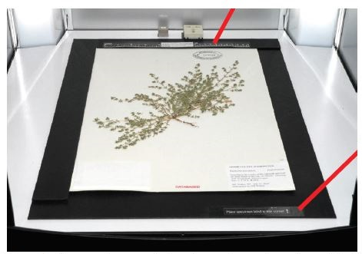
Image credit: Ben Legler, Consortium of Pacific Northwest Herbaria

- Make sure the entire specimen, ruler, and color guide are visible in the viewscreen and that the specimen does not appear crooked.
  - If the specimen does not appear aligned, the specimen platform or camera may have been jostled or shifted. Adjust the camera and/or specimen platform if necessary. Do NOT untape the specimen platform or unscrew the camera from its mount. Contact a supervisor if you cannot fix the problem without doing so.
- Find a representative part of the specimen that has a good amount of vegetation and make a mental note of where it is on the screen. This will be where you will focus the camera initially.
- Check the box next to “Zoom” in the Liveview portion of the Camera Controls toolbar. A small rectangle will appear on the viewscreen surrounded either by black or the most recently created image.
  - NOTE: There is a glitch in the program, and the most recently created image will be displayed after you click “Zoom.” This image does NOT show the specimen that is in the lightbox currently. You will have to ignore this image as you move the zoom rectangle in step 21.
- Drag the zoom rectangle to the approximate location of the representative part of the specimen you previously identified (see below).
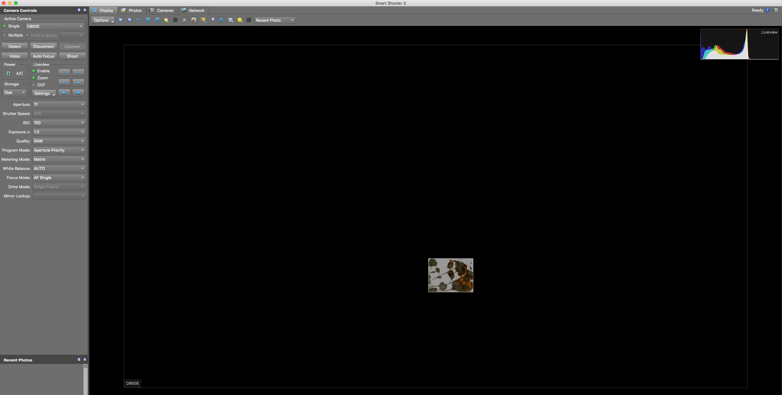
- Click the “Auto Focus” button once you are satisfied with your choice of focal point.
- Click “Shoot.”
- Uncheck the boxes next to “Zoom” and “Enable.”
- View the image you just captured. It should have appeared on the screen after you unchecked “Enable.” If this is not the case, make sure that you are in the Display tab and that “Recent Photo” is selected from the dropdown menu in the top right (circled below).
- Check the quality of the image you just took.
  - Is the whole label and barcode visible?
  - Is the specimen straight and aligned with the edges of the specimen platform?
  - Is the focus sharp? Zoom in and check the focus in multiple places on the specimen.
    - If there are any problems with focus:
      - Return to the Display tab.
      - Switch the camera back to Autofocus (AF) mode.
      - Re-focus the camera by repeating steps 19-26.
      - Uncheck the “Enable” box, but instead of clicking “Shoot” for step 23, click the Photos tab (circled below) and right click the name of the problematic image.
      - Select “Reshoot with same name” from the dropdown menu and repeat steps 25-26 with this new photo.
- If you are happy with the focus, switch the camera from Autofocus (AF) mode to Manual (M) mode by flipping the switch to the left of the lens on the camera (near the cord that connects the camera to the computer).
- Carefully remove the specimen from the lightbox and place it in your "imaged" pile or to the right of the imaging station.
- Get a new specimen and place it in the lightbox like you did in step 17.
  - For the remaining specimens in this stack, you do NOT need to refocus and check for quality!
- Image the remaining specimens in your stack by placing each specimen in the lightbox individually and clicking “Shoot.”
- When you have finished imaging your stack, put it in the gray cabinet in front of the imaging station. Write the numbers of the cabinet and cubby from which you obtained this stack of specimens on the whiteboard cabinet diagram on the outside of the gray cabinet.
- Switch the camera back to Autofocus (AF) by flipping the switch on the camera body.
- Repeat steps 15-32, switching to Autofocus at the beginning of each cubby and checking the quality of the first specimen of each cubby as instructed.
- At the end of your shift, navigate to the Photos tab.
- Check that all the images have names in the expected format: the institution code of your collection followed by a set number of digits (e.g., OBI100259).
  - If any images are not named correctly:
    - View the image by right clicking on it and selecting “Open in editor” in the dropdown menu.
    - Rename the image according to the barcode by right clicking on the record in the Smart Shooter 3 table, selecting “Rename” in the dropdown menu, and manually entering the barcode number.
    - Double check that you have entered the entire barcode correctly, including the institution abbreviation (e.g., OBI) at the beginning.
- Return to the Smart Shooter 3 Photos tab.
- Randomly select one of the images in the table. Double click to open it in the Display tab.
- Check that the barcode number in the image matches the image name.
- Repeat steps 37-48 for at least four additional specimens.
- Turn off the camera and lightbox and replace the lens cap on the camera.
- Complete your Imaging Log entry by indicating your ending cabinet/cubby and the number of specimens you imaged. You can find the number of images you created by right clicking on the folder into which you imaged the specimens, clicking Properties, and looking for the number of files.

Example Imaging Log
  - This document should be printed and kept next to the imaging station. Alternatively, a digital version (e.g., Google sheets document) could be curated on the imaging/processing computer.

Date | Imager(s) | Starting Cabinet + Cubby | Ending Cabinet + Cubby | Number of images | Processed (date/initials) | Uploaded to iDigBio | Linked to CCH2 | DNGs stored

Cabinet Log
For collections that barcode and image specimens in separate steps

A copy of this document (or the half-cabinet version on the next page) should be printed and attached to the outside of each cabinet in the collection.

Cabinet Number: ___________
1. Barcoded | Imaged | 14. Barcoded | Imaged
2. Barcoded | Imaged | 15. Barcoded | Imaged
3. Barcoded | Imaged | 16. Barcoded | Imaged
4. Barcoded | Imaged | 17. Barcoded | Imaged
5. Barcoded | Imaged | 18. Barcoded | Imaged
6. Barcoded | Imaged | 19. Barcoded | Imaged
7. Barcoded | Imaged | 20. Barcoded | Imaged
8. Barcoded | Imaged | 21. Barcoded | Imaged
9. Barcoded | Imaged | 22. Barcoded | Imaged
10. Barcoded | Imaged | 23. Barcoded | Imaged
11. Barcoded | Imaged | 24. Barcoded | Imaged
12. Barcoded | Imaged | 25. Barcoded | Imaged
13. Barcoded | Imaged | 26. Barcoded | Imaged

Completely imaged and frozen: _________________________Date:_____________

Cabinet Log (half-cabinet version)
For collections that barcode and image specimens in separate steps

1. Barcoded | Imaged | 8. Barcoded | Imaged
2. Barcoded | Imaged | 9. Barcoded | Imaged
3. Barcoded | Imaged | 10. Barcoded | Imaged
4. Barcoded | Imaged | 11. Barcoded | Imaged
5. Barcoded | Imaged | 12. Barcoded | Imaged
6. Barcoded | Imaged | 13. Barcoded | Imaged
7. Barcoded | Imaged | 14. Barcoded | Imaged

Completely imaged and frozen: _________________________Date:_____________

