Image Processing Protocol (Windows OS)
Last updated by Katie Pearson and Jenn Yost on January 23, 2019

  - Goals: This protocol should be used by supervisors or trained technicians to process folders of raw images. Processing steps include cropping, adjusting sharpening, adding metadata, and exporting raw images as DNG and JPEG files.

Once the supervisor/technician is trained and has practiced this protocol, s/he should refer to the Image Processing Checklist (page 5) when processing images.

(Some material adapted from Skema & Barber 2018)

- Create a folder on the desktop that mimics the name of the folder of images you will process plus “_Processed” (e.g., 20181001_Pearson_Processed). Within this folder, create a subfolder called “JPEGs.”
- Open Adobe Lightroom.
- Click the Import button at the bottom left of the Lightroom window.
- Drag the folder of images you wish to process from its location (e.g., on the desktop) into the Lightroom library. (Or navigate to the folder in the Source menu on the left side of the window.)
- In the menu on the right side of the window, click the triangle next to “Apply During Import.” Select the preset metadata settings from the dropdown menu.
First time set-up note:
Upon first use, set up a metadata standard for your institution that can be applied to all images during processing by doing the following:
- From the metadata settings in “Apply During Import,” select “New” from the dropdown menu.
- Name the Metadata preset something recognizable (e.g., your herbarium acronym).
- Under the heading “IPTC Copyright,” type your herbarium/institution name in the “Copyright” box followed by “- funded by National Science Foundation award number” followed by your NSF award number.
- Select “Copyrighted” in the Copyright Status dropdown list.
- In the Rights Usage Terms field, enter “CC BY-NC-SA.” This means that users of your images must credit your institution when using the image, the image cannot be used for commercial means, and the image and its derivatives must be shared using a copyright license that is no more restrictive than the copyright license you provide.
- Click “Create” (or “Done”). Now you should be able to select that metadata preset in the Metadata drop down menu, and that copyright will be applied to every photo you import into your catalog.
- Make sure all of the images in the folder you wish to process are checked (upper left corner of each thumbnail), then click the “Import” button at the bottom right corner of the window.
- Select all the images in the resulting Library page by clicking one thumbnail image and pressing the Control and A keys simultaneously. Hover your cursor over one of the thumbnails and rotate the images so that the labels are right-side-up by clicking the arrow keys to the bottom left or right of the thumbnail you are hovering over (circled in white below).

- Click the thumbnail of the first image in the resulting Library and click the “Develop” tab in the menu at the top right side of the screen (see below). If this menu is not immediately available, click the top right side of the Lightroom window.

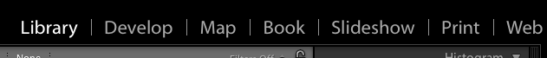

- In the editing toolbar on the right side of the window (shown below), click the Crop Overlay tool symbol (circled in white below). This will open a new menu for the Crop & Straighten Tool.

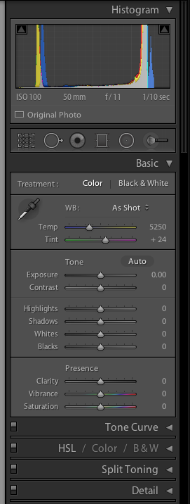
- Crop the image by adjusting the edges of the cropping rectangle to remove unwanted empty space. Be sure that all edges of the specimen sheet and the color separation guide and ruler remain inside the cropped image.
- Click “Close” at the bottom right of the Crop & Straighten Tool.
- In the editing toolbar, open the Detail panel by clicking the triangle to the right of the word “Detail.” If this panel is already open, you do not need to click the triangle.
- Under “Sharpening” in the Detail menu, click the number to the right of the “Amount” slider. Type 50 into this value.
- Click on the thumbnail image at the bottom left of the window (circled below) and press Control (Ctrl) and “A” simultaneously to select all of the recently imported images.

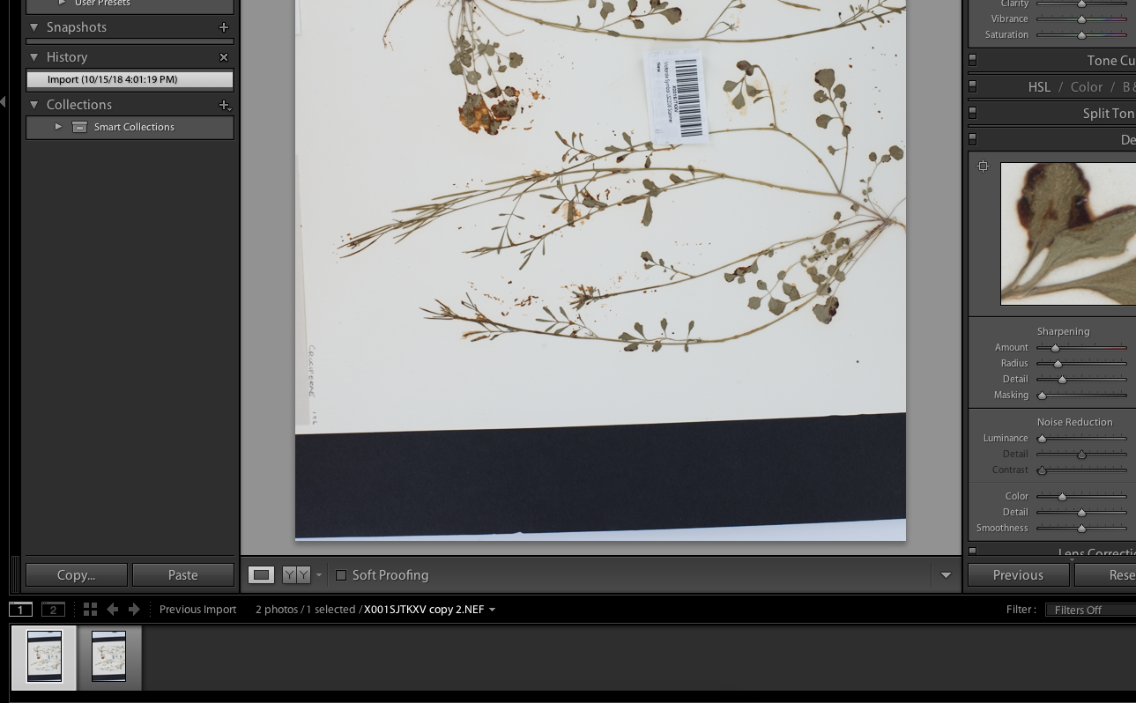

- Press Control (Ctrl), Shift, and “S” simultaneously (or, in the menu bar at the top of the screen, click “Settings” > Sync Settings…). Make sure that the box next to “Crop” is checked in the Synchronize Settings window. Click “Synchronize.” This will apply all the edits that you made to the first image to all subsequent images.
- Click the Library tab and select all the images by pressing Control and “A” simultaneously.
- Click the “Export” button in the bottom left corner of the window. The following dialogue box will open:
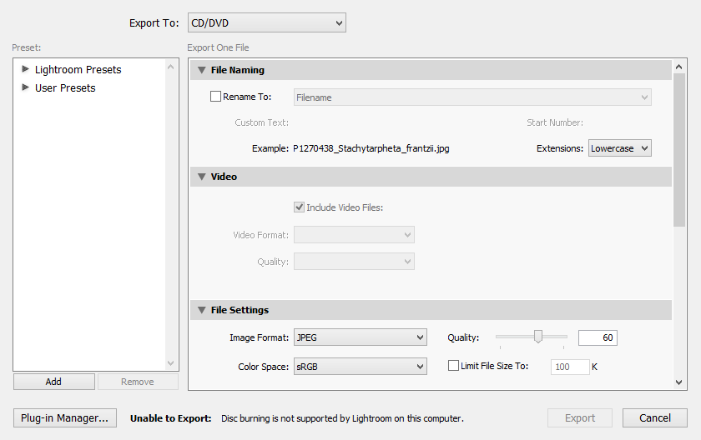
First time set-up note:
Upon first use, set up two User Presets that can be used for future exports by doing the following:
    - On the left side of this window, click the “Add” button. Enter DNG as the preset name. Click Create.
    - In the export settings, make sure the “Rename To:” checkbox is unchecked.
    - Scroll down. Under File Settings, change the Image Format to DNG.
    - Right click on the name of the preset (DNG) in the menu on the left. Select Update with Current Settings.
    - Click the “Add” button on the left side of the window. Enter JPEG as the present name. Click Create.
    - In the export settings, make sure the “Rename To:” checkbox is unchecked.
    - Scroll down. Under File Settings, change the Image Format to JPEG.
    - In the Color Space dropdown menu, select sRBG.
    - Check the Limit File Size box and enter 7000 in the text box.
    - Scroll down. Make sure the Include: field in the Metadata box says “All Metadata”
    - Uncheck the “Remove Person Info” and “Remove Location Info” boxes.
    - Right click on the name of the preset (JPEG) in the menu on the left. Select Update with Current Settings.
- Select the JPEG preset from the menu on the left side of the window
- Change the Export Location to the JPEGs subfolder within the “_Processed” folder that you created on the desktop in step 1.
- Click “Export.” Note that this may take a while if you are processing many images at one time.
- Repeat step 17 and select the DNG preset from the export window.
- Click “Export.” Note that this may take a while if you are processing many images at one time.
- Ensure that both DNGs and JPEGs are found in the “_Processed” folder that you created in step 1 and that the number of DNG files and number of JPEG files are both identical to the “Number of Images” listed in the Imaging Log entry for the file you are processing.
- Write your initials and the date in the Imaging Log under “Processed” on the corresponding entry (see below).

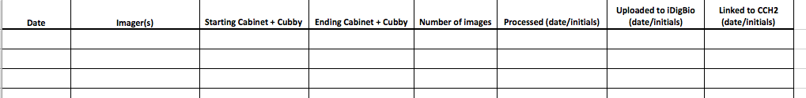

Image Processing Checklist
Print this checklist and post it next to the image processing computer.
- Import with appropriate metadata
- Rotate
- Crop
- Sharpen
- Sync settings
- Export as JPEG
- Export as DNG
Once images are processed:
- Upload DNGs and JPEGs to institutional storage
- Upload JPEGs to iDigBio server
- Link images to CCH2
The last two steps are explained in the Protocol for Uploading Images to iDigBio and Linking to CCH2.

