Setting up Cyberduck to upload JPEGs (one time only)
Last updated by Katie Pearson on 10 August 2020
Adapted from the CyVerse User Manual, also available here: https://cyverse.atlassian.net/wiki/spaces/DS/pages/241869843/Using+Cyberduck+for+Uploading+and+Downloading+to+the+Data+Store
  - Goal: These directions describe how to set up the system that will be used to make images web-accessible and linked to the CCH2 portal. Once the system is set up once, you can refer only to the Protocol for Uploading Images to CyVerse and Loading into CCH2.

Step 1: Create a CyVerse account and request access to BisQue
- Go to www.cyverse.org and click on the in the top right corner of the page.
- Click Sign Up and follow the provided instructions for creating a CyVerse account.
- Email your portal manager (kdpearso@calpoly.edu) with your CyVerse account name so that you can be given permission to edit your institution’s folder.
- Log in to your CyVerse account (https://user.cyverse.org/).
- Click the AVAILABLE tab (see screenshot below).
- Find the BisQue tool in the resulting list and click Request Access.
Note: You may not be instantaneously given access to BisQue. Please wait at least six hours after requesting access before uploading images to CyVerse.
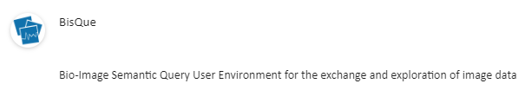

Step 2: Install or update Cyberduck
- If Cyberduck is already installed, check if you need to update (this allows you to be compatible with iRODS 4.1):
  - Click the Cyberduck menu.
  - Click Check for Updates.
  - Determine if your installed version requires an update:
    - If using < 4.7.0, the update is required.
    - If using > 4.7.0 and < 5.0.0, the update is recommended.
    - If using 5.0.0 and later, the update is optional.
  - Depending on your version, click Install Update.
- To install Cyberduck for your operating system for the first time:
  - Go to the Cyberduck installation page at https://cyberduck.io/ .
  - Follow the steps for your OS (not available for LINUX users):
    - For Mac OS:
      - Click Download Cyberduck for Mac.
      - Move the downloaded file (either a zip file or the unzipped application file, depending on your browser) to your Applications folder.
If the zip file is listed, unzip the file in your Applications folder.
IMPORTANT: The file must be located in your Applications folder.
    - For Windows:
      - Click Download Cyberduck for Windows.
      - Locate the downloaded file and double-click to begin installation.
      - Go through the install process.

Step 3: Configure Cyberduck for use with the Data Store
- Click to open Cyberduck.
- Click this link to download the Connection Profile, which contains preconfigured settings for using Cyberduck with the CyVerse Data Store.
- Double click the file to open the downloaded CyVerse Data Store.cyberduckprofile file.
- In the Cyberduck configuration window, enter your CyVerse username in the field iPlant username.
- Under Advanced Options ensure Transfer Files option is set to “Open Multiple Connections”. Close this window - your entries will be automatically saved.
- Double-click on the Data Store bookmark in the Cyberduck window. Enter your CyVerse credentials. You should now be connected to the CyVerse Data Store and viewing the contents of your home directory.

Protocol for Uploading Images to CyVerse and Loading into CCH2
Last updated by Katie Pearson on 4 August 2020
  - Goal: This protocol describes how a supervisor or trained technician can upload specimen images to CyVerse, which will then make these images web-accessible. The URLs for these images will then be linked to the specimen records in the CCH2 portal.
This protocol replaces the Protocol for Uploading Images to iDigBio and Linking to CCH2

Uploading JPEGs to CyVerse
- If necessary, click to open Cyberduck (or find the Cyberduck program in your applications or programs list).
- In the Cyberduck window, click the bookmark icon and then click Open Connection.
- In the drop-down list, click the repository to use (data.cyverse.org – iRODS if you set it up as instructed above)
- Log in to Cyberduck by entering your CyVerse username and password.
- Click Connect.
- Click the image of the hard drive that now appears in your bookmarks page (see example below).
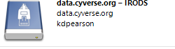
- You will be brought to your home folder, which may look something like that below. Notice that the folder you are currently viewing is your personal CyVerse home folder with the path name: /iplant/home/username
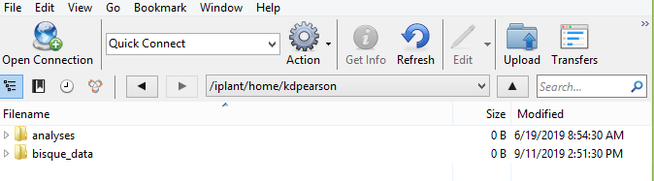
- You now need to navigate to the shared folder where we store CAP TCN images. At the top of the window, click Go and select Go to Folder... from the dropdown menu.
- In the pop-up window, enter the following path: /iplant/home/shared/CAP_TCN . Click Go.
- Click the folder with the acronym of your institution. If there are many files in this folder, just wait; it may take some time to list the directory.
- Click Upload at the top of the window and navigate to the folder that you intend to upload. Select the folder and click the Choose button. Let the uploader run until the whole folder has been successfully transferred.
  - Alternatively, you can drag and drop the folder you intend to upload into the Cyberduck window. Note that, if you intend to put that folder within a new folder, you will need to click on that folder and open it up before dragging and dropping.
Note: In case of an unsuccessful or partial transfer, or if incorrect files are uploaded, contact your portal manager to delete the appropriate files. You will not be able to delete files from CyberDuck.

Loading JPEGs into CCH2
**The user conducting this protocol must have administrator permissions in CCH2.***
Notes:
- After uploading your images to CyVerse using Cyberduck as described above, wait at least 30 minutes before doing the next step.
- If the process is not successful after 30 minutes, try again on the following day.
- Note that the servers often undergo maintenance on Tuesdays, which can cause a delay in processing or unexpected errors.

- Log in to your account in CCH2 and navigate to the collection management page (My Profile > Specimen Management tab > name of collection).
- In the administration control panel, click Processing Toolbox.
- Select the Image Loading tab and select iPlant Image Processing from the Saved Image Processing Profiles box.
- Ensure that the Processing start date is the same as the Last Run Date. This means that the API will search and load your folder for all the images that were uploaded since you last loaded JPEGs into CCH2.
- Click the Process Images button. Examine the resulting log file to ensure the expected number of images was loaded into CCH2.
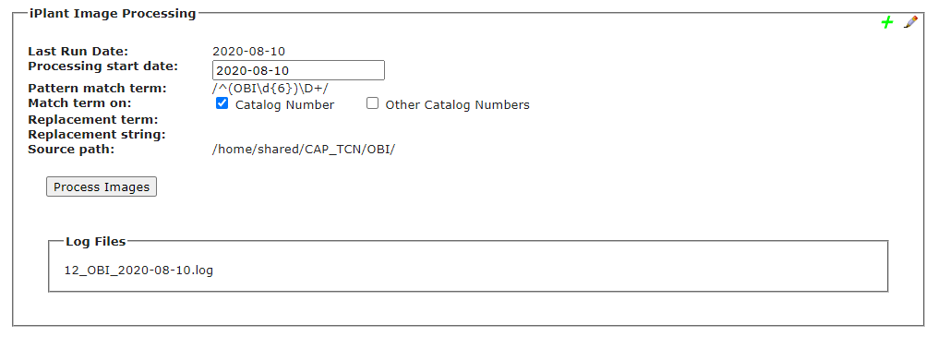
Date that you want to start processing from (should likely be the same as the Last Run Date)
Previous imaging logs

Understanding the Log File
The image linking algorithm will work chronologically to load all the images uploaded each day since the last day you ran the algorithm. For each day, the log will list how many images were recognized and linked (see screenshot below).
Images will be recognized and linked only if they have been (1) uploaded to the appropriate folder in CyVerse and (2) processed by BisQue. Processing in BisQue happens automatically once you have uploaded the images; however, the BisQue server can get busy at times, which can delay the processing of your images. This is why we recommend waiting 30 minutes or longer after uploading images to CyVerse before conducting steps 1-5 above.
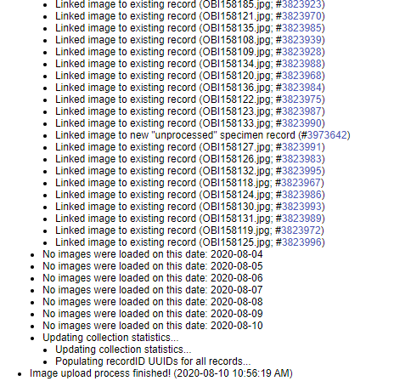
The log shows you what happened to each image we uploaded. You will see one of the following messages for each image that was recognized and loaded:
- Linked image to new "unprocessed" specimen record - this means that CCH2 did not find an existing record for this image, so it created a skeletal record (i.e., record with just the barcode number and image) for that image. The Processing Status of this specimen will be "unprocessed," and you can use this fact to search for these skeletal records in the future.
- Linked image to existing record - this means that CCH2 found an existing record for the image and added the image to it. This happens when you have already entered barcode numbers into CCH2 or when you upload multiple images for a single record at one time (i.e., a skeletal record was created for the first image for that record, then CCH2 linked the second image to that skeletal record as well).
- Replacing previously mapped image with new input; Linked image to existing record - this means that an image with the same name already existed in the portal, so CCH2 is replacing the old image with the most recently uploaded one.
- NOTICE: Imaging mapping skipped; image identifier already in system – the means that an image already exists for the specimen for which you were uploading an image; CCH2 does not replace images if they already exist on the server. To replace an image, you will need to delete the previous image from the CCH2 occurrence record first. See the Section 9.1 of the Symbiota Guide (https://www.capturingcaliforniasflowers.org/symbiota.html) for instructions on deleting previous images.
Note that the number following each line of the log is the SymbiotaID number, rather than the catalog number of the specimen. The first time you view the log, you can click the SymbiotaID number to navigate to that record. When you download the log later, these links do not exist. Instead, you can look up a specimen by copying the SymbiotaID number and pasting it after occid= in the following URL:
http://cch2.org/portal/collections/editor/occurrenceeditor.php?occid=

