Protocol for Uploading Images to iDigBio and Linking to CCH2
Last updated by Katie Pearson and Jenn Yost on November 19, 2018

  - Goal: This protocol describes how a supervisor or trained technician can upload specimen images to the iDigBio server, which will then make these images web-accessible. The URLs for these images will then be linked to the specimen records in the CCH2 portal.

(Adapted from instructions provided on symbiota.org)

Uploading Images to iDigBio

Initial installation
- Download and install the iDigBio Image Ingestion Utility from their GitHub repository (https://github.com/iDigBio/idigbio-media-appliance/wiki/Installing). This only has to be done once, if the software is already installed, continue to step 3.
- Enter your assigned UUID and API key (email Katie for this) into the appropriate fields. The Account Alias field can be left blank.

For each upload
- Open the iDigBio Media Appliance by typing idigbio_media_appliance in Spotlight (Mac users) or the start menu (Windows users)
  - Windows users: if typing “idigbio_media_appliance” in the start menu fails to start the application, restart your computer and try again. Also try typing “idigbio_media_appliance.bat”. If that still fails, search your file system for the “bat” file located in the “Scripts” directory within the root media appliance directory. Depending on the operating system and installation options, the root directory may be one of the following:
    - C:\idigbioMediaAppliance\
    - C:\Users\<YOUR_USER_NAME>\idigbioMediaAppliance\
  - C:\Program Files\idigbioMediaAppliance\. Once you locate the .bat file, create a shortcut on your desktop by right clicking on the file and selecting Create Shortcut from the dropdown menu.
  - If you have previous versions of the appliance installed, you may want to clear your browser cache to make sure that previous versions and code are not loaded from the cache.
- Click the “Generate CSV” tab (screenshot below).
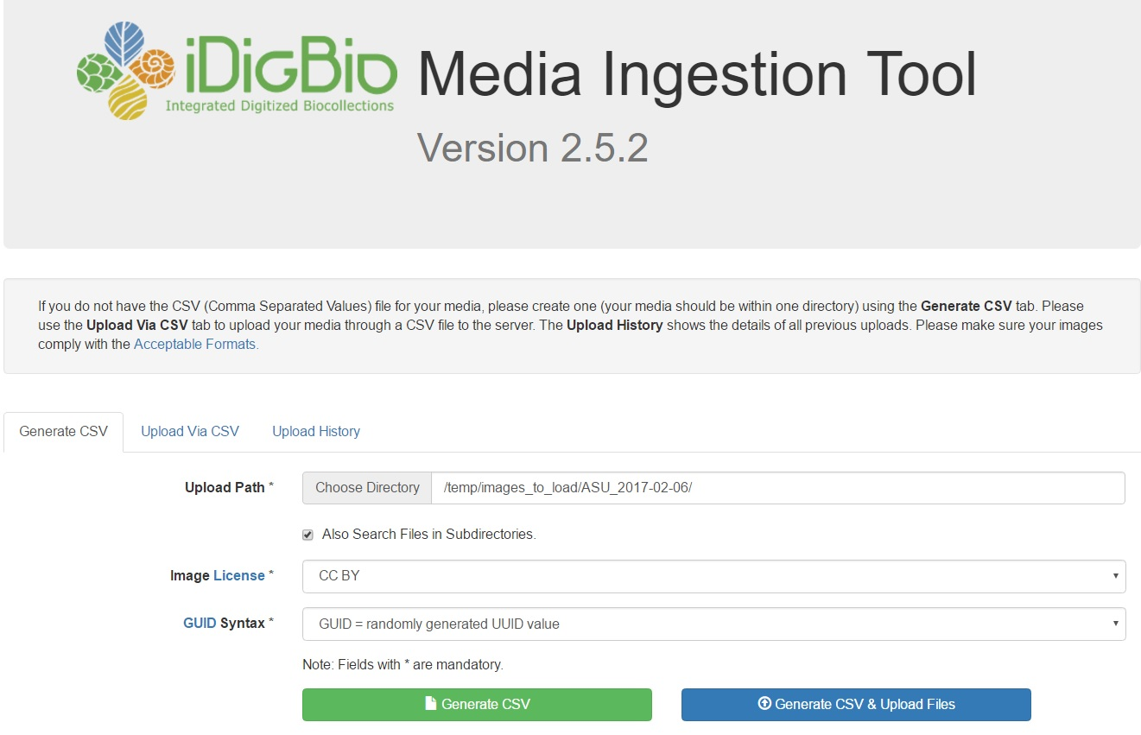
- Enter the full pathway to where your images are stored on your local system (e.g. C:\<YOUR_USER_NAME\Desktop\JPEGs2Upload or /Desktop/...) or navigate to this pathway by clicking “Choose Directory.” Make sure that you select the folder that contains ONLY the JPEG images you wish to upload, not the DNGs.
  - NOTE: When using a Windows OS, clicking on “Choose Directory” button will open a file browser, but it may open it behind the main browser window. If nothing seems to happen when you click the button, minimize the main window and look for the file browser panel hiding behind. If you clicked the button multiple times, you will have to close multiple file browser panels.
- Set your desired Image License and GUID Syntax. We recommend “CC BY-NC-SA” (this means that users of your images must credit your institution when using the image, the image cannot be used for commercial means, and the image and its derivatives must be shared using a copyright license that is no more restrictive than the copyright license you provide) and “GUID = randomly generated UUID.”
- Click “Generate CSV & Upload Files”. The Upload History tab should automatically open and a progress bar will be displayed.
  - If some of the upload fails halfway through due to a network connection issue or such. You can restart the process by going to the “Upload History” tab and clicking on the “Restart Upload Task” button.
  - Once the image upload process is complete, all the images will be web accessible through any web browser.

Linking Images to CCH2 Records
  - Note: To complete these steps, the user must have administrator permissions in CCH2.
- After you upload your images in the iDigBio Media Ingestion Tool, click the “Upload History” tab and click “download Media as CSV”. This should download a CSV report to your local system.
  - Depending on the configuration of your local system, the report might be placed within your download folder, desktop, or you may be asked where you want to save the file. You can use the pulldown to the right of the page to limit the report to only the most recent records.
  - Note that there are buttons to purge missing and failed image loadings.
- Log into your account in CCH2 (http://www.portal.capturingcaliforniasflowers.org/).
- Navigate to the Administrator Control Panel for the collection for which you will be uploading images.
- Click Processing Toolbox in the Administrator Control Panel.
- Select the Image Loading tab.
- Select “iDigBio Media Ingestion Report” from the dropdown menu. If you don’t see an “iDigBio CSV Upload” profile setup, contact Katie or Jason to set one up using the specific format of your barcodes.
- Click “Choose File” and select the report that you downloaded in step 1.
- Click “Process Output File”. This will start the linking process which inspects each record and does the following: 1) extracts the catalog number (i.e., barcode number) from the file name, 2) looks to see if a record with that that catalog number already exist, 3a) if it does, it links the image to the existing record, 3b) if not, it links the image to a new empty records primed only with the specimen catalog number, and these records are assigned a Processing Status value of "unprocessed".
  - Note that if a large number of images are loaded on to the iDigBio system by several contributors at once, the processing scripts can fall behind and create a delay in generating the image derivatives used in the portal display. Therefore, if you see an image not available message after mapping to your data portal, be patient and the images should eventually appear. If they are not available within a 24 hours period, email your portal manager or iDigBio support staff to check on the status.

