Barcode Recommendations
Last updated 30 July, 2020 by Katie Pearson

Formatting
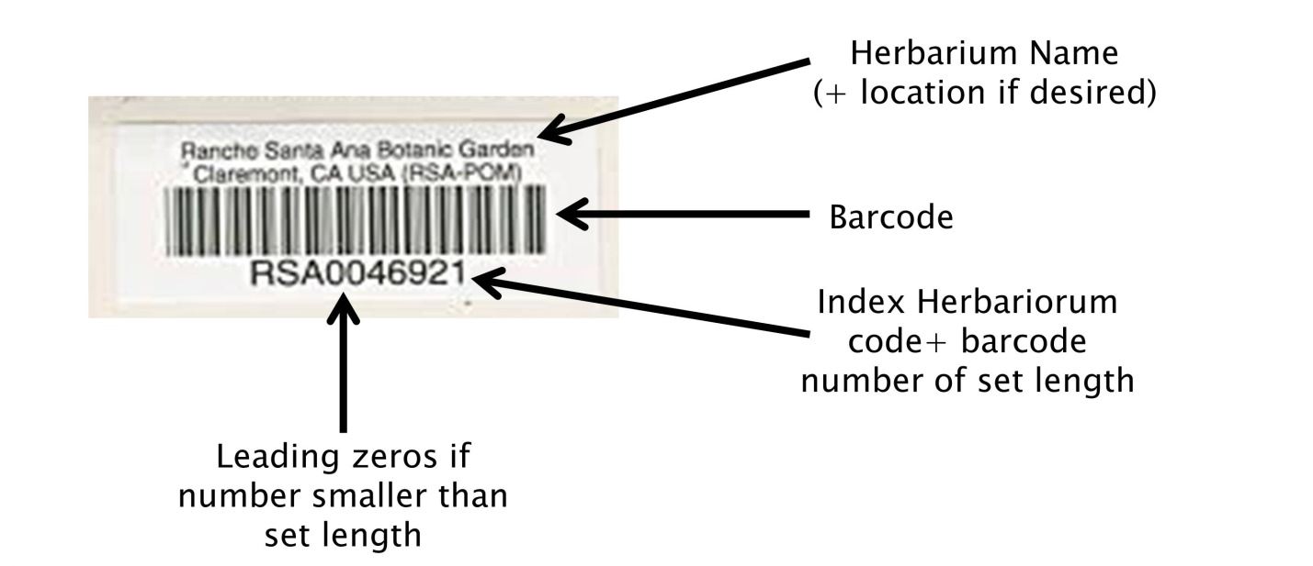
- Above barcode: name of institution (optional: location of institution)
- Barcode: “code 39” format, which includes letters and numbers
- Below barcode: barcode number, consisting of your Index Herbariorum (http://sweetgum.nybg.org/science/ih/) herbarium abbreviation followed by a unique number of a set number of digits.
  - Decide ahead of time how many digits will be in your barcode. Any numbers shorter than the set length of your barcode should be left-padded by zeros. For example, if your barcodes will include 9 digits (which means your institution can have a maximum of 999,999,999 specimens), and you have barcode number 38, your barcode should read: INST000000038. We recommend following this format so that the records can be sorted appropriately in Symbiota, Excel , or other management softwares.
  - We recommend including the IH abbreviation of your institution prior to the barcode number to maximize the “uniqueness” of this barcode number relative to other institutions’.

Sourcing
To order barcodes, email the “Barcode Form for Credit Card Payments” (attached to related email) to Sandra Schmidt <sschmidt@reliancebarcode.com>
In the email, make sure to provide:
- Label Quantity
- Text to be printed above Barcode (2 lines max)
- Number range and the way the number should appear. Specify the number of total digits you want (including leading zeros). For example, OBI000001 – OBI082000

For example, OBI’s look like this:
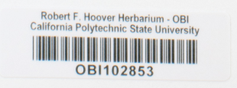

Cal Poly investigated purchasing barcodes from Reliance Barcode Solutions, Computype Inc, and Watson Label Solutions. Reliance Barcode Solutions was the most cost-effective at 2-4¢ per barcode. These labels are fully archival and have been used by other institutions including the Utah State University and Florida State University. They can be purchased by the roll or in printed sheets. Below is the estimate from Reliance for barcodes in rolls, which are expected to facilitate quicker barcode application than sheets.
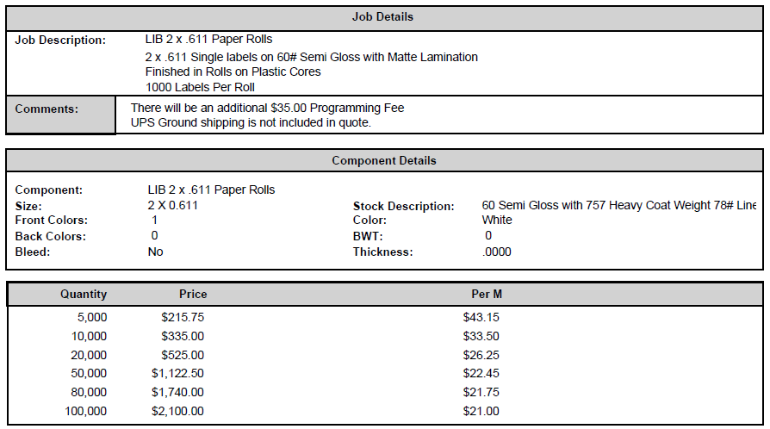
The quotes from Computype, Inc. and Watson Label Solutions are shown below, for your reference:
Computype, Inc.
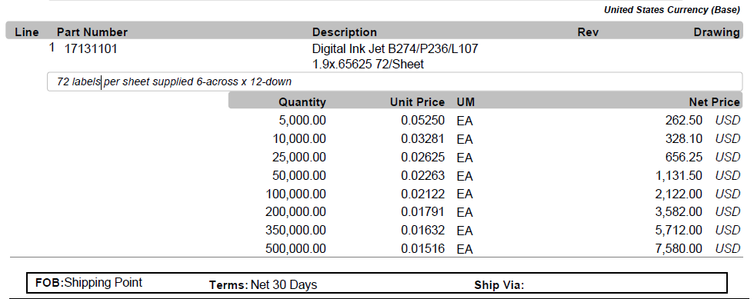
Watson Label Solutions
