Protocol for Making Batch Annotations on CCH2
Created by Jennifer Poore 2020
OK to update as necessary

This protocol is for the task of making five or more identical nomenclature adjustments such as synonymy name changes or determination changes to five or more specimens at once. This is not an efficient way to do one or two annotations, those should be completed by looking up the specimen individually and updating them directly in the Determination edits tab in the CCH2 database. This takes a variable amount of time depending on the number of specimens you are updating and requires the physical specimens you which to annotate to be present.

After signing into your CCH2 account,
- Select My Profile to the right of the “Welcome/ Your Name!” salutation.
- On the tabs page that comes up next, select Specimen Management.
- From the menu under that tab, select your herbarium, e.g. DAV – UC Davis Herbarium (DAV)
- In the Data Editor Control Panel, choose “Add Batch Determinations/Nomenclature Adjustments”

The Add Batch Determinations/Nomenclature forum is where you will update nomenclature changes.
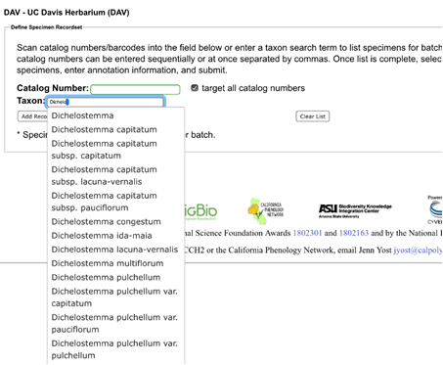
- Type the Scientific Name of the taxon you wish to annotate, then select the species from the autofill options.
- Select “Add record(s) To List”

This will generate a list of all the specimens with the scientific name you queried within our collections.
- Check the Select/Deselect all Specimens Column so that each specimen is unchecked.
- With your specimens present, carefully find each record and check each one you have present for the update.

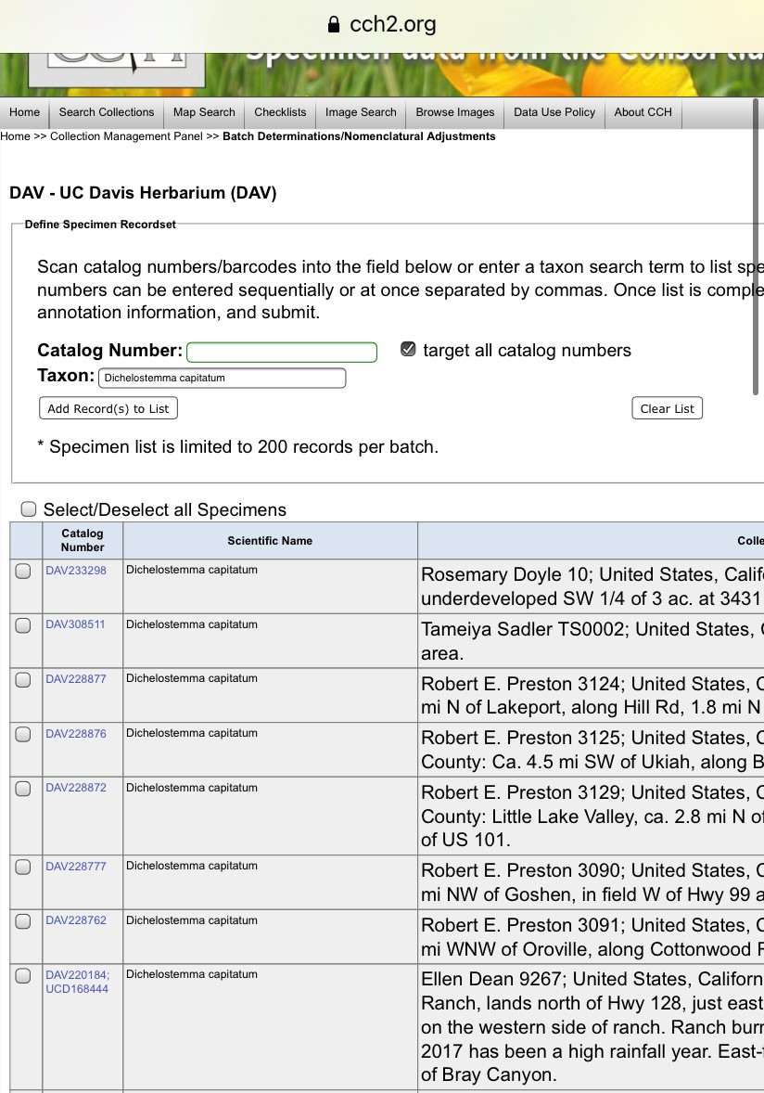

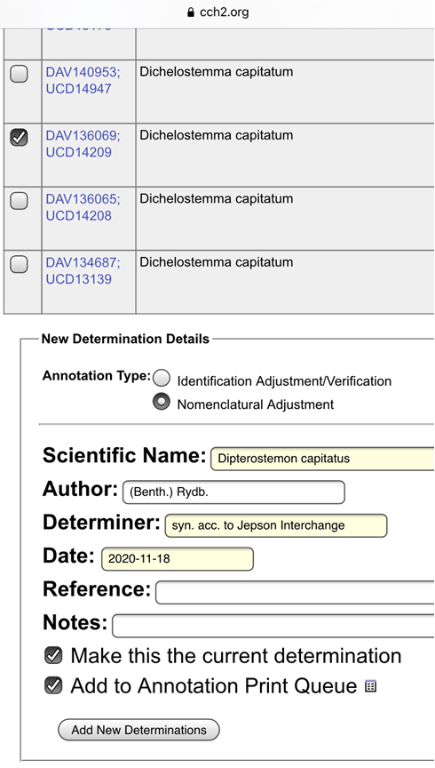
Once all of the specimens present are inspected for nomenclature adjustment, scroll to the bottom of the page to the Determination Details box.

- Select Nomenclature Adjustment for Annotation Type here.
- Type in the updated Scientific Name which will give suggestions for autofill.
- The Author box will autofill.
- In the Determiner field, type: “syn. acc. to Jepson Interchange”
- The Date Field should autofill with today’s date.
- Leave both “Make this the current determination” and “Add to Annotation Print Queue” Checked.

*Review at this point for any spelling errors as these errors will need to fixed one-by-one if they are not caught here*

- Click button: Add New Determinations.
- This command will take you to an option to Display Annotation Print Queue
- You can go there now, or enter another Sci Name and start this process over to make another Nomenclature Adjustment.
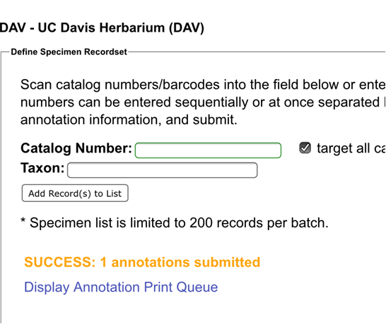

*Helpful tip: If you are doing a large number of specimens at a time, it is nice to click Add New Determinations button and make the list smaller and more manageable from time to time.

At this point, determination adjustments have been made and you will need to edit and print the annotations labels, cut them and glue them to the specimen sheets. For this purpose, we recommend YES! Paste.

Next: See Protocol for Printing Batch Annotations

