California phenology tcn
Digitization Manual
for the California Phenology Thematic Collections Network (CAP TCN)
last updated by Katie Pearson
6/19/2019

Contents
1. Project Goals 3
2. Workflow 5
3. Tracking Workflow Progress 6
3.1 Cabinet Logs 6
3.1.1 Cabinet Log (barcoding and imaging as separate steps) 7
3.1.2 Cabinet Log (barcoding and imaging as separate steps, half-cabinet version) 8
3.1.3 Cabinet Log (barcoding and imaging in same step, half-cabinet version) 8
3.2 Imaging Log 9
4. Imaging Station Setup 10
4.1 General Imaging Station Setup 10
4.2 Equipment Recommendations 10
4.3 Imaging Software 11
5. Custom Imaging Equipment 11
5.1 Camera Mount System 12
5.2 Specimen Backdrop 14
6. Barcode Recommendations 16
6.1 Barcode Formatting 16
6.2 Barcode Sourcing 16
7. Barcoding Protocol 19
8. Imaging Protocol 21
9. Combined Barcoding & Imaging Protocol 26
10. Image Processing 31
10.1 Image Processing Protocol 31
10.2 Image Processing Checklist 34
Image Processing Checklist 35
11. Protocol for Set Up and Upload of Images to CyVerse and Loading into CCH2 36
Part 1: Setting up Cyberduck to upload JPEGs (one time only) 36
Part 2: Uploading JPEGs to CyVerse 38
Part 3: Loading JPEGs into CCH2 38
12. Protocol for Associating Barcode Numbers with Accession Numbers 39
13. Guide to Transcribing Label Data in CCH2 41
13.1 Navigating to records to transcribe 41
13.2 Transcribing records 42
13.3 Transcribing annotation labels 45
13.4 Example diagrammed specimen labels 47
14. Georeferencing Protocol 49
15. Phenological Scoring Protocol 56
16. CCH2 Portal Guide 56
16.1 Navigating the CCH2 portal website 56
16.2 Creating a new user 57
16.3 Managing your profile and collection(s) 57
16.3.1 Data Editor Control Panel 57
16.3.2 Administration Control Panel 58
16.4 Managing user permissions 60
16.5 Adding specimen records 61
16.6 Searching and sorting specimen records 61
16.7 Editing existing specimen records 62
16.7.1 Explanation of Record Editor tabs 63
16.7.2 Explanation of Occurrence Data fields 63
16.7.3 Batch editing specimen records 66
16.7.4 Batch editing scientific names 67
16.8 Adding skeletal records 67
16.9 Importing record data 68
16.10 Adding determination/annotation data 70
16.11 Printing labels or annotations 71
16.12 Managing loans, gifts, and exchanges 72
Appendix 1: Processing Status 73
References 73

1. Project Goals
The digitization goals of this project are to:
- Image, transcribe, and georeference 904,200 specimens of over 3000 taxa (Table 1.1) at 22 collaborating institutions (Table 2.1)
- Capture phenological data for all 904,200 specimens
Additional goals include:
- Develop and maintain the Symbiota-based “CCH2” portal
- In collaboration with community experts, develop standards for recording and storing specimen-based phenological data
- Build Symbiota functionality to accommodate newly developed phenological standards
- Engage citizen scientists in transcription and phenological scoring of specimen images

Table 1.1: Taxa targeted for imaging, digitization, and phenological scoring. Families for which all species will be digitized are indicated by “ALL” in the species column. Note that all specimens of these taxa, regardless of collection location, are to be digitized.
Family | Species
Acanthaceae | Avicennia germinans
Adoxaceae | ALL
Agavaceae | ALL
Altingiaceae | Liquidambar styraciflua
Amaranthaceae | Atriplex canescens
Amaranthaceae | Atriplex hymenelytra
Amaranthaceae | Krascheninnikovia lanata
Amaranthaceae | Salicornia virginica
Anacardiaceae | Anacardium excelsum
Anacardiaceae | Malosma laurina
Anacardiaceae | Rhus glabra
Anacardiaceae | Rhus integrifolia
Anacardiaceae | Rhus ovata
Anacardiaceae | Toxicodendron diversilobum
Apiaceae | Daucus carota
Apiaceae | Heracleum maximum
Apiaceae | Ligusticum grayi
Apiaceae | Lomatium macrocarpum
Apocynaceae | Apocynum androsaemifolium
Apocynaceae | Apocynum cannabinum
Apocynaceae | Asclepias asperula
Apocynaceae | Asclepias cordifolia
Apocynaceae | Asclepias curassavica
Apocynaceae | Asclepias eriocarpa
Apocynaceae | Asclepias fascicularis
Family | Species
Apocynaceae | Asclepias latifolia
Apocynaceae | Asclepias linaria
Apocynaceae | Asclepias speciosa
Apocynaceae | Asclepias subulata
Apocynaceae | Asclepias tuberosa
Apocynaceae | Asclepias verticillata
Apocynaceae | Asclepias viridis
Apocynaceae | Funastrum cynanchoides
Aquifoliaceae | Ilex aquifolium
Araceae | Lysichiton americanus
Araliaceae | Hedera helix
Asparagaceae | Asparagus officinalis
Asparagaceae | Camassia quamash
Asparagaceae | Dichelostemma capitatum
Asparagaceae | Hesperocallis undulata
Asparagaceae | Maianthemum dilatatum
Asparagaceae | Maianthemum racemosum
Asteraceae | Achillea millefolium
Asteraceae | Ambrosia artemisiifolia
Asteraceae | Ambrosia dumosa
Asteraceae | Ambrosia psilostachya
Asteraceae | Anaphalis margaritacea
Asteraceae | Antennaria corymbosa
Asteraceae | Artemisia californica
Asteraceae | Artemisia douglasiana
Family | Species
Asteraceae | Artemisia tridentata
Asteraceae | Baccharis pilularis
Asteraceae | Baccharis salicifolia
Asteraceae | Baileya multiradiata
Asteraceae | Balsamorhiza sagittata
Asteraceae | Centaurea solstitialis
Asteraceae | Centaurea stoebe
Asteraceae | Cirsium arvense
Asteraceae | Cirsium occidentale
Asteraceae | Cirsium vulgare
Asteraceae | Coreopsis lanceolata
Asteraceae | Encelia californica
Asteraceae | Encelia farinosa
Asteraceae | Ericameria (all species)
Asteraceae | Erigeron (all species)
Asteraceae | Eriophyllum (all species)
Asteraceae | Gaillardia pulchella
Asteraceae | Gutierrezia sarothrae
Asteraceae | Helianthus annuus
Asteraceae | Hieracium aurantiacum
Asteraceae | Lessingia germanorum
Asteraceae | Leucanthemum vulgare
Asteraceae | Malacothrix glabrata
Asteraceae | Nothocalais alpestris
Asteraceae | Petasites frigidus
Asteraceae | Psilostrophe cooperi
Asteraceae | Ratibida columnifera
Asteraceae | Rudbeckia hirta
Asteraceae | Silphium laciniatum
Asteraceae | Solidago altissima
Asteraceae | Solidago canadensis
Asteraceae | Symphyotrichum novae-angliae
Asteraceae | Taraxacum officinale
Asteraceae | Verbesina encelioides
Asteraceae | Wyethia mollis
Berberidaceae | Achlys triphylla
Berberidaceae | Mahonia aquifolium
Berberidaceae | Mahonia nervosa
Family | Species
Berberidaceae | Mahonia repens
Betulaceae | Alnus incana
Betulaceae | Alnus rubra
Betulaceae | Alnus viridis
Betulaceae | Betula glandulosa
Betulaceae | Betula nana
Betulaceae | Corylus cornuta
Bignoniaceae | Campsis radicans
Bignoniaceae | Chilopsis linearis
Boraginaceae | ALL
Brassicaceae | ALL
Cactaceae | Carnegiea gigantea
Cactaceae | Echinocereus engelmannii
Cactaceae | Escobaria vivipara
Cactaceae | Opuntia acanthocarpa
Cactaceae | Opuntia basilaris
Campanulaceae | Campanula griffinii
Campanulaceae | Lobelia cardinalis
Cannabaceae | Celtis laevigata
Cannabaceae | Celtis reticulata
Caprifoliaceae | Linnaea borealis
Caprifoliaceae | Lonicera involucrata
Caprifoliaceae | Lonicera japonica
Caprifoliaceae | Lonicera tatarica-arnoldred
Caprifoliaceae | Symphoricarpos albus
Caprifoliaceae | Symphoricarpos oreophilus
Caprifoliaceae | Valeriana sitchensis
Caryophyllaceae | Minuartia obtusiloba
Convolvulaceae | Calystegia sepium
Cornaceae | Cornus nuttallii
Cornaceae | Cornus officinalis
Cornaceae | Cornus sericea
Cupressaceae | Juniperus osteosperma
Cupressaceae | Thuja plicata
Ebenaceae | Diospyros virginiana
Elaeagnaceae | Elaeagnus angustifolia
Elaeagnaceae | Shepherdia argentea
Elaeagnaceae | Shepherdia canadensis
Family | Species
Ericaceae | ALL
Euphorbiaceae | Euphorbia esula
Euphorbiaceae | Triadica sebifera
Fabaceae | Acacia greggii
Fabaceae | Amorpha canescens
Fabaceae | Cytisus scoparius
Fabaceae | Darlingtonia californica
Fabaceae | Gleditsia triacanthos
Fabaceae | Lathyrus japonicus
Fabaceae | Lathyrus littoralis
Fabaceae | Leucaena leucocephala
Fabaceae | Lupinus (all species)
Fabaceae | Medicago sativa
Fabaceae | Melilotus officinalis
Fabaceae | Olneya tesota
Fabaceae | Parkinsonia florida
Fabaceae | Parkinsonia microphylla
Fabaceae | Prosopis glandulosa
Fabaceae | Prosopis pubescens
Fabaceae | Prosopis velutina
Fabaceae | Robinia neomexicana
Fabaceae | Robinia pseudoacacia
Fabaceae | Senna covesii
Fabaceae | Trifolium (all species)
Fagaceae | ALL
Fouquieriaceae | Fouquieria splendens
Garryaceae | Garrya elliptica
Gentianaceae | Gentiana calycosa
Geraniaceae | Erodium botrys
Geraniaceae | Geranium robertianum
Grossulariaceae | Ribes aureum
Grossulariaceae | Ribes cereum
Grossulariaceae | Ribes montigenum
Grossulariaceae | Ribes roezlii
Grossulariaceae | Ribes sanguineum
Haloragaceae | Myriophyllum spicatum
Hydrangeaceae | Philadelphus lewisii
Iridaceae | Iris douglasiana
Family | Species
Iridaceae | Iris giganticaerulea
Iridaceae | Iris tenax
Iridaceae | Olsynium douglasii
Iridaceae | Sisyrinchium bellum
Lamiaceae | ALL
Lauraceae | Persea americana
Lauraceae | Umbellularia californica
Liliaceae | Erythronium grandiflorum
Liliaceae | Erythronium oregonum
Liliaceae | Fritillaria pudica
Liliaceae | Lilium pardalinum
Liliaceae | Prosartes hookeri
Liliaceae | Tulipa clusiana
Lythraceae | Lythrum salicaria
Malvaceae | Gossypium hirsutum
Melanthiaceae | ALL
Menyanthaceae | Menyanthes trifoliata
Montiaceae | Cistanthe umbellata
Montiaceae | Claytonia lanceolata
Montiaceae | Claytonia perfoliata
Montiaceae | Lewisia rediviva
Nyctaginaceae | Abronia umbellata
Nymphaeaceae | Nuphar lutea
Nymphaeaceae | Nymphaea odorata
Oleaceae | Forestiera pubescens
Oleaceae | Fraxinus latifolia
Oleaceae | Fraxinus velutina
Oleaceae | Ligustrum (all species)
Oleaceae | Olea europaea
Onagraceae | ALL
Orchidaceae | Epipactis helleborine
Orchidaceae | Goodyera oblongifolia
Orobanchaceae | ALL
Oxalidaceae | Oxalis oregana
Papaveraceae | ALL
Phrymaceae | ALL
Phytolaccaceae | Phytolacca americana
Plantaginaceae | ALL
Family | Species
Platanaceae | Platanus racemosa
Polemoniaceae | ALL
Polygonaceae | ALL
Pontederiaceae | Eichhornia crassipes
Primulaceae | Dodecatheon pulchellum
Primulaceae | Trientalis borealis
Ranunculaceae | ALL
Rhamnaceae | ALL
Rosaceae | ALL
Rubiaceae | Cephalanthus occidentalis
Salicaceae | Populus angustifolia
Salicaceae | Populus balsamifera
Salicaceae | Populus fremontii
Salicaceae | Populus tremuloides
Salicaceae | Populus trichocarpa
Salicaceae | Salix gooddingii
Salicaceae | Salix hookeriana
Salicaceae | Salix laevigata
Salicaceae | Salix lasiolepis
Salicaceae | Salix planifolia
Salicaceae | Salix scouleriana
Sapindaceae | ALL
Sarraceniaceae | Sarracenia purpurea
Saururaceae | Anemopsis californica
Saxifragaceae | Lithophragma bolanderi
Saxifragaceae | Tellima grandiflora
Saxifragaceae | Tolmiea menziesii
Scrophulariaceae | Leucophyllum frutescens
Scrophulariaceae | Scrophularia californica
Simmondsiaceae | Simmondsia chinensis
Solanaceae | Datura wrightii
Solanaceae | Lycium torreyi
Solanaceae | Solanum dulcamara
Solanaceae | Solanum elaeagnifolium
Solanaceae | Solanum (all species)
Typhaceae | Typha domingensis
Typhaceae | Typha latifolia
Ulmaceae | Ulmus pumila
Family | Species
Urticaceae | Urtica dioica
Violaceae | Viola glabella
Violaceae | Viola sempervirens
Vitaceae | Vitis vinifera
Zosteraceae | Zostera marina
Zygophyllaceae | ALL

Table 2.1: Imaging, databasing, and georeferencing goals of each collaborating institution. Index Herbariorum (Thiers, 2011) codes are given in parentheses. UC = University of California, CSU = California State University
Digitizing institutions and herbarium codes | Organizational structure | Total records in this project | Target specimens to image only | Target specimens to fully database | Target specimens to georeference
(BSCA) Colorado Desert District, California Dept. of Parks and Rec. | Sending to RSA | 5,000 |  | 5,000
(CHSC) CSU, Chico | Collaborator | 30,000 | 22,000 | 8,000
(CSLA) CSU, Los Angeles | Collaborator | 35,000 |  | 35,000
(CSUSB) CSU, San Bernardino | Sending to RSA | 4,200 | 4,000 | 200
(DAV) UC, Davis | Collaborator | 50,000 | 50,000
(FSC) CSU, Fresno | Collaborator | 40,000 |  | 40,000
(HSC) CSU, Humboldt | Collaborator | 30,000 | 30,000 | 0 | 100,000
(IRVC) UC, Irvine | Collaborator | 35,000 |  | 35,000
(LA) UC, Los Angeles | Collaborator | 45,000 |  | 45,000
(LOB) CSU, Long Beach | Collaborator | 11,000 |  | 11,000
(MACF) CSU, Fullerton | Collaborator | 25,000 |  | 25,000
(OBI) California Polytechnic State University, San Luis Obispo | Collaborator - Lead | 40,000 |  | 40,000 | 100,000
(RSA) Rancho Santa Ana Botanic Garden | Collaborator | 100,000 | 80,000 | 20,000
(SBBG) Santa Barbara Botanic Garden | Collaborator | 80,000 | 70,000 | 10,000
(SD) San Diego Natural History Museum | Collaborator | 71,000 | 67,000 | 4,000 | 100,000
(SDSU) San Diego State University | Collaborator | 20,000 | 20,000
(SFV) CSU, Northridge | Collaborator | 25,000 | 15,000 | 10,000
(SJSU) CSU, San Jose | Collaborator | 10,200 | 10,200 | 0
(UC/JEPS) UC, Berkeley | Collaborator | 100,000 | 100,000
(UCSB) UC, Santa Barbara | Collaborator | 34,000 | 30,000 | 4,000
(UCSC) UC, Santa Cruz | Collaborator (unfunded) | 7,000 | 4,000 | 3,000
(UCR) UC, Riverside | Collaborator | 105,000 | 100,000 | 5,000
 | Totals | 904,200 | 602,200 | 302,400 | 300,000 +

2. Workflow
The general recommended workflow for this project is shown in the diagram below. The steps are:
- Barcode specimens (Section 7)
*Note: can be combined with imaging (see Section 9)
- Image specimens in raw format (Section 8)
- Process images, including: add metadata (i.e., copyright information), rotate, crop, sharpen, and export as digital negative (DNG) and jpeg formats (Section 10)
- Archive images (both DNGs and copy of JPEGs) to institutional storage
- Upload JPEGs to CyVerse, which will create a URL for each image (Section 11)
- Load image URLs into CCH2 (Section 11)
- If data already exist in CCH2: associate new images (and barcode Number) to existing records (and accession numbers) (Section 12)
- Transcribe data (Section 13), georeference (Section 14), and score phenology (Section 15) as time and workforce capacity allows.
- Potentially after completion of project: quality check data
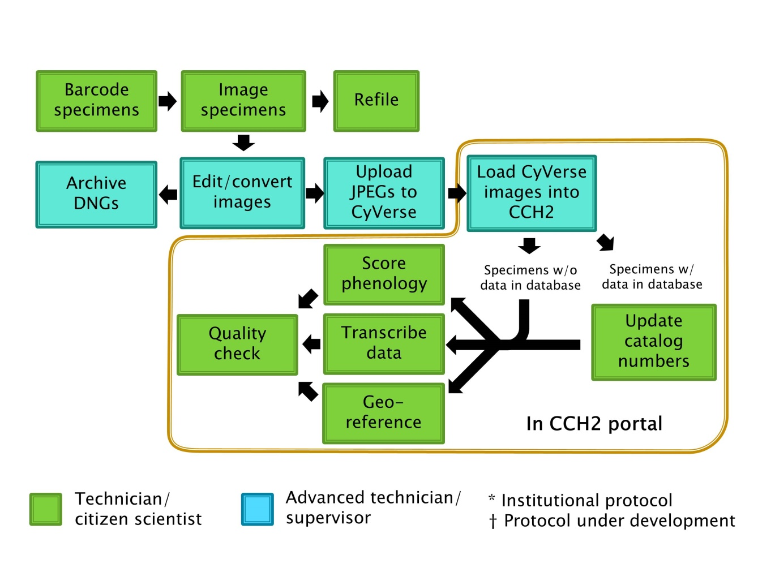

3. Tracking Workflow Progress
One of the most significant challenges of a digitization workflow is tracking the status of specimens and specimen images through the many steps of the digitization process. Here we offer some simple tools to aid in tracking workflow progress.

3.1 Cabinet Logs
Cabinet logs are diagrams that can be placed on the front of each cabinet to track which cubbies of that cabinet have been processed, by whom, and when they were processed. Each rectangle in the cabinet log diagram corresponds to a cubby in the actual cabinet. Once a worker has barcoded or imaged (if these steps are separated) a cubby of specimens, she or he should initial and date under the appropriate process in the corresponding cubby on the diagram.

Cubbies that are out-of-scope for this project (i.e., do not belong to one of the taxa listed in Table 1.1) should be crossed out by a supervisor when the cabinet logs are being placed unless the entire collection is being imaged.

Three example cabinet logs are provided in sections 3.1.1-3.1.3. Cabinet logs in sections 3.1.1 and 3.1.2 are appropriate for institutions that barcode and image in separate steps. A cabinet log such as that provided in section 3.1.3 can be used for institutions that barcode specimens at time of imaging.

3.1.1 Cabinet Log (barcoding and imaging as separate steps)

Cabinet Number: ___________

1. Barcoded | Imaged | 14. Barcoded | Imaged
2. Barcoded | Imaged | 15. Barcoded | Imaged
3. Barcoded | Imaged | 16. Barcoded | Imaged
4. Barcoded | Imaged | 17. Barcoded | Imaged
5. Barcoded | Imaged | 18. Barcoded | Imaged
6. Barcoded | Imaged | 19. Barcoded | Imaged
7. Barcoded | Imaged | 20. Barcoded | Imaged
8. Barcoded | Imaged | 21. Barcoded | Imaged
9. Barcoded | Imaged | 22. Barcoded | Imaged
10. Barcoded | Imaged | 23. Barcoded | Imaged
11. Barcoded | Imaged | 24. Barcoded | Imaged
12. Barcoded | Imaged | 25. Barcoded | Imaged
13. Barcoded | Imaged | 26. Barcoded | Imaged

Imaging complete: _________________________Date:_____________

3.1.2 Cabinet Log (barcoding and imaging as separate steps, half-cabinet version)
Cabinet Number: ___________

1. Barcoded | Imaged | 8. Barcoded | Imaged
2. Barcoded | Imaged | 9. Barcoded | Imaged
3. Barcoded | Imaged | 10. Barcoded | Imaged
4. Barcoded | Imaged | 11. Barcoded | Imaged
5. Barcoded | Imaged | 12. Barcoded | Imaged
6. Barcoded | Imaged | 13. Barcoded | Imaged
7. Barcoded | Imaged | 14. Barcoded | Imaged

Imaging complete: _________________________Date:_____________

3.1.3 Cabinet Log (barcoding and imaging in same step, half-cabinet version)
Cabinet Number: ___________

1. Imaged | 8. Imaged
2. Imaged | 9. Imaged
3. Imaged | 10. Imaged
4. Imaged | 11. Imaged
5. Imaged | 12. Imaged
6. Imaged | 13. Imaged
7. Imaged | 14. Imaged

Imaging complete: _________________________Date:_____________

3.2 Imaging Log
To prevent duplication of work and potential loss of data, it is essential to track the status of each batch of images as it is created, processed, uploaded to CyVerse, loaded into the CCH2 portal, and moved to permanent institutional storage. An imaging log like that shown below can be used to document which processing steps have been completed for each batch of images. The imaging log should be printed and stationed next to the imaging station or a digital version (e.g., Google Sheets document) can be curated on the imaging/processing computer.

At the beginning of each imaging session, the imaging technician creates a new file on the computer and names it according to the date and the imager’s name (e.g., 20190103_Pearson). Similarly, the imaging technician begins each imaging log entry with the date and his or her name. In this way, the processing technician/supervisor will know which batch of digital images corresponds to each imaging log entry. As she or he completes each processing step, the processing technician/supervisor will date and initial the corresponding column in the imaging log. Columns can be added or removed from the example imaging log as necessary. For example, Cal Poly added “Time In” and “Time Out” columns.

Date | Imager(s) | Starting Cabinet + Cubby | Ending Cabinet + Cubby | Number of images | Processed (date/initials) | Uploaded to iDigBio | Linked to CCH2 | Images stored

4. Imaging Station Setup

4.1 General Imaging Station Setup
A simplified diagram of the general imaging station setup is shown below. Camera setting recommendations for the Nikon D800E with AF-S 50 mm f/1.8D lens (see Section 4.2) are also provided.

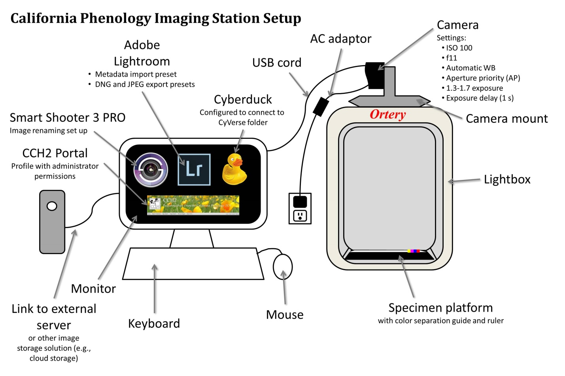

4.2 Equipment Recommendations
The following equipment was recommended for institutions that did not already have imaging stations at the start of the project. Many institutions were able to use preexisting equipment.

Item | Expected price | Source(s)
Nikon D800E 36.3 MP CMOS FX-Format Digital SLR Camera  (if you cannot find this model, a D800 or D810 would also work) | $1000-1500 | Amazon, etc. (note that this model is no longer supplied by Nikon, you will need to purchase from a third party)
Nikon AF-S FX NIKKOR 50mm f/1.8D Lens | $150-220 | Amazon, Best Buy, etc.
Nikon EP-5B Power Supply Connector | $48 | Amazon, etc.
Nikon EH-5b AC Adapter | $100 | Amazon, etc.
Ortery Photosimile 50 lightbox | $1500 + ~$300 shipping | Direct contact with Ortery
Symbol LS2208 General Purpose Barcode Scanner | $80 | Amazon, etc.
Goose neck stand for Symbol Scanner LS2208 | $13 | Amazon, etc.
Tiffen Q-13 Color Separation Guide (Small) | $32 | B&H Photo
Imaging computer with 4+ GB of RAM and 500+ GB of internal storage, preferably with a solid state drive (SSD), reasonable graphics card, more than three USB ports (USB 3.0 preferred); Mac or PC OK | up to $1200 | Best Buy, Costco, Amazon, etc.  Examples: HP Pavilion i3, faster = HP Pavilion i5
(If desktop computer) Good quality computer monitor
(If desktop computer) Mouse and keyboard
Ethernet cable | $5 (likely available for free through IT department)
Smart Shooter 3 PRO | $195 | Smart Shooter 3 website
Adobe Lightroom 6 or Adobe Lightroom Classic CC | $150 | Adobe website or institutional license
Camera Mount System (see Section 5) | ~$60* | *Manufactured at Cal Poly and provided to partner institutions free of charge
Specimen Backdrop (see Section 5) | ~$7 | Craft store or online materials source
Barcodes | see Section 6

4.3 Imaging Software
We recommend the following software:
- Smart Shooter 3 PRO: This camera tethering software enables the user to (1) change camera settings on the computer screen (except for exposure delay mode), (2) set the focal point on a specimen and autofocus, (3) take images by clicking a button, and, most importantly, (4) automatically rename images according to their barcode number by clicking a button. Once the name policy is set (see imaging protocol), Smart Shooter 3 PRO will scan the images for barcodes and rename them each according to their barcode number.
- Adobe Lightroom 6 or Classic CC: This software is used to process images and create derivative files. The processing steps include adding metadata (i.e., copyright information, including funding source and institution name), rotating images, cropping, enhancing sharpening, and exporting digital negative (DNG, archival format) and jpeg files for each image.
- Cyberduck: This free software is used to facilitate transfer of jpeg images into the CAP TCN community data folder in CyVerse. CyVerse will then make the images web-accessible and assign a URL to each image. The user will then run a process in the CCH2 portal that will link these image URLs to their appropriate specimen records in CCH2.

5. Custom Imaging Equipment
Institutions using the Ortery Photosimile 50 will need a camera mount system and specimen backdrop. The Cal Poly machine shop designed and manufactured camera mount systems for institutions that needed them at the beginning of the grant. The specifications for this camera mount system are provided in Section 5.1. Each institution should manufacture a specimen platform (Section 5.2).

5.1 Camera Mount System
The camera mount shown below was constructed for each institution that purchased an Ortery lightbox.
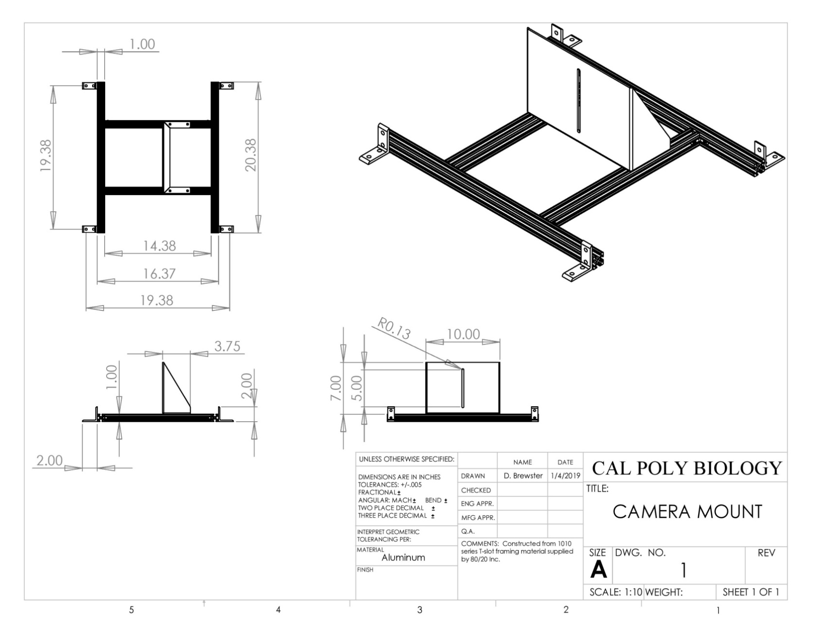

Installing the Camera Mount System
- Unscrew the four white knobs from the top four corners of the lightbox.
- Place the camera mount on the lightbox with the black rubber pad of the flat, upright piece facing left (see image below).
- Use the black knobs to fasten the four corners of the mount to the lightbox (circled in Figure 5.1).
- Mount the camera on the flat, upright piece by placing the bottom of the camera along the black rubber strip, fitting a black screw through the slot, and tightening it into place
- Adjust the positioning of the camera to be able to fit an entire specimen and the color bar into the camera’s field of view. You can accomplish this by:
  - moving the camera up or down in the camera mount slot,
  - using a 4 mm Allen wrench to loosen and tighten the black screws (see arrows on Figure 5.1) that hold the flat, upright piece to the aluminum bars
  - and using a 2.5 mm Allen wrench to loosen and tighten small hex-head screws in the gussets (L-shaped connectors) that connect the aluminum bars to one another (see arrows on Figure 5.2).
- Once you have tightened all the screws, double-check the field of view. Even slight adjustments can change the angle of the camera lens and greatly affect the resulting field of view.

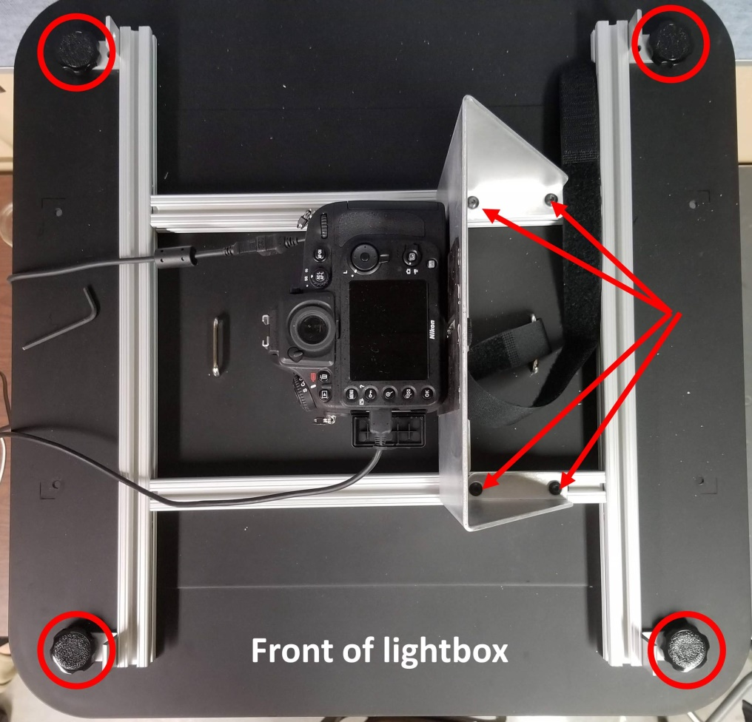
Figure 5.1 Top view of lightbox with installed camera mount. The knobs that secure the mount to the lightbox are circled in red, and the arrows indicate screws that can be tightened or loosened with a 4 mm Allen wrench to move the camera left or right.

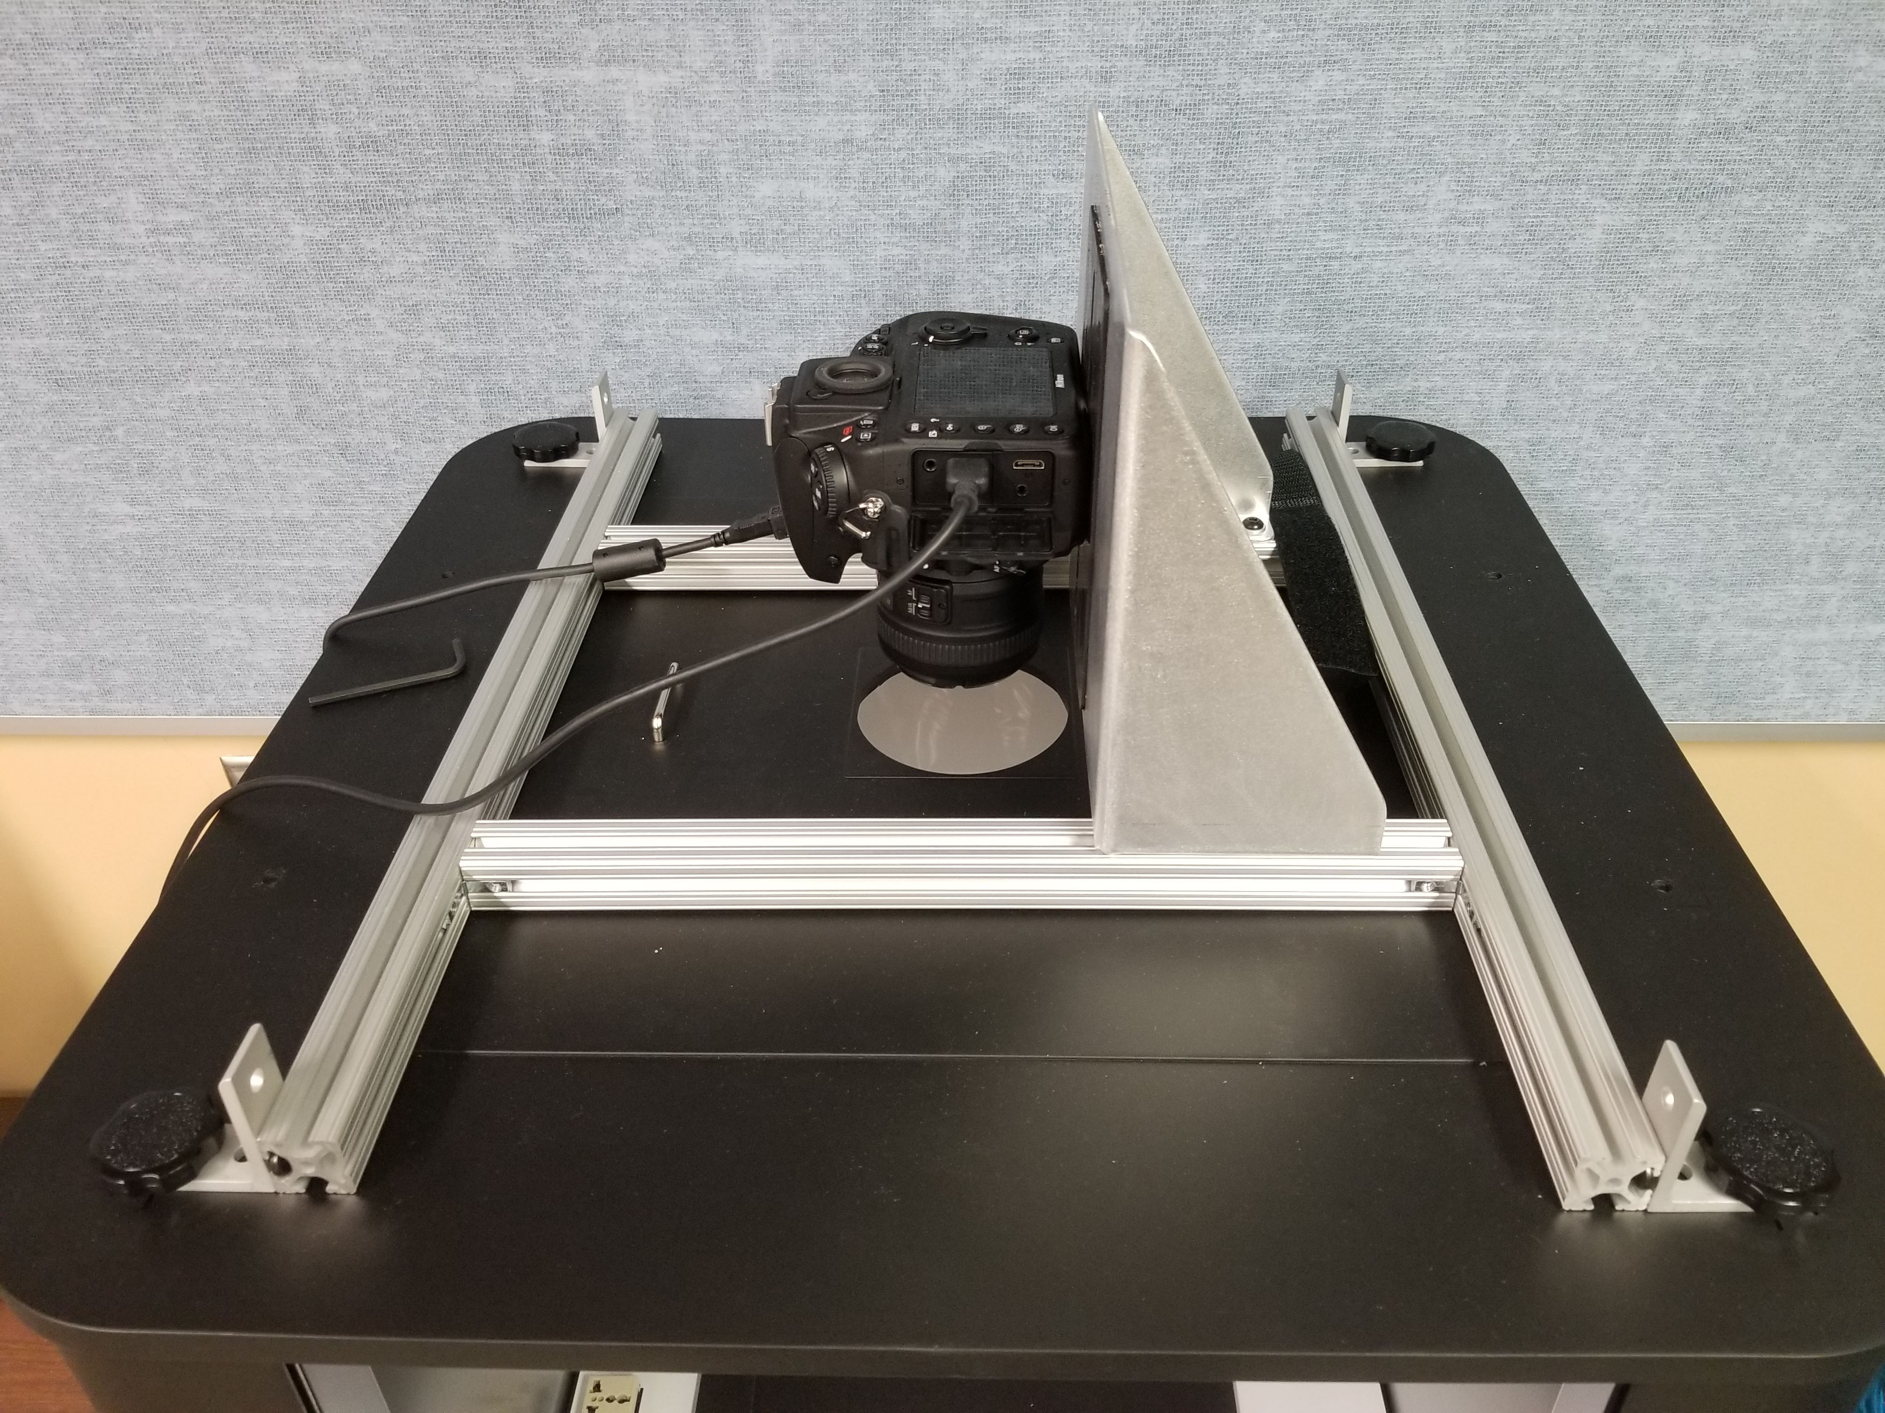
Figure 5.2 Angled view of top of lightbox with installed camera mount. The arrows indicate screws that can be tightened or loosened with a 2.5 mm Allen wrench to move the camera away from or toward the door of the lightbox.

5.2 Specimen Backdrop
(Adapted from Legler 2010, Assembling the Custom Components for Specimen Imaging, Consortium of Pacific Northwest Herbaria)

Supplies
- Black foamboard or fiberboard (approximately 1/8” thick) CLEANLY cut into the following pieces
  - 15” x 20”
  - 15” x 1.5”
  - 18.5” x 1.75”
- Double-sided tape
- Razor blade or X-acto knife
- Metal ruler or other straight-edge for cutting
- Tiffen Q-13 color separation guide (see Section 4.1) or other color guide
- Color printout of your institution’s logo, no taller than 2.5 centimeters

Assembly and Installation
- Cut the foamboard into the necessary sizes, making sure that cuts are clean and straight. Use outside edges whenever possible, which are already straight.
- Use double-sided tape to attach the 15” x 1.5” strip to one of the 15” ends of the large (15” x 20”) sheet. Carefully align the outside edges of the strip with the outside edges of the large sheet. The edge will form the top of the holder.
- Use double-sided tape to attach the 18.5” by 1.75” strip to the left side of the sheet and under the 15” strip at the top. The strip should tightly abut the previously attached strip, and its outside edge should align with the outside edge of the uncut sheet.
- Cut the Tiffen color separation guide such that it will completely fit on the 1.5” strip at the top of the specimen backdrop. This will mean cutting off the text of the color control patch (see dashed line below). Do not discard either piece of the color control patch.

- Cut the ruler at the top of the Tiffen color separation guide down to about 13 centimeters.
- Use double-sided tape to affix the colored strip, the printout of your institution’s logo, and the shortened ruler to the top 1.5” strip, as seen in the photo below.
- Lay the specimen platform in the lightbox such that the raised strips are to the top and left. The color bar and ruler should be furthest away from the lightbox opening.
- Before affixing the specimen platform to the lightbox floor with double-sided tape, install the camera mount system. You may need to adjust the position of the specimen platform as you adjust the camera mount so that your images are properly aligned.
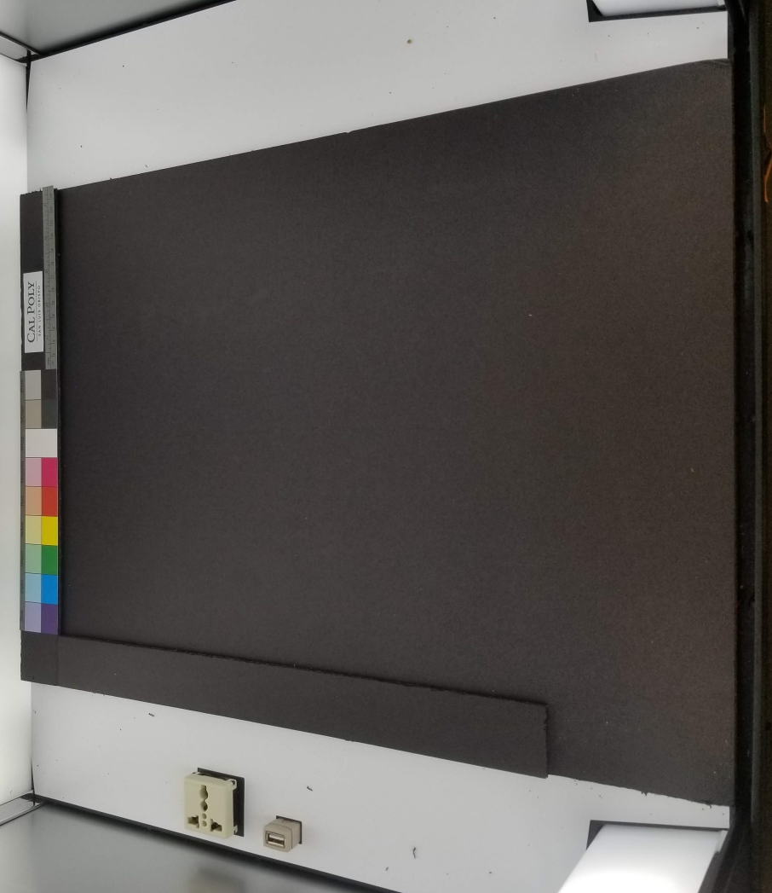

6. Barcode Recommendations
All specimens digitized during this project will be labeled with barcodes to facilitate computer-readability of the resulting images and assign a quasi-unique identifier to each specimen. Barcodes are also beneficial for accelerating curation tasks such as preparing and receiving loans.

6.1 Barcode Formatting
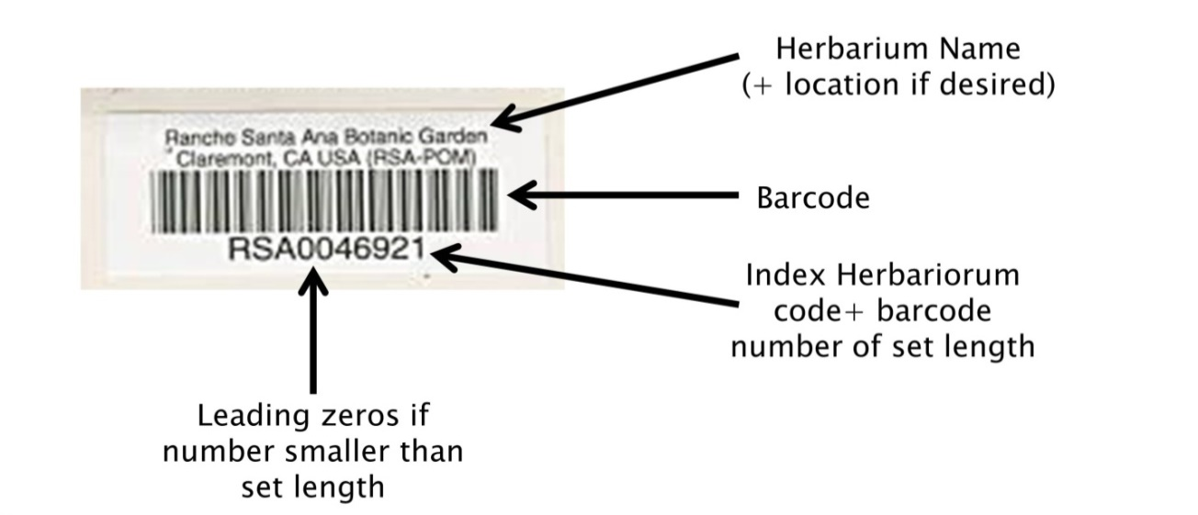
- Above barcode: name of institution (optional: location of institution)
- Barcode: “code 39” format, which includes letters and numbers
- Below barcode: barcode number, consisting of your Index Herbariorum (http://sweetgum.nybg.org/science/ih/) herbarium abbreviation followed by a unique number of a set number of digits.
  - Decide ahead of time how many digits will be in your barcode. Any numbers shorter than the set length of your barcode should be left-padded by zeros. For example, if your barcodes will include 9 digits (which means your institution can have a maximum of 999,999,999 specimens), and you have barcode number 38, your barcode should read: INST000000038. We recommend following this format so that the records can be sorted appropriately in Symbiota, Excel , or other management softwares.
  - We recommend including the IH abbreviation of your institution prior to the barcode number to maximize the “uniqueness” of this barcode number relative to other institutions’.

6.2 Barcode Sourcing
To order barcodes, email the “Barcode Form for Credit Card Payments” (attached to related email) to Gina Musick <gmusick@Reliancelabel.com>
In the email, make sure to provide:
- Label Quantity
- Text to be printed above Barcode (2 lines max)
- Number range and the way the number should appear. Specify the number of total digits you want (including leading zeros). For example, OBI100001 – OBI182000 (see below)
Cal Poly investigated purchasing barcodes from Reliance Barcode Solutions, Computype Inc, and Watson Label Solutions. Reliance Barcode Solutions was the most cost-effective at 2-4¢ per barcode. These labels are fully archival and have been used by other institutions including the Utah State University and Florida State University. They can be purchased by the roll or in printed sheets. Below is the estimate from Reliance for barcodes in rolls, which are expected to facilitate quicker barcode application than sheets.
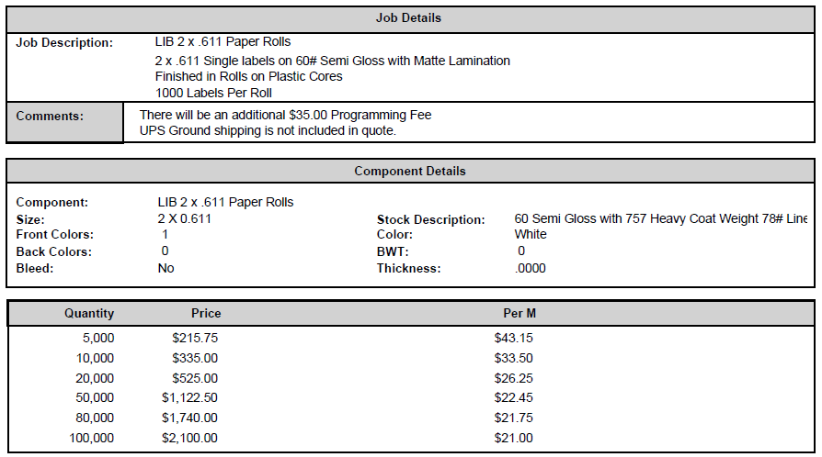

The quotes from Computype, Inc. and Watson Label Solutions are shown below, for reference:

Computype, Inc.
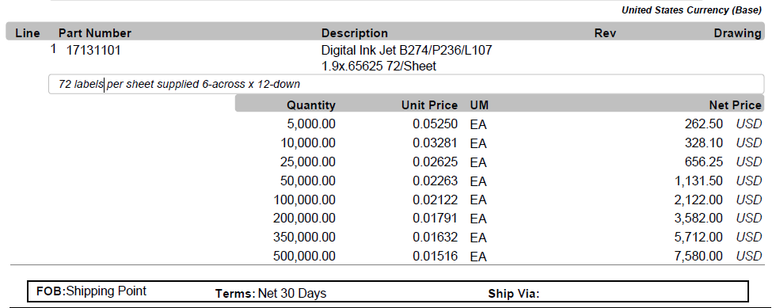
Watson Label Solutions
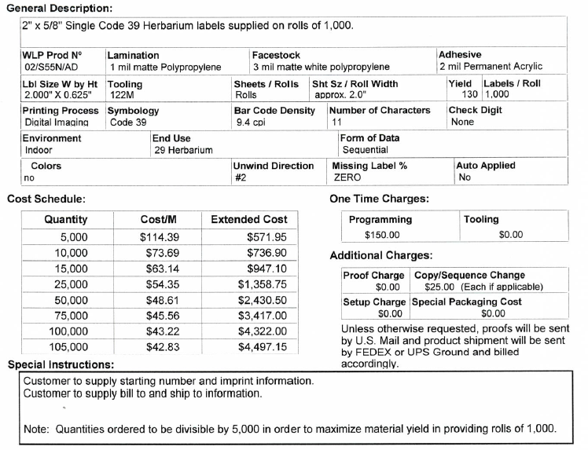

7. Barcoding Protocol

Goals: This protocol describes how to barcode specimens independently of any other digitization steps.
(Some content adapted from the Florida State University barcoding protocol by Austin Mast)

- Determine where you most recently left off barcoding by looking at the cabinet logs taped to the front of the herbarium cabinets (see Section 3.1). The last barcoded cubby will be indicated by initials and a date under the word “Barcoded” on that cubby, while the following cubbies in the diagram will not have initials or a date under “Barcoded”.
  - Note that these steps are based off the Cal Poly (OBI) workflow for tracking the imaging status of the cabinets.
- Remove all the specimens from the next cubby to be barcoded. Bring this cubby of specimens to your barcoding workstation.
- Place the first/next specimen on a level surface by itself.
- Apply a barcode 1/8 inch (NO CLOSER) from the bottom left corner of the first specimen (see image below).
  - DO NOT apply a barcode sticker on top of anything else (e.g., herbarium stamp, piece of the specimen, or a label).
  - If there is not space in the bottom left corner, place the barcode somewhere else along the bottom of the specimen. If there is not space at the bottom of the specimen, you may use the top edge of the specimen.
  - If a sheet has an indication that there are two different species on a single sheet, set this sheet aside and notify a supervisor, making sure to record the folder in which the specimen had been filed (Supervisor: see note at end)

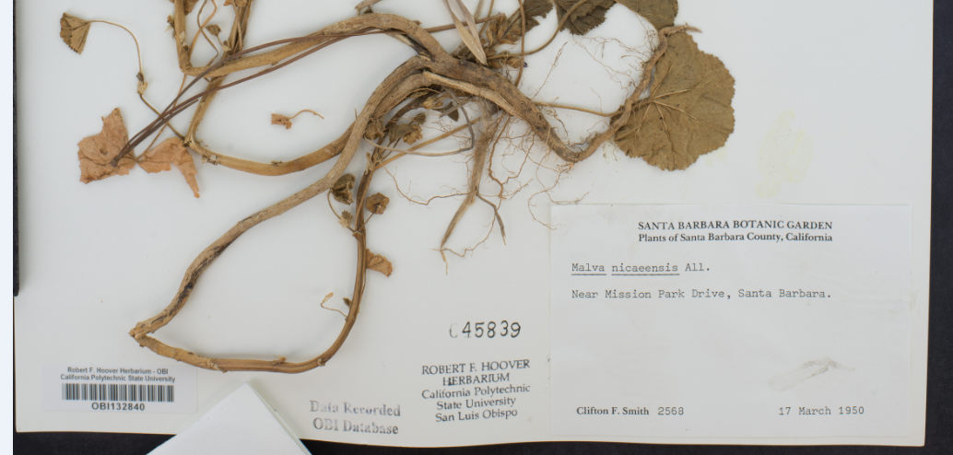

- Repeat steps 3 and 4 for every specimen in the stack
- Put away the cubby of specimens. Write your name and the date under the word “Barcoded” on the corresponding cubby on the cabinet diagram.
- Obtain a new cubby of specimens, keeping track of your progress on the cabinet diagram taped to the outside of the cabinet.

Supervisor Notes
Specimens with multiple specimens on a single sheet should be barcoded once for every specimen on that sheet. Then, when imaging, one image will be taken for each barcode on that sheet (i.e., 3 barcodes = 3 identical images, each with a different image name corresponding to one of the barcodes on the sheet).
Note that the program we are using to rename images at the time of imaging, Smart Shooter 3 will not be able to automatically name specimens with multiple barcodes on the sheet! Therefore, during imaging, the technicians should make a note of which barcodes belong to this anomalous specimen, they will have to manually rename the images accordingly.
Specimens that consist of multiple sheets or items should be treated as a set of botanical duplicates, with each sheet or item receiving its own barcode. Each sheet or item should then have a corresponding record in the database.

8. Imaging Protocol

Goals: This protocol describes how to image previously barcoded specimens using the Ortery lightbox setup and Smart Shooter 3.

- Turn on the lightbox using the switch labeled “Front & Rear.” Do not turn on the “Back” switch.
- Ensure that the camera is correctly plugged in to a power source and the computer.
- Turn on the computer and camera, in that order.
- Remove the camera lens cap.
- Start an Imaging Log entry by writing the date, your name, and the starting cabinet/cubby numbers in the appropriate fields on the Imaging Log (see Section 3.2).
- Create a folder on the desktop with the date (YYYYMMDD) and your last name separated by an underscore. Include a zero before single-digit days or months (e.g., if Katie Pearson made a file on October 1st, 2018, the filename should be 20181001_Pearson).
- Open the application Smart Shooter 3. In the Camera Controls toolbar (shown below), click the “Detect” button and look toward the bottom right of the screen.

If the Camera Controls toolbar is not visible, click “Display” in the menu bar at the top of your screen and click “Camera Controls” in the dropdown menu.

You should see the following message:
If you do not see this message, close Smart Shooter 3, turn off the camera, and unplug the camera from the computer. Then plug the camera in to the computer, turn on the camera, and re-open Smart Shooter 3.

- Click the “Connect” button in the Camera Controls toolbar.
- Press the Command (PC: Control) and comma keys simultaneously. (Or, in the menu bar at the top of your screen, click “Smart Shooter 3” followed by “Preferences”; PC: Click “File” followed by “Options”).
- In the Photo Download Directory box of the Preferences (PC: Options) menu, click “Browse” and navigate to the file that you created in step 6. Click “Open.”
- Navigate to the “Name Policy” tab in the preferences window. Ensure that the text in the “Filename Expression field” is “[Z]” with no quotation marks and no spaces before or after.
- Navigate to the “Barcode” tab. Ensure that the “Autoscan for barcode” box is checked. Click “OK”.
- Ensure that all the camera settings match those shown in the example below. Select the correct values from the dropdown menus as necessary.
  - You will not be able to change the greyed-out fields unless you alter other settings.
  - If you find that it produces better results in terms of brightness, you may choose to set the Program Mode to Manual and select 1/13 for the Shutter Speed.
  - Also consider experimenting with different values for Exposure. Depending on the lighting conditions at your location, higher or lower exposure compensation may be necessary.

- Click the checkbox next to “Enable” in the Liveview portion of the Camera Control toolbar. You should now be able to see camera’s view in the viewscreen. Click the picture icon ( ) to the right of the Options button (top of the viewscreen) to fit the viewscreen to the window. The image will look grainy on the screen, but don’t worry, the pictures will not!
- Determine where imaging was most recently left off by looking at the Cabinet Logs attached to the herbarium cabinet doors (examples in Section 3.1).
  - The last imaged cubby will be indicated by initials and a date under the word “Imaged” on that cubby, while the following cubbies in the diagram will not have initials or a date under “Imaged.”
  - Make sure that the cubby you are about to remove has been signed and dated beneath the word “Barcoded” on the cabinet log.
- Remove all the specimens from the next cubby to be imaged and bring them to your workstation, taking care to initial and date under the word “Imaged” on the corresponding cubby of the cabinet log.
- Place the specimen inside the lightbox, aligning the top left corner of the specimen to the inside corner of the raised pieces of foamboard (see picture below).
  - The ruler and color guide should be at the top of the specimen. If the label is on the bottom right corner of the specimen, like most are, the label should be closest to you and on your right side.
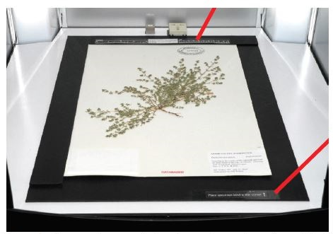
Image credit: Ben Legler, Consortium of Pacific Northwest Herbaria

- Make sure the entire specimen, ruler, and color guide are visible in the viewscreen and that the specimen does not appear crooked.
  - If the specimen does not appear aligned, the specimen platform or camera may have been jostled or shifted. Adjust the camera and/or specimen platform if necessary. Do NOT untape the specimen platform or unscrew the camera from its mount. Contact a supervisor if you cannot fix the problem without doing so.
- Find a representative part of the specimen that has a good amount of vegetation and make a mental note of where it is on the screen. This will be where you will focus the camera initially.
- Check the box next to “Zoom” in the Liveview portion of the Camera Controls toolbar. A small rectangle will appear on the viewscreen surrounded either by black or the most recently created image.
  - NOTE: There is a glitch in the program, and the most recently created image will be displayed after you click “Zoom.” This image does NOT show the specimen that is in the lightbox currently. You will have to ignore this image as you move the zoom rectangle in step 21.
- Drag the zoom rectangle to the approximate location of the representative part of the specimen you previously identified (see screenshot below).
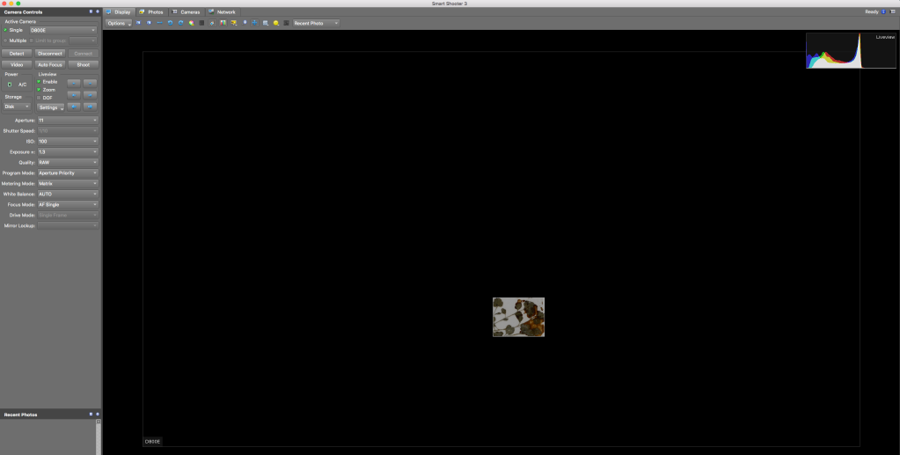
- Click the “Auto Focus” button once you are satisfied with your choice of focal point.
- Click “Shoot.”
- Uncheck the boxes next to “Zoom” and “Enable.”
- View the image you just captured. It should have appeared on the screen after you unchecked “Enable.” If this is not the case, make sure that you are in the Display tab and that “Recent Photo” is selected from the dropdown menu in the top right (circled below).
- Check the quality of the image you just took.
  - Is the whole label and barcode visible?
  - Is the specimen straight and aligned with the edges of the specimen platform?
  - Is the focus sharp? Zoom in and check the focus in multiple places on the specimen.
    - If there are any problems with focus:
      - Return to the Display tab.
      - Switch the camera back to Autofocus (AF) mode.
      - Re-focus the camera by repeating steps 19-26.
      - Uncheck the “Enable” box, but instead of clicking “Shoot” for step 23, click the Photos tab (circled below) and right click the name of the problematic image.
      - Select “Reshoot with same name” from the dropdown menu and repeat steps 25-26 with this new photo.
- If you are happy with the focus, switch the camera from Autofocus (AF) mode to Manual (M) mode by flipping the switch to the left of the lens on the camera (near the cord that connects the camera to the computer).
- Carefully remove the specimen from the lightbox and place it in your "imaged" pile or to the right of the imaging station.
- Get a new specimen and place it in the lightbox like you did in step 17.
  - For the remaining specimens in this stack, you do NOT need to refocus and check for quality!
- Image the remaining specimens in your stack by placing each specimen in the lightbox individually and clicking “Shoot.”
- When you have finished imaging your stack, put it in the gray cabinet in front of the imaging station. Write the numbers of the cabinet and cubby from which you obtained this stack of specimens on the whiteboard cabinet diagram on the outside of the gray cabinet.
- Switch the camera back to Autofocus (AF) by flipping the switch on the camera body.
- Repeat steps 15-32, switching to Autofocus at the beginning of each cubby and checking the quality of the first specimen of each cubby as instructed.
- At the end of your shift, navigate to the Photos tab.
- Check that all the images have names in the expected format: the institution code of your collection followed by a set number of digits (e.g., OBI100259).
  - Note: Pay particular attention to barcodes that are longer than expected (e.g., OBI100259_1). This may indicate that Smart Shooter 3 was unable to recognize the barcode in that image or that the image is a duplicate.
  - If any images are not named correctly:
    - View the image by right clicking on it and selecting “Open in editor” in the dropdown menu.
    - Rename the image according to the barcode by right clicking on the record in the Smart Shooter 3 table, selecting “Rename” in the dropdown menu, and manually entering the barcode number.
    - Double check that you have entered the entire barcode correctly, including the institution abbreviation (e.g., OBI) at the beginning.
- Return to the Smart Shooter 3 Photos tab.
- Randomly select one of the images in the table. Double click to open it in the Display tab.
- Check that the barcode number in the image matches the image name.
- Repeat steps 37-38 for at least four additional specimens.
- Turn off the camera and lightbox and replace the lens cap on the camera.
- Complete your Imaging Log entry by indicating your ending cabinet/cubby and the number of specimens you imaged. The number of images you created should be listed underneath the name of the folder you created on the desktop. If this is not the case, right click on the folder into which you imaged the specimens, click Get Info, click the triangle next to “General”, and find the number of items next to Size (if you use this method, you will need to subtract 1 from this number to account for the file itself). If you are using a PC, right click on the folder and click Properties. The number of files will be listed in the pop-up window.

9. Combined Barcoding & Imaging Protocol

Goals: This protocol describes how to barcode and image specimens using the Ortery lightbox setup and Smart Shooter 3.

- Turn on the lightbox using the switch labeled “Front & Rear.” Do not turn on the “Back” switch.
- Ensure that the camera is correctly plugged in to a power source and the computer.
- Turn on the computer and camera, in that order.
- Remove the camera lens cap.
- Start an Imaging Log entry by writing the date, your name, and the starting cabinet/cubby numbers in the appropriate fields on the Imaging Log (see Section 3.2).
- Create a folder on the desktop with the date (YYYYMMDD) and your last name separated by an underscore. Include a zero before single-digit days or months (e.g., if Katie Pearson made a file on October 1st, 2018, the filename should be 20181001_Pearson).
- Open the application Smart Shooter 3. In the Camera Controls toolbar (shown below), click the “Detect” button and look toward the bottom right of the screen.

If the Camera Controls toolbar is not visible, click “Display” in the menu bar at the top of your screen and click “Camera Controls” in the dropdown menu.

You should see the following message:
If you do not see this message, close Smart Shooter 3, turn off the camera, and unplug the camera from the computer. Then plug the camera in to the computer, turn on the camera, and re-open Smart Shooter 3.

- Click the “Connect” button in the Camera Controls toolbar.
- Press the Command (PC: Control) and comma keys simultaneously. (Or, in the menu bar at the top of your screen, click “Smart Shooter 3” followed by “Preferences”; PC: Click “File” followed by “Options”).
- In the Photo Download Directory box of the Preferences (PC: Options) menu, click “Browse” and navigate to the file that you created in step 6. Click “Open.”
- Navigate to the “Name Policy” tab in the preferences window. Ensure that the text in the “Filename Expression field” is “[Z]” with no quotation marks and no spaces before or after.
- Navigate to the “Barcode” tab. Ensure that the “Autoscan for barcode” box is checked. Click “OK”.
- Ensure that all the camera settings match those shown in the example below. Select the correct values from the dropdown menus as necessary.
  - You will not be able to change the greyed-out fields unless you alter other settings.
  - If you find that it produces better results in terms of brightness, you may choose to set the Program Mode to Manual and select 1/13 for the Shutter Speed.
  - Also consider experimenting with different values for Exposure. Depending on the lighting conditions at your location, higher or lower exposure compensation may be necessary.

- Click the checkbox next to “Enable” in the Liveview portion of the Camera Control toolbar. You should now be able to see camera’s view in the viewscreen. Click the picture icon ( ) to the right of the Options button (top of the viewscreen) to fit the viewscreen to the window. The image will look grainy on the screen, but don’t worry, the pictures will not!
- Determine where imaging was most recently left off by looking at the Cabinet Logs attached to the herbarium cabinet doors (examples in Section 3.1).
  - The last imaged cubby will be indicated by initials and a date under the word “Imaged” on that cubby, while the following cubbies in the diagram will not have initials or a date under “Imaged.”
- Remove all the specimens from the next cubby to be imaged and bring them to your workstation, making sure to initial and date under the word “Imaged” on the corresponding cubby of the cabinet log.
- Place the first/next specimen on a level surface by itself.
- Apply a barcode 1/8 inch (NO CLOSER) from the bottom left corner of the first specimen (see following image).
  - DO NOT apply a barcode sticker on top of anything else (e.g., herbarium stamp, piece of the specimen, or a label).
  - If there is not space in the bottom left corner, place the barcode somewhere else along the bottom of the specimen. If there is not space at the bottom of the specimen, you may use the top edge of the specimen.
  - If a sheet has an indication that there are two different species on a single sheet, set this sheet aside and notify a supervisor, making sure to record the folder in which the specimen had been filed (Supervisor: see note at end of protocol)

- Place the specimen inside the lightbox, aligning the top left corner of the specimen to the inside corner of the raised pieces of foamboard (see picture below).
  - The ruler and color guide should be at the top of the specimen. If the label is on the bottom right corner of the specimen, like most are, the label should be closest to you and on your right side.
Image credit: Ben Legler, Consortium of Pacific Northwest Herbaria

- Make sure the entire specimen, ruler, and color guide are visible in the viewscreen and that the specimen does not appear crooked.
  - If the specimen does not appear aligned, the specimen platform or camera may have been jostled or shifted. Adjust the camera and/or specimen platform if necessary. Do NOT untape the specimen platform or unscrew the camera from its mount. Contact a supervisor if you cannot fix the problem without doing so.
- Find a representative part of the specimen that has a good amount of vegetation and make a mental note of where it is on the screen. This will be where you will focus the camera initially.
- Check the box next to “Zoom” in the Liveview portion of the Camera Controls toolbar. A small rectangle will appear on the viewscreen surrounded either by black or the most recently created image.
  - NOTE: There is a glitch in the program, and the most recently created image will be displayed after you click “Zoom.” This image does NOT show the specimen that is in the lightbox currently. You will have to ignore this image as you move the zoom rectangle in step 22.
- Drag the zoom rectangle to the approximate location of the representative part of the specimen you previously identified (see screenshot below).
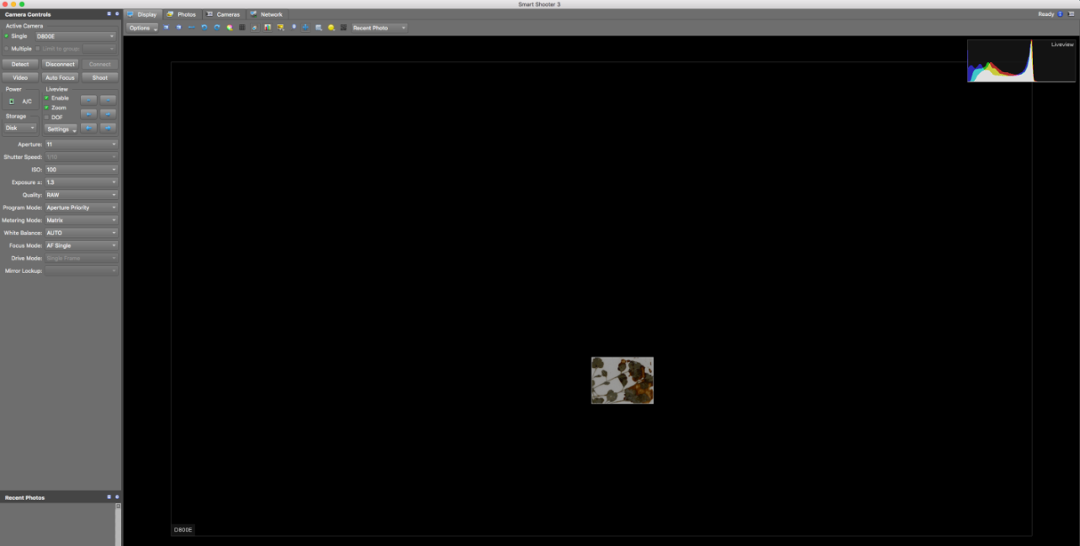
- Click the “Auto Focus” button once you are satisfied with your choice of focal point.
- Click “Shoot.”
- Uncheck the boxes next to “Zoom” and “Enable.”
- View the image you just captured. It should have appeared on the screen after you unchecked “Enable.” If this is not the case, make sure that you are in the Display tab and that “Recent Photo” is selected from the dropdown menu in the top right (circled below).
- Check the quality of the image you just took.
  - Is the whole label and barcode visible?
  - Is the specimen straight and aligned with the edges of the specimen platform?
  - Is the focus sharp? Zoom in and check the focus in multiple places on the specimen.
    - If there are any problems with focus:
      - Return to the Display tab.
      - Switch the camera back to Autofocus (AF) mode.
      - Re-focus the camera by repeating steps 21-24.
      - Uncheck the “Enable” box, but instead of clicking “Shoot” for step 25, click the Photos tab (circled below) and right click the name of the problematic image.
      - Select “Reshoot with same name” from the dropdown menu and repeat steps 26-28 with this new photo.
- If you are happy with the focus, switch the camera from Autofocus (AF) mode to Manual (M) mode by flipping the switch to the left of the lens on the camera (near the cord that connects the camera to the computer).
- Carefully remove the specimen from the lightbox and place it in your "imaged" pile or to the right of the imaging station.
- Get a new specimen and place it in the lightbox like you did in step 19.
  - For the remaining specimens in this stack, you do NOT need to refocus and check for quality!
- Image the remaining specimens in your stack by placing each specimen in the lightbox individually and clicking “Shoot.”
- When you have finished imaging your stack, put it in the gray cabinet in front of the imaging station. Write the numbers of the cabinet and cubby from which you obtained this stack of specimens on the whiteboard cabinet diagram on the outside of the gray cabinet.
- Switch the camera back to Autofocus (AF) by flipping the switch on the camera body.
- Repeat steps 15-34, switching to Autofocus at the beginning of each cubby and checking the quality of the first specimen of each cubby as instructed.
- At the end of your shift, navigate to the Photos tab.
- Check that all the images have names in the expected format: the institution code of your collection followed by a set number of digits (e.g., OBI100259).
  - Note: Pay particular attention to barcodes that are longer than expected (e.g., OBI100259_1). This may indicate that Smart Shooter 3 was unable to recognize the barcode in that image or that the image is a duplicate of the same specimen.
  - If any images are not named correctly:
    - View the image by right clicking on it and selecting “Open in editor” in the dropdown menu.
    - Rename the image according to the barcode by right clicking on the record in the Smart Shooter 3 table, selecting “Rename” in the dropdown menu, and manually entering the barcode number.
    - Double check that you have entered the entire barcode correctly, including the institution abbreviation (e.g., OBI) at the beginning.
- Return to the Smart Shooter 3 Photos tab.
- Randomly select one of the images in the table. Double click to open it in the Display tab.
- Check that the barcode number in the image matches the image name.
- Repeat steps 39-40 for at least four additional specimens.
- Turn off the camera and lightbox and replace the lens cap on the camera.
- Complete your Imaging Log entry by indicating your ending cabinet/cubby and the number of specimens you imaged. The number of images you created should be listed underneath the name of the folder you created on the desktop. If this is not the case, right click on the folder into which you imaged the specimens, click Get Info, click the triangle next to “General”, and find the number of items next to Size (if you use this method, you will need to subtract 1 from this number to account for the file itself). If you are using a PC, right click on the folder and click Properties. The number of files will be listed in the pop-up window.

Supervisor Note:
Specimens with multiple specimens on a single sheet should be barcoded once for every specimen on that sheet. Then, when imaging, one image will be taken for each barcode on that sheet (i.e., 3 barcodes = 3 identical images, each with a different image name corresponding to one of the barcodes on the sheet)
Note that the program we are using to rename images at the time of imaging, Smart Shooter 3 will not be able to automatically name specimens with multiple barcodes on the sheet! Therefore, during imaging, the technicians should make a note of which barcodes belong to this anomalous specimen, they will have to manually rename the images accordingly.

10. Image Processing

10.1 Image Processing Protocol

Goals: This protocol should be used by supervisors or trained technicians to process folders of raw images. Processing steps include cropping, adjusting sharpening, adding metadata, and exporting raw images as DNG and JPEG files.

Once the supervisor/technician is trained and has practiced this protocol, s/he should refer to the Image Processing Checklist (Section 10.2) when processing images.

(Some material adapted from Skema & Barber 2018)

- Create a folder on the desktop that mimics the name of the folder of images you will process plus “_Processed” (e.g., 20181001_Pearson_Processed). Within this folder, create a subfolder called “JPEGs.”
- Open Adobe Lightroom.
- Click the Import button at the bottom left of the Lightroom window.
- Drag the folder of images you wish to process from its location (e.g., on the desktop) into the Lightroom library. (Or navigate to the folder in the Source menu on the left side of the window.)
- In the menu on the right side of the window, click the triangle next to “Apply During Import.” Select the preset metadata settings from the dropdown menu.
First time set-up note:
Upon first use, set up a metadata standard for your institution that can be applied to all images during processing by doing the following:
- From the metadata settings in “Apply During Import,” select “New” from the dropdown menu.
- Name the Metadata preset something recognizable (e.g., your herbarium acronym).
- Under the heading “IPTC Copyright,” type your herbarium/institution name in the “Copyright” box followed by “- funded by National Science Foundation award number” followed by your NSF award number.
- Select “Copyrighted” in the Copyright Status dropdown list.
- In the Rights Usage Terms field, enter “CC BY-NC-SA.” This means that users of your images must credit your institution when using the image, the image cannot be used for commercial means, and the image and its derivatives must be shared using a copyright license that is no more restrictive than the copyright license you provide.
- Click “Create” (or “Done”). Now you should be able to select that metadata preset in the Metadata drop down menu, and that copyright will be applied to every photo you import into your catalog.
- Make sure all of the images in the folder you wish to process are checked (upper left corner of each thumbnail), then click the “Import” button at the bottom right corner of the window.
- Select all the images in the resulting Library page by clicking one thumbnail image and pressing the Command and A keys simultaneously. Hover your cursor over one of the thumbnails and rotate the images so that the labels are right-side-up by clicking the arrow keys to the bottom left or right of the thumbnail you are hovering over (circled in white below).

- Click the “Develop” tab in the menu at the top right side of the screen (see below). If this menu is not immediately available, click the top right side of the Lightroom window.

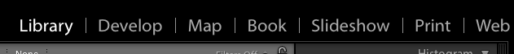

- In the editing toolbar on the right side of the window (shown below), click the Crop Overlay tool symbol (circled in white below). This will open a new menu for the Crop & Straighten Tool.

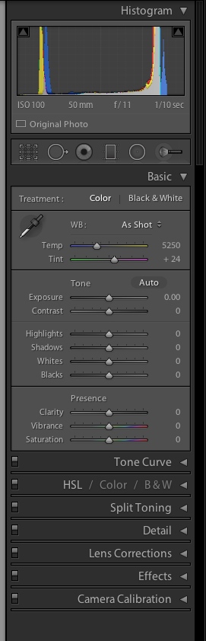
- Crop the image by adjusting the edges of the cropping rectangle to remove unwanted empty space. Be sure that all edges of the specimen sheet and the color separation guide and ruler remain inside the cropped image.
- Click “Close” at the bottom right of the Crop & Straighten Tool.
- In the editing toolbar, open the Detail panel by clicking the triangle to the right of the word “Detail.” If this panel is already open, you do not need to click the triangle.
- Under “Sharpening” in the Detail menu, click the number to the right of the “Amount” slider. Type 50 into this value.
- Click on the thumbnail image at the bottom left of the window (circled below) and press Command (PC: Controand “A” simultaneously to select all of the recently imported images.

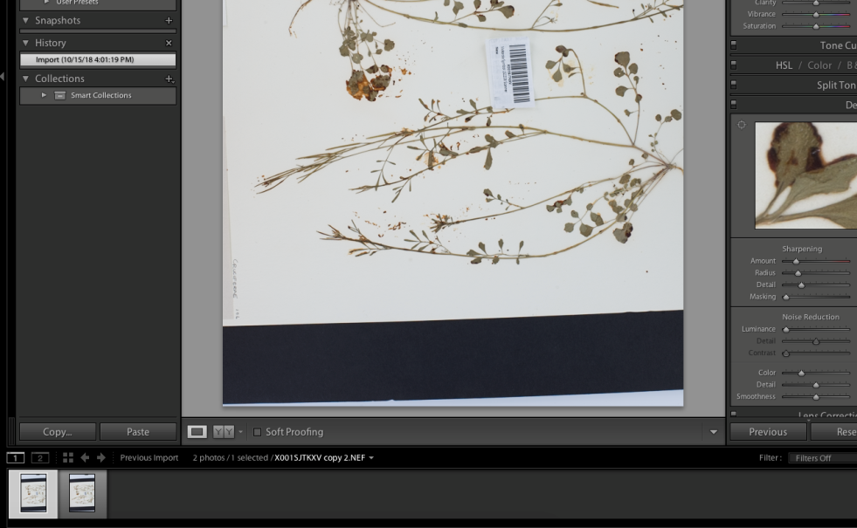

- Press Shift, Command, and “S” simultaneously (or, in the menu bar at the top of the screen, click “Settings” > Sync Settings…). Make sure that the box next to “Crop” is checked in the Synchronize Settings window. Click “Synchronize.” This will apply all the edits that you made to the first image to all subsequent images.
- Click the Library tab and select all the images by pressing Command and “A” simultaneously.
- Click the “Export” button in the bottom left corner of the window. The following dialogue box will open:
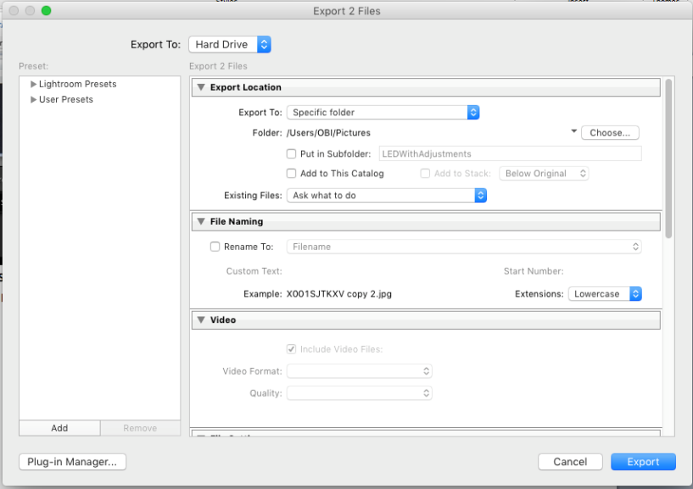
First time set-up note:
Upon first use, set up two User Presets that can be used for future exports by doing the following:
    - On the left side of this window, click the “Add” button. Enter DNG as the preset name. Click Create.
    - In the export settings, make sure the “Rename To:” checkbox is unchecked.
    - Scroll down. Under File Settings, change the Image Format to DNG.
    - Right click on the name of the preset (DNG) in the menu on the left. Select Update with Current Settings.
    - Click the “Add” button on the left side of the window. Enter JPEG as the present name. Click Create.
    - In the export settings, make sure the “Rename To:” checkbox is unchecked.
    - Scroll down. Under File Settings, change the Image Format to JPEG.
    - In the Color Space dropdown menu, select sRBG.
    - Check the Limit File Size box and enter 7000 in the text box.
    - Scroll down. Make sure the Include: field in the Metadata box says “All Metadata”
    - Uncheck the “Remove Person Info” and “Remove Location Info” boxes.
    - Right click on the name of the preset (JPEG) in the menu on the left. Select Update with Current Settings.
- Select the JPEG preset from the menu on the left side of the window
- Change the Export Location to the JPEGs subfolder within the “_Processed” folder that you created on the desktop in step 1.
- Click “Export.” Note that this may take a while if you are processing many images at one time.
- Repeat step 17 and select the DNG preset from the export window.
- Click “Export.” Note that this may take a while if you are processing many images at one time.
- Ensure that both DNGs and JPEGs are found in the “_Processed” folder that you created in step 1 and that the number of DNG files and number of JPEG files are both identical to the “Number of Images” listed in the Imaging Log entry for the file you are processing.
- Write your initials and the date in the imaging log under “Processed” on the corresponding entry (see below).

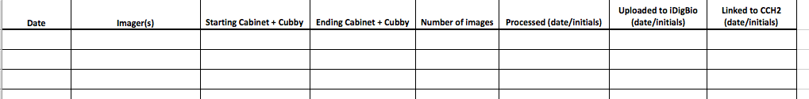

10.2 Image Processing Checklist
The quick-reference checklist on the following page was developed to expedite the process of image processing for supervisors.

Image Processing Checklist
Print this checklist and post it next to the image processing computer.
- Import with appropriate metadata
- Rotate
- Crop
- Sharpen
- Sync settings
- Export as JPEG
- Export as DNG
Once images are processed:
- Upload DNGs and JPEGs to institutional storage
- Upload JPEGs to iDigBio server
- Link images to CCH2
The last two steps are explained in the Protocol for Uploading Images to iDigBio and Linking to CCH2.

11. Protocol for Set Up and Upload of Images to CyVerse and Loading into CCH2

Part 1: Setting up Cyberduck to upload JPEGs (one time only)
Adapted from the CyVerse User Manual, also available here: https://wiki.cyverse.org/wiki/display/DS/Using+Cyberduck+for+Uploading+and+Downloading+to+the+Data+Store

Goal: Part 1 of these directions describes how to set up the system that will be used to make images web-accessible and linked to the CCH2 portal. Once the system is set up once, you can refer only to Part 2 and 3 of this protocol. Part 2 describes how a supervisor or trained technician can upload specimen images to CyVerse, which will then make these images web-accessible. Part 3 describes how to link the URLs for these images to the specimen records in the CCH2 portal.

Step 1: Create a CyVerse account
- Go to www.cyverse.org and click on the in the top right corner of the page.
- Click Sign Up and follow the provided instructions for creating a CyVerse account.

Step 2: Install or update Cyberduck
- If Cyberduck is already installed, check if you need to update (this allows you to be compatible with iRODS 4.1):
  - Click the Cyberduck menu.
  - Click Check for Updates.
  - Determine if your installed version requires an update:
    - If using < 4.7.0, the update is required.
    - If using > 4.7.0 and < 5.0.0, the update is recommended.
    - If using 5.0.0 and later, the update is optional.
  - Depending on your version, click Install Update.
- To install Cyberduck for your operating system for the first time:
  - Go to the Cyberduck installation page at https://cyberduck.io/ .
  - Follow the steps for your OS (not available for LINUX users):
    - For Mac OS:
      - Click Download Cyberduck for Mac.
      - Move the downloaded file (either a zip file or the unzipped application file, depending on your browser) to your Applications folder.
If the zip file is listed, unzip the file in your Applications folder.
IMPORTANT: The file must be located in your Applications folder.
    - For Windows:
      - Click Download Cyberduck for Windows.
      - Locate the downloaded file and double-click to begin installation.
      - Go through the install process.

Step 3: Configure Cyberduck for use with the Data Store
- Click 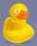 to open Cyberduck.
- Click this link to download the Connection Profile, which contains preconfigured settings for using Cyberduck with the CyVerse Data Store.
- Click to open the downloaded CyVerse Data Store.cyberduckprofile file.
- Verify CyVerse Data Store is displayed in the first field.
- In the Nickname field, enter data.cyverse.org – iRODS.
- Create the connection:
  - In the Server field, enter data.cyverse.org.
  - In the Port field, enter 1247.
  - To create the connection with your CyVerse user account for login:
    - Enter your CyVerse user name in the Username field.
    - Verify your username is added to the URL field, as shown above.
Example: irods://yourusername@data.cyverse.org.
  - To create an anonymous connection so you can access public data without a CyVerse user account:
    - Click the Anonymous Login checkbox.
    - Verify anonymous is displayed in the Username field.
The remaining fields are populated.
- Click in the Transfer Files drop-down list and select Open multiple connections.
- Close the window.

Part 2: Uploading JPEGs to CyVerse

Goal: This protocol describes how a supervisor or trained technician can upload specimen images to CyVerse, which will then make these images web-accessible. The URLs for these images will then be linked to the specimen records in the CCH2 portal in Part 3.
- If necessary, click to open Cyberduck (or find the Cyverduck program in your applications or programs list).
- In the Cyberduck window, click the bookmark icon and then click Open Connection.
- In the drop-down list, click the repository to use (data.cyverse.org – IRODS if you set it up as instructed above)
- Log in to Cyberduck:
  - If logging in with your CyVerse account, enter your CyVerse username and password.
  - If logging in without a CyVerse account, click the Anonymous Login checkbox.
- Click Connect.
- At the top of window, click Go and select Go to Folder... from the dropdown menu.
- In the pop-up window, enter the following path: /iplant/home/shared/CAP_TCN. Click Go.
- Click the folder with the acronym of your institution. If there are many files in this folder, just wait; it may take some time to list the directory.
- Click Upload at the top of the window and navigate to the folder that you intend to upload. Note that you will need to open this folder and select all of the contents (Ctrl + A or Command + A) rather than just click the folder to upload. Otherwise, Cyberduck will create a new directory (folder), and you will be unable to link these images to their records in CCH2.

Part 3: Loading JPEGs into CCH2
**The user conducting this protocol must have administrator permissions in CCH2.***
- Log in to your account in CCH2 and navigate to the collection management page (My Profile > Specimen Management tab > name of collection).
- In the administration control panel, click Processing Toolbox.
- Select the Image Loading tab and select iPlant Image Processing from the Saved Image Processing Profiles box.
- Ensure that the Processing start date is the same as the Last Run Date. This means that the API will search and load your folder for all the images that were uploaded since you last loaded JPEGs into CCH2.
- Examine the resulting log file to ensure the expected number of images was loaded into CCH2.

12. Protocol for Associating Barcode Numbers with Accession Numbers

Goal: This protocol describes how to update your old accession number with the specimen’s new barcode number. You can do this only after you have uploaded specimen images to the iDigBio server and linked them to your database in CCH2.
- Log in to your CCH2 account and click My Profile on the right side of the menu bar.
- Click the Specimen Management tab.
- Click the name of the collection that you will be imaging.
- In the Data Editor Control Panel, click Edit Existing Occurrence Records.
- In the Record Search Form, click the Processing Status field select “Unprocessed” from the dropdown menu.
- Click the “Display Table” button.
- Select a specimen from this list by clicking the Symbiota ID number in the far left column. This will take you to the Occurrence Editor form (see screenshot below).
- Locate the accession number (the stamped number, rather than the barcoded number or the collector number) on the specimen in the image to the right of the Occurrence Editor form (screenshot below). You can zoom in by pressing Command (Mac) or Control (Windows) and clicking on the image where you want to zoom in. Alternatively, you can hold Shift, click on the area where you want to zoom in, and move the mouse up (to zoom in) or down (to zoom out).
- Enter the accession number, without leading zeros (e.g., if the number reads “0145”, you will enter “145”), into the Other Cat. #s field (circled below).

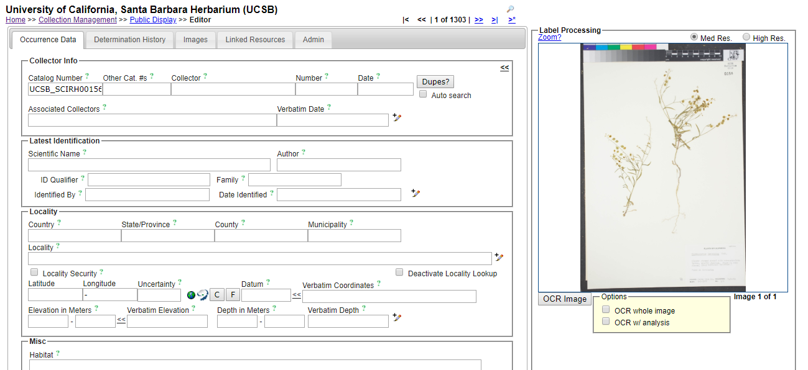
- Click outside of the Other Cat. #s field. A message should show up under the “Dupes?” button. Make sure that your browser’s pop-up blocker is disabled so you can see these messages.
- If the message shows “No Dupes Found” (see below):
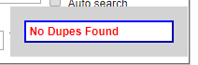
  - Check that the specimen sheet is not stamped “Databased” or has any other indication that it SHOULD have a record in the database. If it is, try adding a leading zero to the accession number and repeat step 9.
  - Press the Save Edits button (or press Tab and Enter on your keyboard)
  - Move on to step 11.

- If a message shows up that says “Record(s) using the same identifier already exists. Do you want to view this record?”:
  - Click OK.
  - Check that the data of the identified duplicate matches the data on the label of the specimen image you were viewing. You need not check every field, just two or three important fields such as Scientific Name, Collector, and Locality.
  - If the data match up, click “Merge Records” and exit the duplicate window. If the data do not match up, scroll down to the Processing status field in the Curation box and select “Expert Required” from the dropdown menu.
- Return to the table of specimens you opened in step 6 by clicking the back button on your browser.
- Click the refresh button on your browser.
- Repeat steps 7-12.
- When you are done with your shift, make sure to log out of your account and close the browser window.

13. Guide to Transcribing Label Data in CCH2

Goal: This protocol describes how to transcribe specimen data from images of skeletal records in the CCH2 portal.

13.1 Navigating to records to transcribe
- Log in to your account in CCH2 (cch2.org).

- Click My Profile.
- Click the Specimen Management tab.
- Click the name of the collection for which you will transcribe specimens (there will likely only be one).
- In the Data Editor Control Panel, click Edit Exiting Occurrence Records.
- In the resulting Record Search Form, select “Unprocessed” from the dropdown list in the Processing Status field.
- For Custom Field 1, select “Other Catalog Numbers” from the first dropdown list and “IS NOT NULL” from the second dropdown list.
  - Note: this step applies to institutions that associate barcode numbers with accession numbers in a separate step; if you are not sure whether this is true, ask a supervisor or omit this step

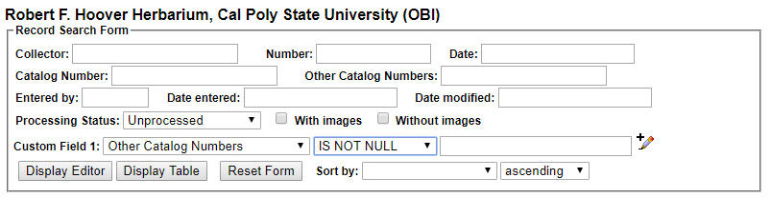
- Click the Display Editor button.

13.2 Transcribing records
If you find that you are unable to transcribe part of a specimen label, set the processing status of the specimen to Expert Required, explain the reason you had trouble transcribing the record in the Notes (Occurrence Remarks) field, and move to another specimen record.

- When you have a specimen record in front of you, scroll down to the bottom of the page to the Status Auto-Set field, which is right above the Save Edits button. Select Pending Review from the dropdown menu (an explanation for the Processing Status field is provided in Appendix 2).
- Scroll back up to the top of the specimen record. Zoom in to the specimen label on the image on the right by clicking and holding on the image, holding the Tab key on your keyboard, and moving the mouse up. Alternatively, you can hold the Control (or Command) button and click somewhere on the specimen image to zoom in.
  - The specimen label is usually on the bottom right of the specimen.
  - If the label is too blurry to read, click the High Res. button above the image.
- Type the name of the primary collector into the Collector field.
  - Type the name exactly as it appears on the label
  - If there are multiple collectors, use the first collector name or the collector name that is associated with the collector number.
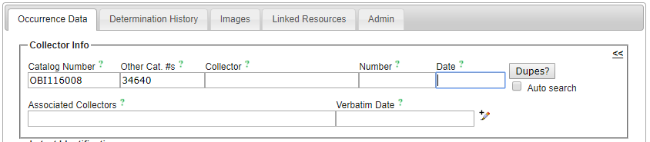
- Type the collector number in the Number field.
  - A collector number is a consecutive number that collectors assign as they collect. This is not the same as the catalog number, barcode number, or accession number.
  - This number will almost always be typed or written on the label rather than stamped onto the herbarium sheet.
  - Collector numbers will occasionally include letters, dashes, or other characters. Enter these as they appear on the label. ***When in doubt, type it out!***
- Type the collection date in the following format: YYYY-MM-DD. For example, if the label says 5 August 2017, the correctly formatted date would be 2017-08-05.
  - For single-digit months and days, include a preceding zero (e.g., 08, 09, 01).
  - If the date does not include a year, month, or date value, enter zeros for that value (e.g., if the label says “August 1987” you would enter 1987-08-00)
- Click the Dupes? button (or, if Auto search is checked, the next step will happen automatically).
  - If you see the “No Dupes Found” message, continue to step 7.
  - If a duplicate is found, a pop-up window will show up. (Make sure that your pop-up blocker is disabled to allow this). Examine the results of this pop-up window.
    - If you see the “Possible Matching Duplicate EVENTS” message, exit out of the window and proceed to step 7.
    - If you see the “Possible EXACT Duplicates” message, look at the record listed in the pop-up window.
Check to see whether the scientific name, collector, date, and general details about the potential duplicate record are the same as those on the label of the specimen you are transcribing. It may help to view the label and the potential duplicate record side-by-side as shown below.
      - If the records are the same, make sure the “Link as Dupes” box is checked in the pop-up window and click “Transfer to Empty Fields Only.” Check that the information imported into the data entry form matches the label exactly and that the data have been imported into the correct fields. You may have to re-type or move information around so it is stored in the correct fields (see step 11).
      - If the records are not the same, double check that you have correctly entered the collector name, number, and date in the original occurrence editor form. If you are sure these values are correct, notify a supervisor that you have found a potential data quality issue. Make sure you record the catalog numbers of the potentially problematic records.

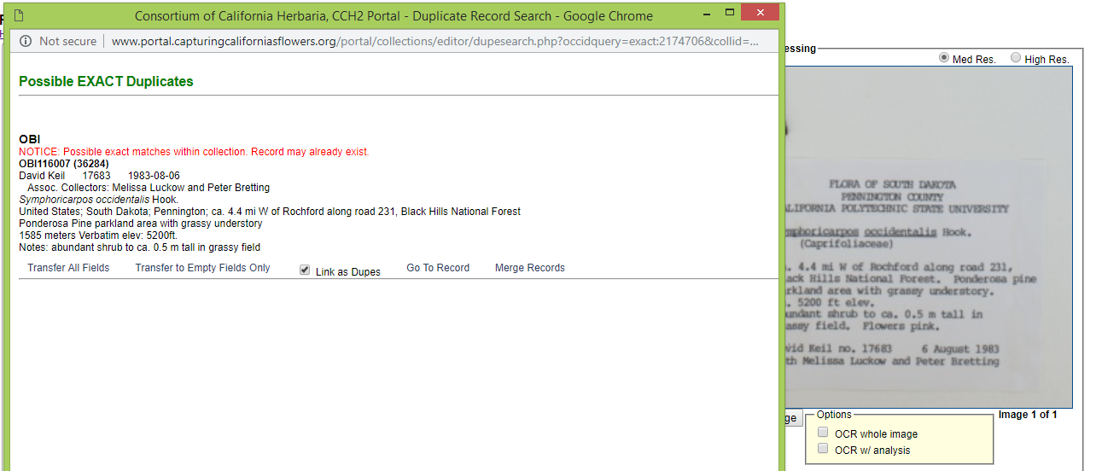

- On the record editor form, enter any collectors other than the primary collector in the Associated Collectors field. Separate names in this field by a comma and do not include words like “with” or “and.”
- Type in the date EXACTLY as it is shown on the label into the Verbatim Date field.
- Begin to type the ORIGINAL scientific name of the specimen into the Scientific Name field. If there are annotations (i.e., a more recent name for the specimen), you will add these in future steps. Once the field begins to auto-populate, select the appropriate scientific name from the dropdown menu.
  - The ORIGINAL scientific name is the one that is on the original label. If there is no scientific name on the original label, leave this field blank.
  - Note that you do not need to enter authorship (e.g., the last names and abbreviations after the genus and specific epithet); these will be auto-populated.
  - You also do not need to enter the family name, since it will also be auto-populated.
- Start typing the Country, State, and County into the appropriate fields and select the appropriate values from the dropdown menus as they appear.
  - Always select from the dropdown menus whenever possible.
  - Enter any reference to the USA as “United States”
  - The State/Province field primarily applies to states or provinces of the United States, Canada, and Mexico. If you are unsure about what to enter here, leave it blank.
- Look at the label to see what further information is provided on the label. The most common fields for which there are label data are described below. See Section 13.4 for examples of specimen labels and how they would be transcribed into CCH2.
  - Locality – geographic description of where the plant was collected
    - This should not include country, state, or county information, since these data are found in alternate fields, unless the locality includes a description of an area within the county or state (e.g., “southwest corner of Jefferson county” or “northeast Arizona”).
    - This field should include directions to the collection location, city names, road names, names of parks, etc.
    - Some habitat information may be included in this field if it would help someone be able to re-locate the specimen’s locality. This information can be entered into this field AND the habitat field.
    - Note that you can check the “Locality Security” box if the locality information should be protected (e.g., protected species location).
  - Verbatim Coordinates – the latitude and longitude for the collection location of the specimen
    - Enter the latitude and longitude coordinates and click the double arrows (<<) .
    - Degree/minutes/seconds lat/longs can be entered by clicking “Tools,” entering Lat/Long in degrees, minutes, seconds boxes, and clicking “Insert Lat/Long Values” to convert to decimal format.
    - If coordinates were provided on the sheet, enter “Coordinates recorded at time of collection” in the Georeference Remarks field.
  - Verbatim Elevation – elevation or altitude of the collection location of the specimen
    - Enter the elevation value and units provided on the specimen label and click the double arrows (<<) to standardize to meters.
  - Habitat – environmental conditions in which the plant was found (e.g., marsh, grassy field, roadside)
  - Substrate – technical definitions given for substrate (e.g., soil type/series or rock formation)
  - Associated Taxa – other plant taxa listed as growing with the collected specimen.
    - Begin to type scientific names into this field and a dropdown list will appear. Make sure to select the appropriate name from this dropdown list.
    - Separate multiple associated taxa with a comma. Once you have placed a comma, the field will “understand” that you are about to type in a new associated taxon and will clear the dropdown menu.
  - Description – information specific to the individual plant (e.g., condition, color)
  - Notes (Occurrence Remarks) – population characteristics (e.g., frequency: rare, common, etc.) and any additional data on the label that does not fit easily into the other data fields.
    - This field can also be used as temporary holder to write notes for records that require further review.
- Once you have filled out the above fields as appropriate, check to see that any additional information is visible on the specimen label.
  - If the specimen is noted to be cultivated or planted, check the Cultivated/Captive box.
  - You do not need to include label headers (e.g., “Flora of California”) or the name of the herbarium.
  - If there are additional notes about the specimen having been collected for a specific study, enter this information in the Notes field.
  - For additional explanations of the Occurrence Data Fields, see Appendix 1.
- Click the Save Edits button or press Enter on your keyboard.

13.3 Transcribing annotation labels
- On the image that you just transcribed, check to see if there are any annotation labels on the specimen (see the example image below)
  - Annotation labels are usually above the specimen label but may be beside the label or elsewhere on the specimen. Make sure you view the full specimen for annotations before you move on.
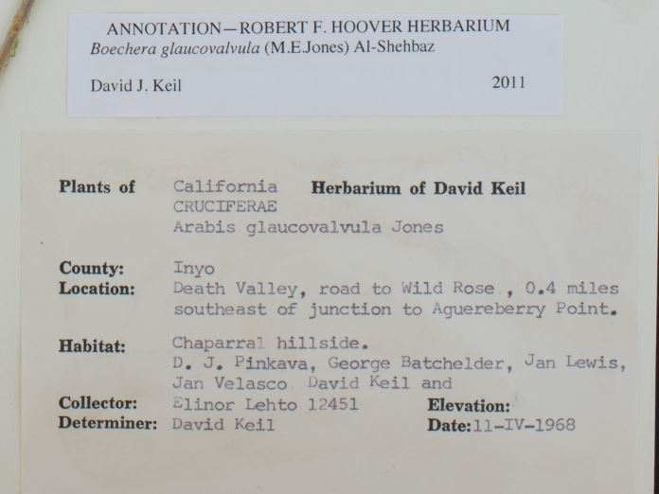
- If there are annotation labels, click the Determination History tab at the top of the occurrence editor form.

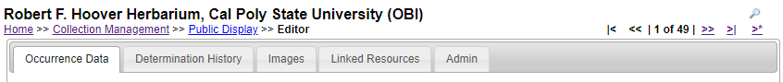
- Start to type the scientific name of the specimen annotation into the Scientific Name field. Select the appropriate scientific name from the dropdown menu once it appears.
  - If there is an identification qualifier (for example: cf., aff., or ?), enter this in the Identification Qualifier field above the Scientific Name field.
- Enter the name of the determiner (the person making the annotation) exactly as it appears on the annotation label into the Determiner field.
- Enter the determination date in the YYYY-MM-DD format in the Date field.
- If any references by which the specimen was identified or other notes occur on the annotation label, enter them in the appropriate fields.
- If this is the most recent annotation, make sure the “Make this the current determination box” is checked. If there are more recent annotations after the annotation you are entering, uncheck this box.
- Click Submit Determination.
- Repeat steps 16-21 for any remaining annotation labels on the specimen.

13.4 Example diagrammed specimen labels
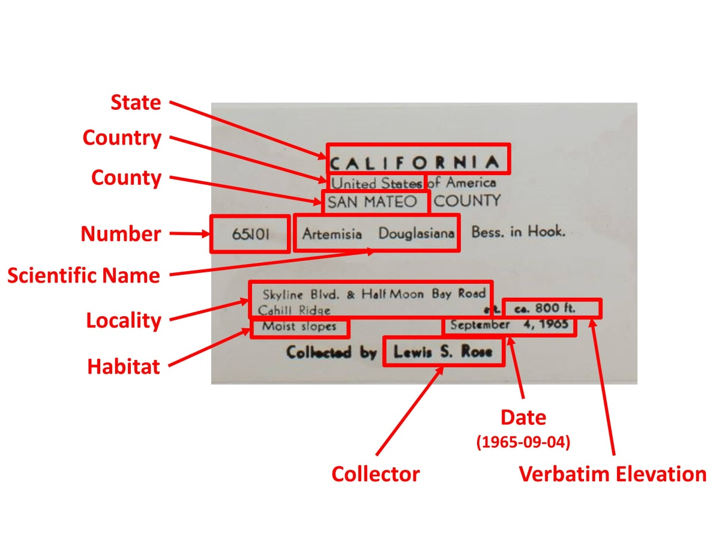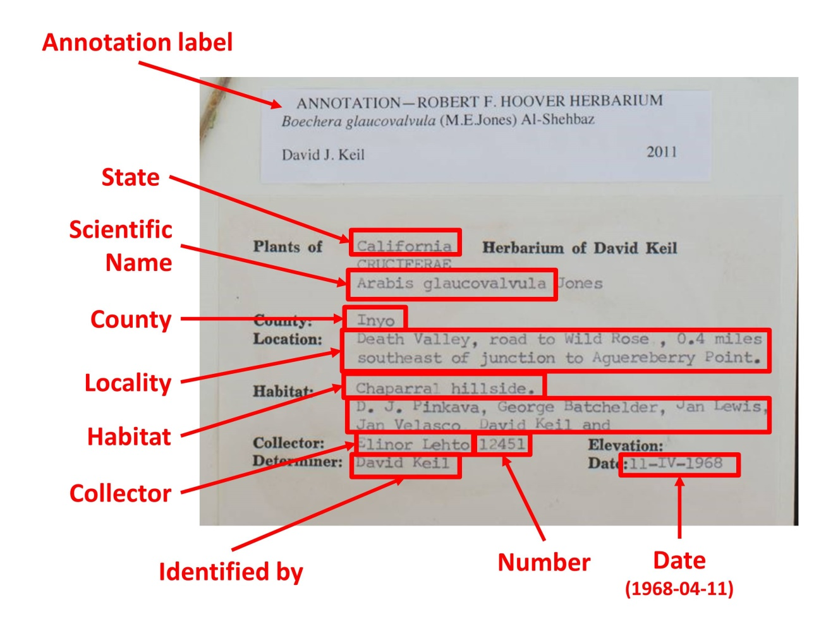
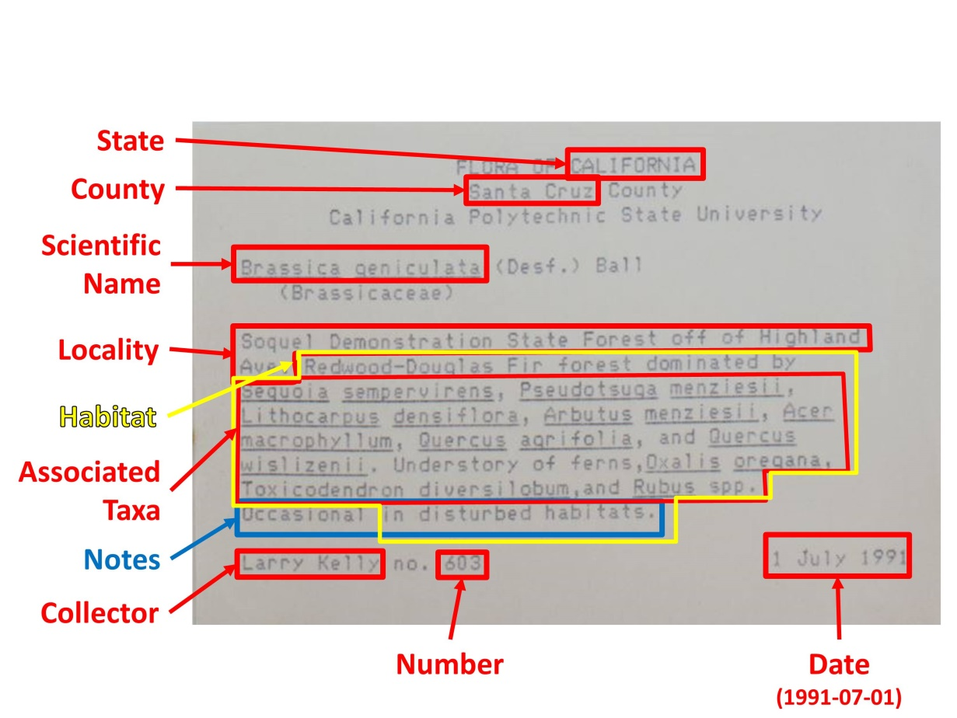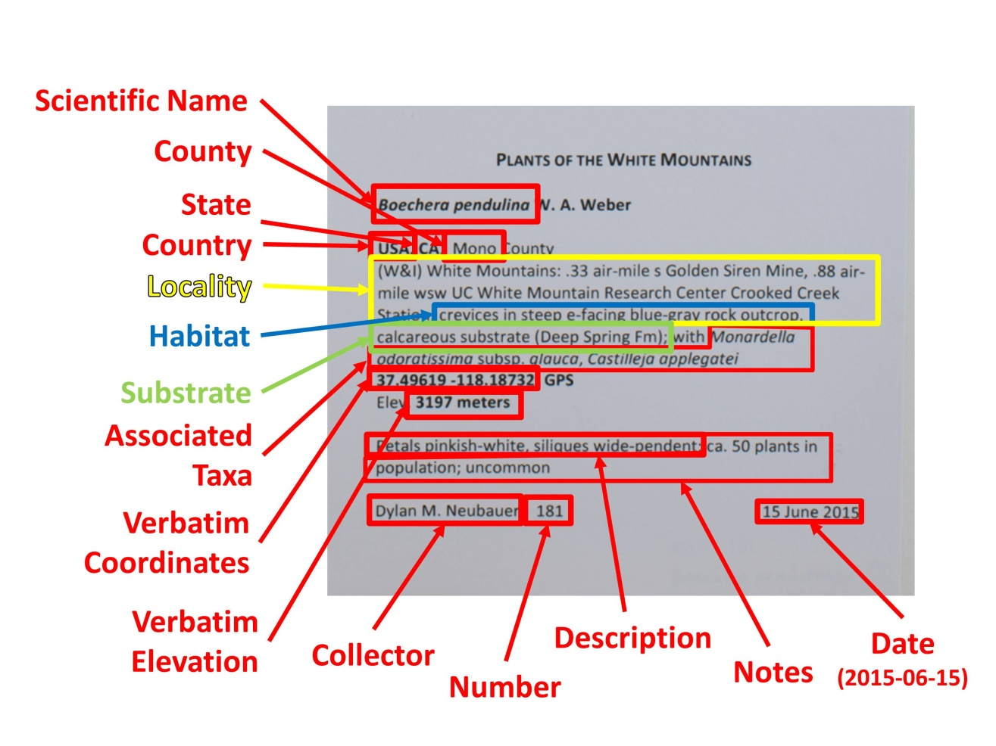

14. Georeferencing Protocol

Goals: This document describes how to georeference specimen records using the GeoLocate instance on the CCH2 portal.

- Log in to your account in the CCH2 portal, click “My Profile,” navigate to the “Specimen Management” tab, and click the name of the institution for which you will be georeferencing.
- In the Data Editor Control Panel, click “Batch Georeference Specimens.”
- In the Query Form box, select the country, state, and county that you wish to focus on and click the “Generate List” button. You will then see a list of results in the box below the Query Form (see screenshot below).
  - If no results are returned, select a new county or state in the Query Form.

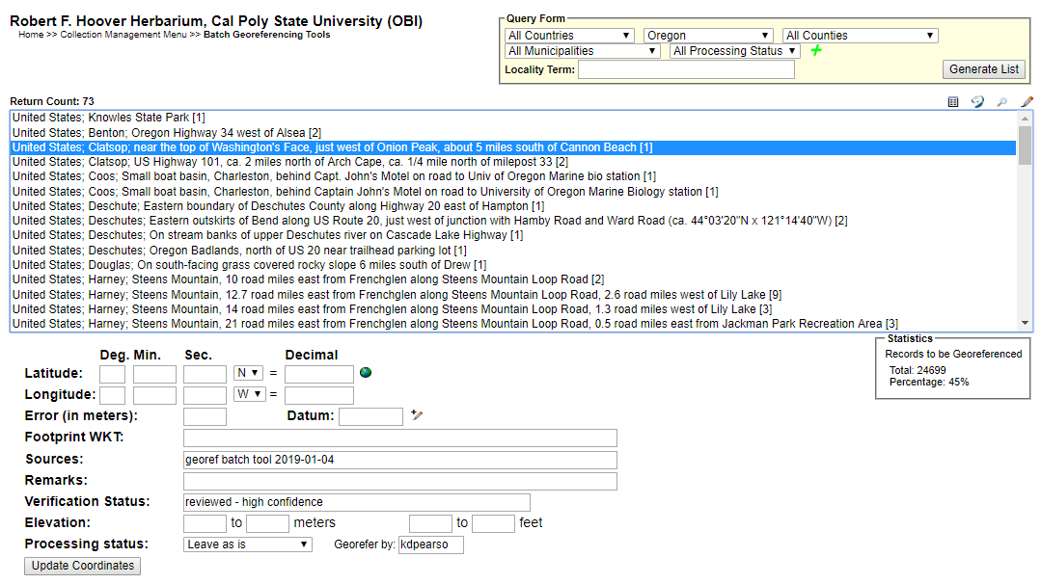
- Select the entry that you want to work on and click the Geolocate () icon at the top right of the search results. This will open a new GeoLocate window (see screenshot on next page) displaying a map and, in some cases, possible location(s) for the specimen that GeoLocate inferred from the text.
  - The green dot is GeoLocate’s best guess for the locality of the specimen. You may also see red dots, which are alternative guesses.
  - To view the reasons why GeoLocate selected these dots, click the “# possible locations found” tab to the right of the Workbench tab. The words in all caps are those that GeoLocate used to infer a location.
- Click the “Options” button on the bottom left of the GeoLocate window and ensure the “Do Uncertainty” box is checked. Close the Georeferencing options window.
- Make sure that all of the boxes (latitude, longitude, uncertainty, and error polygon) near the bottom right of the window are checked.
- If there are dots on the map, investigate whether any of them could be a good starting point for your georeferencing by comparing the dots’ locations on the map to the text in the Locality String (see dashed box in screenshot above). It is possible that none of the dots indicate the correct locality. If this is the case, you can ignore the dots or remove them by clicking the “# possible locations found” tab and clicking the circled ‘x’ to the left of each rejected entry (see below).
  - When deciding whether to use one of the GeoLocate dots, make sure to check that the state and county where the dot has been placed matches the state and county indicated by the record.
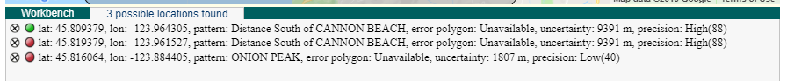
- Either starting with a GeoLocate dot, if appropriate, or from scratch, use the Locality String to determine an approximate location for the specimen. This will likely require searching other references (e.g., Google maps) for location and feature names.
  - You can change the base layer (i.e., the type of map shown in the GeoLocate window) by clicking the plus symbol in the upper right corner of the window (see screenshot on next page).
  - To measure a distance on the map, click the button next to “Measure” and click on a starting point on the map. You can then move your cursor anywhere on the map and a line will be measured between those two points. The length of the line will be shown in green next to the line. To measure between more than one point, click again to anchor another point. To stop measuring, double click on the ending point of your measurement.
  - If there is not enough information in the Locality String to assign an approximate point, view the specimen record by returning to the search results page (see screenshot on page 49) and clicking the pencil icon () on the top right of the search results box. This will bring up the specimen record, where you can see whether there is more locality information in another data field (e.g., habitat) or on the specimen image (if available).
    - If you are still not able to assign an approximate point from this information, scroll down to the bottom of the specimen record until you see the Processing Status field. Select “Expert Required” from the dropdown menu of this field. In the “Notes (Occurrence Remarks)” field above and to the left, enter a brief note in brackets, such as “[Not enough data to georeference]”. Click the “Save Edits” button, close the record, and select a new record to georeference.
- Once you have found an approximate location for the specimen record, click the button next to “Place Marker” and click on the map where you want to place the GeoLocate dot. Follow the guidelines provided in Table 14.1 when deciding where to place the dot.
- Set the error radius and/or create an error polygon to indicate the uncertainty of the specimen’s locality. Follow the guidelines provided in Table 14.1 when deciding how large of an error radius to use for a given dot and whether you should use an error polygon.
  - To edit the size of the error radius, click the green dot on the map and select “Edit Uncertainty” in the pop-up box. Click and drag the grey arrowhead that will appear on the outer rim of the error circle to resize the error radius.
  - To create an error polygon, click the button next to “Create polygon” and click on the map where you want to begin drawing the polygon. A corner of the polygon will be created time you click on the map. To finish the polygon, double click. Once you have completed the polygon, click the green dot again and select “Resize uncertainty to polygon.”
    - To redo a polygon, click the “Clear Polygon” button to the right of the “Options” button.
  - Make sure to note any uncertainty you experienced when setting the error radius. For example, if you were georeferencing a named place that did not have clear boundaries, explain how you determined a suitable error radius by putting a note in the Remarks field on the search results page where you first selected your specimen record (indicated by the arrow below).
- When you are confident in your GeoLocate point and error radius, click the “Save To Your Application” button at the bottom of the GeoLocate window. You will be taken back to the search results page where you first selected your specimen record (see screenshot on page 49).
  - The coordinates and error will now show up below the search results in the appropriate Latitude, Longitude, and Error fields. If you created an error polygon, its coordinates will be listed in the Footprint WKT field.
- Click the “Update Coordinates” button at the bottom of the page.
- Select a new record or set of records to georeference from the search results list and repeat steps 7-13.

Table 14.1 Guidelines for georeferencing from different types of locality information. Adapted from Wieczorek et al. 2012 “Georeferencing Quick Reference Guide” (http://manisnet.org/GeoreferencingQuickReferenceGuide.pdf)
Locality type | Example | How to place coordinates | How to measure error radius/polygon
Bounded area: locality refers to a geographic feature with discernible spatial boundaries | “Las Vegas”  “Puerto Madryn”  “San Fernando” | Estimate the geographic center of the boundaries of the named place | Measure the distance from the center of the named place to the border of the named place farthest from the center
Undefined area: locality refers to a geographic feature that does not have a clear spatial boundary | “Hoosier Pass”  “Hills south of Los Osos” | Determine the coordinates for the named place as well as possible using visual evidence near the label for the named place on the map | Use half the measured distance from the selected coordinates to the center of the nearest named place.  Make note of the named place that you measured to in the “Remarks” field on the search results page.
Street address | “1 Orchard Lane, Berkeley, CA”  “319 Stadium Dr., Tallahassee, FL” | Locate the address on, e.g., Google maps, and find this location on the map in GeoLocate. | Use half the measured distance from the selected coordinates to the location of an address on either side of the given address. If the next address is too difficult to determine, use half the distance from the coordinates of the address to the further end of the block on which it sits.
Junction, intersection, crossing | “junction of Coora Rd. and E Siparia Rd.”, “bridge over Willamette River”, “interscn of CA 166 and 399” | Use the coordinates of the center of the intersection. | Use satellite or aerial images to find the extent of the intersection by measuring the distance from the center to the furthest part of it. If this is not possible, use the number of lanes of the larger of the two roads and multiply by 4 meters.
River, stream, road, path | “Sacramento River”, “Los Osos Valley Road”, “Rio Parana” | Make a straight line between the two points on the geographic feature that are most removed from each other, yet still within the administrative boundaries (e.g., county) specified in the locality description. Choose the point on the feature nearest to the midpoint of the line. | Use one of the ends of the straight line that you made between the two points on the geographic feature that are most removed from each other, yet still within the specified administrative boundaries.
Locality type | Example | How to place coordinates | How to measure error radius/polygon
Mouth or headwaters of a river, confluence of waterways, trailhead | “headwaters of the Missouri River”, “Triangle Lake trailhead” | For a river mouth or confluence of waterways, select the midpoint of the line connecting the opposite shores where the waterways meet. For a river source, select the point of highest elevation on the river or create a boundary around the multiple streams contributing to the river and find the geographic center of that bounded area. For a trailhead, select the point where the trail begins. | For a river mouth or confluence of waterways, use the distance from the chosen point to the shore. For a single river source or trailhead, use 10 m.
Near a named place | “vicinity of Mt. Hood”, “near the Hoover Dam” | Determine the coordinates as either a Bounded area or Undefined area, as appropriate. | Determine the distance as either a Bounded area or Undefined area, as appropriate.
Between two places | “between Atascadero and San Luis Obispo” | Use the midpoint between the centers of the two named places | Use half the distance between the centers of both named places
Direction only, no distance | “N of Berkeley”, “SW of Gainesville” | Use the midpoint between the centers of the specified named place and the nearest named place, where the nearest named place to use is in the specified direction. The nearest named place should be, for the first example, the nearest named place somewhere between NW and NE of Berkeley | Use half the distance between the centers of both named places
Specified distance in unnamed direction | “5 km outside Calgary”, “2 miles from Morro Bay” | Determine the coordinates as either a Bounded Area or Undefined Area, as appropriate. | The length of the radius should be the same as the distance given in the locality description
Specified distance in a direction, no path given | “50 miles W of Las Vegas”, “30 km E of Sacramento” | Find the center of the named place and measure the provided distance in the direction provided in the locality description. | Use half the measured distance from the selected coordinates to the center of the nearest named place.  Make note of the named place that you measured to in the “Remarks” field on the search results page.
Locality type | Example | How to place coordinates | How to measure error radius/polygon
Specified distance in a direction, path given | “7.9 mi N Beatty, on US 95”, “7 mi. W Santa Barbara on 101”, “left bank of Mississippi River, 16 mi downstream from Paris” | Find the geographic center of the named place as either a Bounded area or Undefined area, as appropriate. Use the measuring tool to follow the specified route for the given distance. Use the end point as the coordinates. | Use half the measured distance from the selected coordinates to the center of the nearest named place.  Make note of the named place that you measured to in the “Remarks” field on the search results page.

15. Phenological Scoring Protocol
UNDER CONSTRUCTION

16. CCH2 Portal Guide

16.1 Navigating the CCH2 portal website

The portal can be accessed at www.portal.capturingcaliforniasflowers.org.

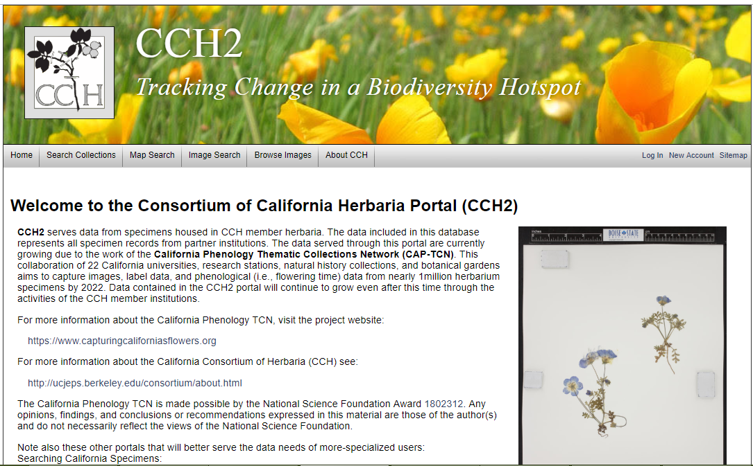

From the homepage (shown above), you can search collections and view data and images, even if you do not have an account in the portal, by clicking the “Search Collections” tab in the toolbar at the top left side of the page. The “Map Search” tab can be used to search specimens within a certain geographic area. The “Image Search” and “Browse Images” tabs can be used to locate images of certain taxa.
When using the “Search Collections” tool, you will be prompted to select the collections within which the search will be conducted. Check or uncheck the desired boxes on this page, click “Search >”, and enter the remaining search parameters (e.g., the scientific name of the desired specimen) in the appropriate boxes. You can display the results in a list, which will show most specimen data and image thumbnails, by clicking “List Display” to conduct the search, or you can display the results in a table by clicking “Table Display.”
To create or use your user account, edit or add specimen data, or use other Symbiota tools, log in at the right side of the toolbar (see Sections 16.2 and 16.3).

For a video tutorial of the basic uses of a Symbiota-based portal, visit the SCAN TCN website below. Note that the SCAN portal is not identical to the CCH2 portal, but the layout will be similar
http://www.lep-net.org/?page_id=403

16.2 Creating a new user
Users must create their own accounts by clicking “New Account” near the top right side of the portal website. They will be prompted to provide a login name, password, and contact information. When creating an account, make sure to record your login name and password in a safe place for future reference. These can be recovered via email if necessary. Once you have finished entering the required information, click the box next to “I am not a robot” and click “Create Login.”
A new user will not be able to manage collection data until they are granted appropriate permissions (see Section 16.4).

16.3 Managing your profile and collection(s)
To manage your collection(s), click “My Profile” at the top right corner of the portal homepage. You will see a page like the one below.
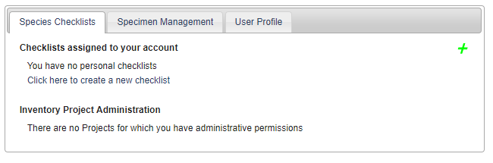
The “Species Checklists” tab allows you to create and share personal species checklists for research, education, or other uses. Species in the checklist can be linked to voucher specimens, enabling you to download custom checklists of specimens for the species on your list. This function will not be described in detail in this guide.
The “Specimen Management” tab is where you will manage your specimen data. Upon clicking this tab, you will see a “Collection Management” box. If you have administrative or data editing permissions for a collection, the name of the collection will be listed in this box. If you do not see your collection listed in this box and you know who the administrator(s) for the collection is(are), contact them directly so they can grant you appropriate permissions. If you do not know an administrator for the collection or you believe you are the administrator, contact Katie (kdpearso@calpoly.edu) for assistance.
Depending on your administrative permissions, when you click on name of your collection in the “Collection Management” box you will see one, both, or neither of the following control panels.

16.3.1 Data Editor Control Panel
The Data Editor Control Panel is used to add and edit specimen records. Data editing permissions can be granted to a portal user without that user receiving full administrative permissions (see Section 16.4). The Data Editor Control Panel can be accessed by logging in to the portal, clicking “My Profile,” and clicking the “Specimen Management” tab. Each of the tools in this panel is briefly described on the following page.
Add New Occurrence Record – This tool is used to create new specimen records from label data. See Section 16.5 for instructions.
Create New Records Using Image – This tool is used to create new specimen records by uploading an image then entering specimen data. This tool will not be used for the CAP TCN and therefore will not be described in this guide.
Add Skeletal Records – This tool is used to quickly create specimen records with minimal information, usually during the process of imaging. These records provide “skeletal” data that can be filled in during later transcription steps by, e.g., technicians or citizen scientists. See Section 16.8 for instructions.
Edit Existing Occurrence Records – This tool is used to add or edit data of records that already exist in the portal. See Section 16.7 for instructions.
Add Batch Determinations/Nomenclatural Adjustments – This tool can be used to add determination/annotation information and/or change the scientific name of a number of specimens all at once. The user can define whether the change is due to a new determination (i.e., identification and annotation by a taxonomic expert) or adjusted nomenclature for the taxon based on taxonomic research. See Section 16.10 for instructions.
Print Labels/Annotations – This tool can be used to print specimen labels or barcodes for records with data entered in the portal. It allows collectors to enter their collection data directly into the portal and print pre-formatted labels rather than requiring collectors to type and format labels only to have technicians re-type label data later in the process. The tool also allows collection managers or determiners to print pre-formatted annotation labels after entering determination data via the “Add Batch Determinations/Nomenclatural Adjustments” tool. The labels can be printed from the browser, downloaded as a CSV file, or downloaded as a Word file. See Section 16.11 for instructions.
Batch Georeference Specimens - This tool can be used to update the geographic coordinates of a number of specimens all at once. This function will be described in a later version of this guide.
Loan Management – This tool can be used to keep track of outgoing and incoming loans, gifts, and exchanges of specimens using the appropriate tab on the Loan Management Main Menu. See Section 16.12 for instructions.

16.3.2 Administration Control Panel
The Administration Control Panel is used to perform higher-level data processing and is thus only available to users with administrative permissions (see Section 16.4). It can be accessed by logging in to the portal, clicking “My Profile,” and clicking the “Specimen Management” tab. The tools available in the Administration Control Panel are described in the following pages.

View Posted Comments – Portal users can post comments on the records of individual specimens if, for example, they notice a typographic error or mis-associated image, or if they suspect a taxon is misidentified. With this tool, the administrator can view the posted comments, mark them as reviewed, hide them from public viewing, or delete them by clicking the appropriate button.
Edit Metadata and Contact Information – This navigates to the “Edit Collection Information” page where you can change your institution name, description, contact information (contact person, email address, etc.), homepage, license, GUID source, or other information.
Manage Permissions – This tool can be used to manage which users have which permissions. See Section 16.4 for instructions.
Import/Update Specimen Records – This tool allows the user to batch add or update specimen records using one of many sources types including a CSV file, Notes from Nature transcriptions, DarwinCore archives, and others. See Section 16.9 for instructions.
Processing Toolbox – This link navigates to a set of tools for processing specimens (see tabs below). These functions will not be described in detail in this guide.
Darwin Core Archive Publishing – This tool allows the user to publish occurrence data to a collection by uploading a Darwin Core Archive. See Section 16.9 for instructions.
Review/Verify Occurrence Edits – This tool can be used by the administrator to review edits to specimen records that have been made by other users. The administrator can select the edits he/she wishes to accept or reject, click either the “apply edits” or “revert edits” bubble, respectively, and click “Update Selected Records” to apply the approval/rejection.
View Access Statistics – This tool allows the administrator to view use of specimens in their collection. The results can be viewed as a summary count or full records, and the results can be filtered according to the access type of date of access.
Duplicate Clustering – This tool allows the user to view and evaluate potential duplicate specimens housed at other institutions by matching specimens with the same collector, collector number, and collection date. The user can view all duplicate specimens or just duplicate specimens with conflicting identifications.
General Maintenance Tasks
Data Cleaning Tools – Available tools include a duplicate record identification tool for discovering accidental duplicate catalog numbers; a political geography tool to help fix and standardize country, state/province, and county designations; and a taxonomy tool that aids in locating and fixing taxonomic errors and inconsistencies (see Section 16.7.3 for instructions on the latter).
Download Backup Data File – This tool allows the user to download a copy of all collection data besides images. This file can be used for archiving or as a backup before making batch edits to the collection.
Restore Backup File – If systematic errors in the collection have been discovered, likely resulting from an erroneous batch editing process, the collection data can be reset to a previous “version” of the data using this tool, provided the user has previously downloaded a backup data file, preferably shortly before the erroneous batch process.
Thumbnail Maintenance – This tool will build thumbnail images based on the specimen images
Update Statistics – Click this link to update collection statistics such as specimen counts and to update null fields (e.g., scientific name fields for specimens that were only identified to family) within the collection.

16.4 Managing user permissions
Non-users may freely access specimen records and images. All users may comment on specimen records. However, only users who have been granted data editing or administrative permissions may edit specimen records and images. There are three levels of permissions:
- Data editor: Users with these permissions will be able to add and edit occurrence records, add batch nomenclatural adjustments, print labels or annotations, batch georeference specimens, or use the “loan management” tool. These users will NOT be able to delete records once they are created. Student workers, interns, and other data entry personnel should be granted this level of permission.
- Administrator: Users with these permissions have all data editing permissions and can access all the tools in the Administration Control Panel (see Section 16.3.2).
- Rare Species Reader: Users with these permissions have no data editing or administrative capabilities. However, they are able to view locality information for rare and protected species, which is normally redacted for non-users and users lacking these or data editor/administrator permissions.
To view and edit user permissions for your collection(s), navigate to your Administration Control Panel (see Section 16.3) and click “Manage User Permissions.”
To add permissions for an existing user, navigate to the “Add a User” box at the bottom of the page (shown on next page). Select the desired user from the drop-down menu, click the bubble next to the appropriate level of permissions you wish to grant to this user, and click the “Add Permissions for User” button.
To remove permissions from an existing user, find the user’s name within the box that corresponds to their current level of permissions and click the red x () to the right of the name. A dialogue box will pop up to ask you whether you are sure of your choice. If you are, click OK.
To change the permissions of an existing user from one level to another, follow the above instructions to first remove their current permissions, then follow the instructions to add the new permissions for the user. It is also possible to add multiple different levels of permissions to the same user, but because this would be redundant, it is recommended to remove the user from one list and add them to the other as described here.
For a video on this topic created by the LepNet TCN, visit their website below. Note that the SCAN portal is not identical to the CCH2 portal, but will be similar in format.
http://www.lep-net.org/?page_id=403

16.5 Adding specimen records
New specimen records can be added by navigating to Add New Occurrence Record or Add Skeletal Records in Data Editor Control Panel (see Section 16.3). For the CAP TCN, we will mostly be adding new records using the Add Skeletal Records tool (see Section 16.8). However, if you need to add a record and all or most of its associated data, you should use the Add New Occurrence Record option. See Section 16.7 for an explanation on how to use the Record Editor tool and its data fields.

16.6 Searching and sorting specimen records
(adapted from Skema & Barber 2018)
The Record Search Form in the portal provides the means to search and sort your entire collection. Access the form by navigating to your collection management page (see Section 16.3), then click “Edit Existing Occurrence Records” in the “Data Editor Control Panel.” You will see a screen like that shown below:
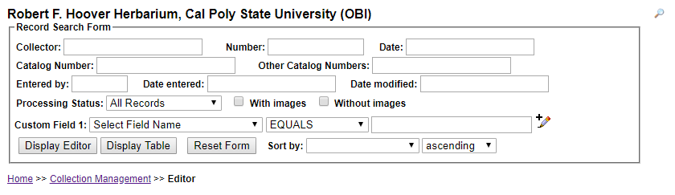
You can enter a search term in any field shown. Hover over a field to see particular instructions for how to best enter search terms for that field (e.g., must enter space before and after dash when entering a range into catalog number). To search using any data field not shown on the form, select a field from the dropdown menu next to “Custom Field 1,” select a modifier from the dropdown menu next to it, and enter the search term in the last box to the right on that line. You may add additional custom fields by clicking on the pencil with the plus sign () at the end of the line for Custom Field 1. You can search for records using as many fields as you wish.

NOTE
A straight search term returns only exact matches. For example, if you enter “Edgar T. Wherry” in the “Collector” field, you will only be returned those records with the exact same spelling, spacing, and punctuation as your entry. Use a percent sign (%) to loosen the search parameters. This acts as a ‘contains’ statement. For example, entering “%Wherry” will return any collector name with Wherry in it (e.g., Edgar T. Wherry, E.T. Wherry, Edgar T Wherry, Amelia Wherry Spencer). Searching with percent signs can also be a good way to find spelling errors in your collection’s data.

To sort the results of your search, use the “Sort by:” field in the lower right corner. For example, if you select “Date Last Modified” from the Sort by drop down, then select “descending” from the drop down menu next to it, you will be returned a table of all records in order of when they were modified from most recent to least recent.
You can view the results of your search by clicking “Display Editor” or “Display Table.” If you click “Display Editor,” you will see the editing window (see Section 16.7) for the first record that matches your search, and the other records that match your search can be viewed by clicking the arrows to the top right of the form (circled in black below). If you click “Display Table,” the results of your search will be displayed as a table that includes most data fields available for these records.

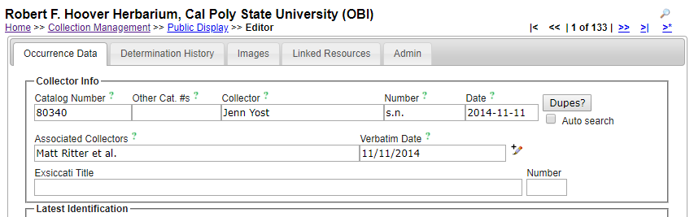

NOTE
To change the parameters of your search, sort the results by different criteria, change the results display, or perform a new search, click the magnifying glass icon () at the top right corner of the page (see arrow above).

16.7 Editing existing specimen records
(adapted from Skema & Barber, 2018)
- Log in to the CCH2 Portal and navigate to the Data Editor Control Panel by clicking “My Profile,” the “Specimen Management” tab, then the name of your collection in the “Collection Management” box.
- Under “Data Editor Control Panel,” click “Edit Existing Occurrence Records.” Click “Display Table” to get a table of every record in your collection OR search for a specific record using by entering search terms in the appropriate fields (see Section 16.6 for help with searching and sorting specimen records).
- To access a record, click on its Symbiota ID in the far left column, which will take you to the Record Editor page, seen on page 64. See Section 16.7.1 for an explanation of the tabs on the Record Editor page, and see Section 16.7.2 for an explanation of the relevant fields in the “Occurrence Data” tab. You can click on the green question mark next to any field to get further explanation of its use.
- Edit a record by changing, adding, or removing data from the fields in the “Occurrence Data” tab. Once record editing is complete, change the processing status as appropriate, and save the work by clicking on “Save Edits” button at base of Occurrence Data tab in Record Editor or by hitting ‘Enter’ once or twice on your keyboard, depending on the browser and/or operating system.

NOTE
If an image of the specimen is available, you can view it to help edit the record. To increase the specimen image size, hover over any outer boundary of the image until you see an arrow and drag to the desired size. To zoom in on one area of the image, hold down the Ctrl key (Cmd on Mac) and click on an area of interest. Alternatively, you can hold down the Shift key, left click, and drag the cursor up. To zoom out, do the same but drag down.

16.7.1 Explanation of Record Editor tabs
Upon opening the Record Editor page, you will see 4-6 tabs, depending on your level of permissions. The image shown below is of the Record Editor page for a user with administrative permissions. A brief explanation of each tab is provided below.
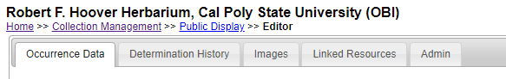
Occurrence Data – See explanation of fields in Section 16.7.2.
Determination History – where annotations are shown and can be entered. Annotations can also be batch uploaded from separate files. See Section 16.10 for instructions for using this tool.
Images – provides information on image(s) associated with the record. An image can be deleted here, if need be. To do this, click the pencil icon for the relevant image. Under “Delete Image,” click the box for “Remove image from server,” then click the “Delete Image” button.
Linked Resources – allows linkage of checklists, duplicates, and genetic resources to the record
Admin – tracks changes made to Edit History, allows for transfers of specimens between collections, and provides a means for deleting an occurrence record. Only users with administrative permissions (see Section 16.4) can delete specimen records.

16.7.2 Explanation of Occurrence Data fields
(adapted from Skema & Barber 2018)
The major fields of interest are described in the following two pages. In the portal, you can click on the green question mark next to any field to get further explanation of the use of that field. For further explanation of all fields, visit http://symbiota.org/docs/data-entry-guides-for-openherbarium/.
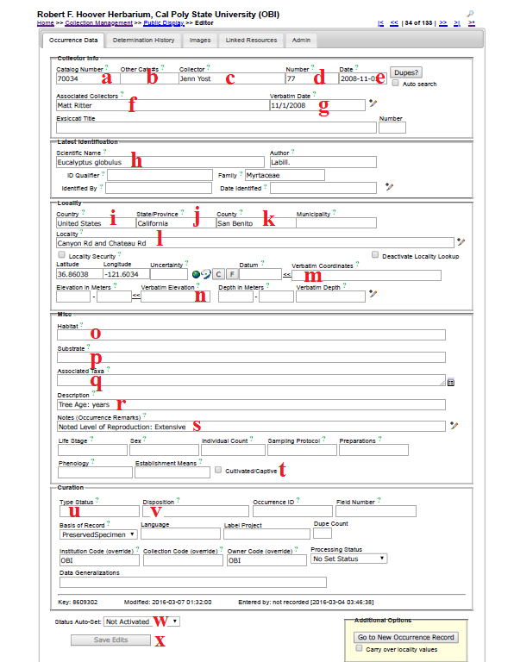
- Catalog Number – the barcode number (and institution code, if included on the barcode label) on the specimen (e.g., OBI00045897)
- Other Catalog #s – the accession number of the specimen, if applicable. If your institution already had data in NANSH or the Consortium of California Herbaria, this may have previously been the number in the Catalog Number field.
- Collector – primary or only collector. The name should be in order of “First name Last name”. On a specimen, this is often the name that follows “col.”, “leg.”, and “legit.” If no collector is present, “Unknown” should be entered in lieu of other institutional standards.
- Number – collector number. If no number is present, “s.n.” (sine numero is Latin for ‘without number’) should be entered in lieu of other institutional standards. If letters or symbols are included in the collector number on the label (e.g., KP-004), they should be included.
- Date – when the specimen was collected in the format YYYY-MM-DD. Institutional standards should be followed for entering 0s when a day or month is omitted, or if a range of dates are listed. See also “Verbatim Date” (g).
- Associated Collectors – collectors following the primary collector. Each name should be in order of “First name Last name.” Multiple names should be separated by a semicolon (;).
- Verbatim Date – date as it appears, verbatim, on the label (e.g., July 21st, 2016). This is particularly useful if part of the date is omitted, the date is in another language, or if a range is listed.
- Scientific Name – the scientific name of the specimen. When populating this field, be sure to select an option from the dropdown list rather than typing out the name. If the specimen is filed under a different name than the name on the specimen, this information should be noted in the Notes field (e.g., “filed under...”) in lieu of other institutional standards.
- Country – the country in which the specimen was collected. If the specimen was collected in the U.S., “United States” should be entered in this field.
- State/Province – the state (or parish, in Louisiana) in which the specimen was collected, if in the U.S., or the province if the specimen was collected in Canada. The state/province name should be entered as a full name rather than an abbreviation (e.g., “California” instead of “CA”).
- County – the county in which the specimen was collected. County designations (e.g., “Co.” or “County”) should not be included in this field. This value should be selected from the dropdown list.
- Locality – geographic description of where plant was collected. This should not include country, state, or county information, since these data are found in alternate fields, unless the locality includes a description of an area within the county or state (e.g., “southwest corner of Jefferson county” or “northeast Arizona”). This field should include directions to the collection location, city names, road names, names of parks, etc. Note that you can check the “Locality Security” box if the locality information should be protected (e.g., protected species location).
- Verbatim Coordinates – If latitude and longitude are provided on the sheet, they should be entered in this field and standardized by clicking << . Degree/minutes/seconds lat/longs can be entered by clicking “Tools,” entering Lat/Long in degrees, minutes, seconds boxes, and clicking “Insert Lat/Long Values” to convert to decimal. If coordinates were provided on the sheet, “Coordinates recorded at time of collection” should be entered in the Georeference Remarks field.
- Elevation in Meters – if elevation in meters is provided on the sheet, it should be entered in this field. If provided in other unit, e.g., feet, the value can be entered into the “Verbatim Elevation” field with its unit and converted to metric by clicking the << .
- Habitat – environmental conditions in which the plant was found (e.g., marsh, grassy field)
- Substrate – technical definitions given for substrate, e.g., soil type/series or rock formation
- Associated Taxa – other plant taxa listed as growing with the collected specimen. To promote standardization and easy entry into this field, a dropdown list of scientific names in the portal’s taxon table can be accessed by clicking the small table icon on the small table icon to the right of the data field.
- Description – information specific to the individual plant (e.g., condition, color)
- Notes (Occurrence Remarks) – population characteristics (e.g., frequency: rare, common, etc.) and any additional data on the label that does not fit easily into the other data fields. This field can also be used as temporary holder to write notes for specimens that require further review.
- Cultivated/Captive Checkbox – this should be checked if the label indicates that the sample was from a cultivated plant
- Type Status – the type status (e.g., holotype, isotype) of the specimen. This field should only contain data if the specimen is a type
- Disposition – the location of the specimen in the herbarium or on loan. This field is especially useful if the specimen is being used for a display, research project, or education use, or if the specimen has two different species on it (i.e., it can only be filed with one of the species).
- Processing Status – this field is used to indicate the record’s stage in the quality control workflow (see Appendix 1: Processing Status for instructions)
- Save Edits – click to save record. If the button is unclickable, click anywhere on screen outside of a field, then click “Save Edits” button again.

16.7.3 Batch editing specimen records
(adapted from Skema & Barber 2018)

NOTE: Caution!
Exercise caution when using this tool. Technicians are not advised to perform batch edits. We also recommend downloading a copy of your database (see Download Backup Data File, Section 16.3.2) prior to making batch edits

For batch editing of scientific names, see Section 16.7.3.

- There are two options for batch editing specimen records: you can change a value for the entire set of records in your collection or change a value for a selected set of records. To change all records, click on “Display Table” in the Record Search Form (see Section 16.6), then click the edit icon () above the resulting table of all records from your collection. Continue to step 3.
- To change a value for a selected set of records, first search for the records of interest using the search form (see Section 16.6). Once you have the set of records to which you would like to make a batch edit, click on the edit icon () at the top of your selected table of records.
- From the dropdown menu next to “Field Name” in Batch Update, select the field you want to edit.
- In “Current Value:” enter the text that is presently in the field you want to edit.
- In “New Value:” enter the text that you want to be in the edited field.
- Choose if you want to match the whole field or just match any part.
- Click “Batch Update Field” to enact your batch edit. A pop-up screen will tell you the number of records to be updated, warn you that the replace operation cannot be undone, and prompt you to OK the update. Proceed with caution and see examples below.

NOTE: Caution!
It is easy to inadvertently change text you did not intend to change. Generally, the more specific your “Current Value:” text, the less likely you are to run into unintended consequences. If possible, get an estimate from your record table of how many records should be affected, and check that against the number of records cited in the warning. If the numbers do not match, rethink your strategy.
It is not possible to check the record count when sorting by “Modified By” first. Doing so returns a count of the number of fields edited by the “Modified By” user for all records to be affected, rather than the number of records to be affected.

Examples
Example of a good use of batch edit: Standardizing plant collector names. If you are standardizing all Wherry’s collections to “Edgar T. Wherry,” then you could enter “E. T. Wherry” in Current Value and “Edgar T. Wherry” in New Value in batch edit for the collector field name, and update. Repeat for alternate forms of this name (e.g., “E T Wherry,” Edgar T Wherry”).
Example of a bad use of batch edit: Changing cardinal directions. For example, if you entered “n.” in Current Value and “N” in New Value in batch edit for the locality in an attempt to change lower case abbreviated instances of the cardinal direction north, you would accomplish that, but you would also change any other character string with “n.” such as a sentence ending in the letter n. This would result in batch misplacements of “N” where “n.” should be. For example, “Next to the station. East side” would be transformed into “Next to the statioN East side.”

16.7.4 Batch editing scientific names
(adapted from Skema & Barber 2018)
There are two options for batch editing scientific names, each appropriate for different situations.
- Taxonomic cleaning tools are one way to change scientific names. To use these, click on “Data Cleaning Tools” in your Administration Control Panel (see Section 16.3.2). Scroll down to the Taxonomy section and click “Analyze taxonomic names.” Select the desired resource by checking the box next to it (Catalog of Life, Tropicos, or both). Leave “Names Processed per Run” at 20 and leave “Start Index” blank. Select the radio dial next to “Semi-Manual” and then click “Analyze Taxonomic Names.” Carefully look through the list. When you find a suggested name that is correct, click “remap to this taxon.” These tools may be useful if you have scientific names that are misspelled.
- The nomenclature adjustment tool may be useful if the names are spelled correctly but are otherwise incorrect or outdated. To use it, click “Add Batch Determinations/Nomenclatural Adjustments” in your Administration Control Panel. See Section 16.10 for instructions on how to use this tool.

16.8 Adding skeletal records
(adapted from the instructions available on the portal)
The Add Skeletal Records feature allows quick addition of new specimen records to the database while recording minimal specimen information.
To add a skeletal record, navigate to the Add Skeletal Records tool via the Data Editor Control Panel (see Section 16.3.1). You will see a page like that shown on the next page.

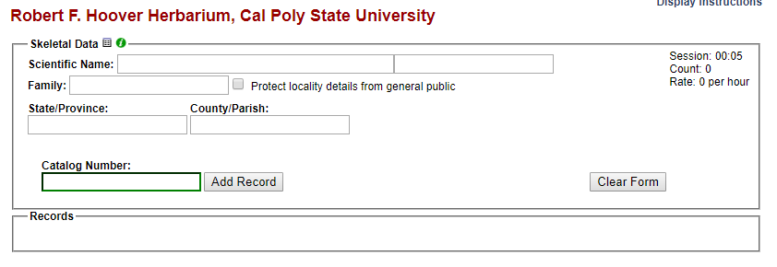

To control which fields are shown on the skeletal record entry form, click the Display Option symbol (a small, grey table) located above the Scientific Name field (circled above). In the dropdown menu of options, check or uncheck the boxes next to the desired fields to be shown. We recommend including Scientific Name, Family, State/Province, and County/Parish. The options menu will also allow you to change the preferred action when a record already exists for a catalog number. We recommend using the “Restrict entry if record exists” option for the CAP TCN project. Even if you choose the “Append values to existing records” option, skeletal data will still not copy over existing field values.
If using the fields recommended above, enter the scientific name by beginning to type the name from the specimen label, then selecting the appropriate name from the dropdown list. If desired and/or possible (given the data provided on the specimen sheet), enter the State/Province and the County/Parish of the specimen if the specimen was collected in the U.S. or Canada. The authorship and family of the name of the taxon will automatically populate if the taxon is in the portal’s taxon table. Enter the barcode number into the Catalog Number field by clicking inside the field and scanning the barcode of the specimen. Once all fields are filled, click Add Record.
Notice that the length of the imaging session, total count of specimens, and rate of specimen addition (in units of records per hour) are visible in the top right corner of the Skeletal Data box. This can be helpful when assessing the efficiency of alternative workflows.

NOTE: Caution!
The data entered in the Skeletal Data box fields will not be cleared after the addition of each record. Make sure you pay attention while adding skeletal records so that incorrect data is not entered.

16.9 Importing record data
For the most part in the CAP TCN project, the project management team (primarily Jason Alexander, Katie Pearson, and Ed Gilbert) will assist you with importing batches of record data into your collection. Nevertheless, these instructions are provided here to guide you through this process should you need to add additional large sets of specimen records (e.g., specimen data from a recent collecting expedition).
There are a number of ways to import data into the portal discussed here:
http://symbiota.org/docs/specimen-search-engine/interoperability-of-specimen-data/
and here:
http://symbiota.org/docs/specimen-upload-procedure-2/
In this section, we will discuss one of the simplest methods of uploading specimen data: importing a comma-separated value (CSV) file. CSV files can be created by using the Save As function in Microsoft Excel or another spreadsheet program and changing the saved file type. A CSV file uploaded to the portal needs only to include a column for catalog number (i.e., barcode number) and can include any number of additional fields, each as its own column in the CSV file.
To batch upload specimen data as a CSV file, navigate to the Import/Update Specimen Records tool in the Administration Control Panel (see Section 16.3.2). Click “Full Text File Import.” On the resulting page, click the “Choose File” button and navigate to the desired CSV file. Click “Open.” Make sure the “Automap Fields” box is checked, and click “Analyze File” button. You will then be taken to page that will look similar to the one shown below. The length and contents of the Source Field/Target Field table will depend on what columns were included in the original CSV file.

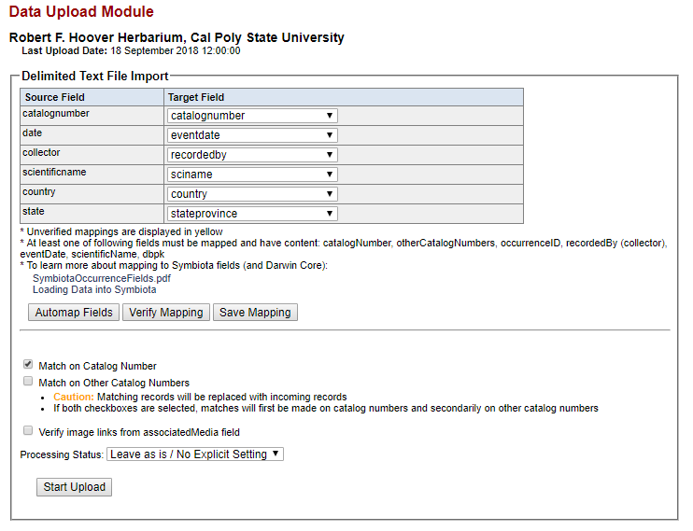

At this point, you will select which fields in your CSV file (Source Fields) will correspond to which fields in the Symbiota portal (Target Fields). Check that each of the auto-mapped fields was appropriately assigned. Check the Symbiota Data Field Guide (http://symbiota.org/docs/symbiota-occurrence-data-fields-2/) for definitions of each data field, should you have any questions about the appropriate field to which to map your data. Katie Pearson (kdpearso@calpoly.edu) can also help you determine the appropriate data field. Once you are satisfied with your field-to-field mapping (see note), click the “Save Mapping” button.

NOTE
If the scientific names in your CSV file include taxonomic authorship (e.g., Acer circinatum Pursh), map this field to the Target Field use “scientificname.” If the scientific names included in your CSV file do NOT include taxonomic authorship (e.g., Acer circinatum), map this field to “sciname.”

Change the processing status as appropriate (see Appendix 1 for instructions on the use of Processing Status for the CAP TCN) and click “Start Upload.” You will be taken to a page that will update periodically while Symbiota ingests your data. Do not navigate away from this page until you see the message “Upload Procedure Complete” (see below).

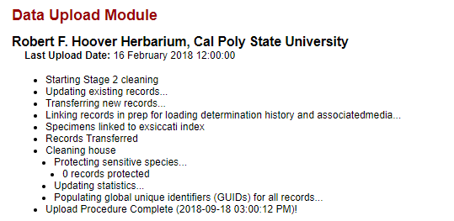

16.10 Adding determination/annotation data
Navigate to this tool by accessing the Data Editor Control Panel (see Section 16.3) and clicking “Add Batch Determinations/Nomenclatural Adjustments.” To select the specimens to which determination data will be added (“Define Specimen Recordset”), either enter a list of catalog numbers (separated by commas) in the “Catalog Number:” field or select a taxon to evaluate by entering its name in the “Taxon:” field. If the latter option is used, a table of specimens of the indicated taxon will appear below the “Define Specimen Recordset” box (see below). You can then select all the specimens that you wish to annotate by checking or unchecking the boxes in the leftmost column of the table. Use the “Select/Deselect all Specimens” to uncheck all the boxes if you would prefer to select specimens one by one rather than eliminating those that do not need to be annotated.

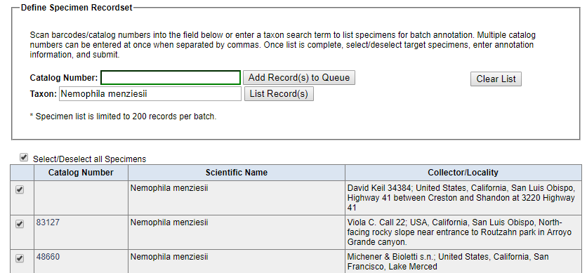

Add information about the name change in the “New Determination Details” box. Here you can indicate whether the change is due to a new identification (“Identification Adjustment/Verification”) or a nomenclatural change (“Nomenclatural Adjustment”). An identification qualifier (e.g., “aff.” or “cf.”) can be added in the “Identification Qualifier:” field. Enter the new scientific name in the “Scientific Name” field, and the “Author:” field will automatically populate if the taxon is already in the taxon table. If the taxon is not in the taxon table, you will have to manually enter the author of the scientific name. You should also enter the name of the determiner in the “Determiner:” field, as well as the full date of determination in the “Date:” field. You can indicate the confidence in the determination (Low, Medium, or High) in the “Confidence of Determination:” field, list your determination references in the “Reference:” field, or include any other notes in the “Notes:” field. Finally, if you check the “Make this the current determination” box, the scientific name will be updated for the selected records. Otherwise, the determination will be added to the specimens’ records, but the name will not be changed. You can print determination/annotation labels by checking the “Add to Annotation Print Queue” box and using the label manager tool (described below).

16.11 Printing labels or annotations
To print specimen labels, navigate to the Data Editor Control Panel (see Section 16.3) and click “Print Labels/Annotations.” Search for the desired specimens by entering search terms in one or many of the available fields in the “Define Specimen Recordset” box and clicking “Filter Specimen Records.” Select all the specimens for which you want to print labels by checking or unchecking the boxes in the leftmost column of the table. Use the “Select/Deselect all Specimens” box to check or uncheck all the boxes as necessary.
At the bottom of the page in the “Label Printing” box, you can then enter a desired heading (e.g., “Robert F. Hoover Herbarium (OBI)”, heading mid-section (e.g., state or family), heading suffix (any additional text information), and label footer (e.g., the name of the project for which the specimen was collected) for all labels to be printed. You can also select from a number of other options in the “Label Printing” box including whether you want to print the specimen barcode.
Once you have selected your desired options, you can print the labels directly from your browser, export the specimen data to a CSV file (similar to an Excel file, this format can be used with mail merge to produce labels), or export the labels to a Word document (DOCX file) by clicking the appropriate button. An example label for printing from the browser is shown below. Note that the boxes to include the barcode and the catalog number were checked when generating this label.

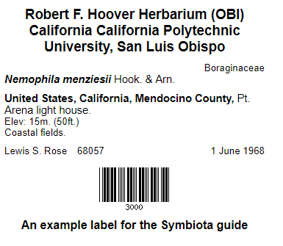

16.12 Managing loans, gifts, and exchanges
Navigate to the loan management tool by accessing the Data Editor Control Panel (see Section 16.3) and clicking “Loan Management.” You will see the following tabs:

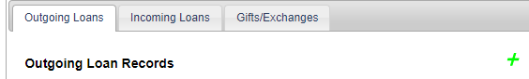

To add a new outgoing loan, click the green plus sign near the right side of the “Outgoing Loans” page. You will be prompted to enter a Loan Identifier (a unique number to mark the identity of the loan) and select an institution to which the loan is being sent from the dropdown list. If the institution is not found in the dropdown list, click the green plus sign to the right of the “Send to Institution:” field and enter the required information. Click “Create Loan” when you have finished entering the required information in the “New Outgoing Loan” box.
Once you click “Create Loan,” you will be taken to the Loan Out Details page. Here you can add information about the loan and generate loan paperwork using the appropriate boxes. To link specimens to the loan, click the “Specimens” tab, click the green plus sign, enter the catalog number of the desired specimen in the field (preferably by scanning the barcode of the physical specimen), and click “Add Specimen.” Repeat as necessary. To edit an outgoing loan or link specimens to the loan in the future, navigate to the “Outgoing Loans” tab and click on the loan identifier (number or name given to the loan) directly to the right of the appropriate bullet point.
To add a new incoming loan, repeat the procedure outlined above using the “Incoming Loans” tab. Note that specimens cannot be linked to incoming loans.
To add a gift or exchange, repeat the procedure outlined above using the Gifts/Exchanges tab. You will be able to enter the number of specimens in either the “gift” boxes or “exchange” box.

Appendix 1: Processing Status
(adapted from Skema & Barber 2018)
Processing Status is a field in Symbiota that helps keep track of what stage a record is at in the workflow. There is no one standard for how to use the different levels of Processing Status across all users of Symbiota, although there is some standardization within projects. If each user in a particular collection uses the processing status field consistently, both in remembering to change the status as required, and in assigning the appropriate status, it is of great help to the workflow. The following table shows the recommended definitions for the status levels in Processing Status to use for the California Phenology TCN.

Status | Definition
Unprocessed | skeletal record (typically with scientific name only)
Pending Review | volunteer/technician transcribed record and had no problems/questions  OR  record imported from a dataset that was previously minimally quality controlled
Expert Required | volunteer/technician transcribed or reviewed record and had problem(s)/questions (volunteer/technician should leave concise notes in Occurrence Remarks to explain problem/question)
Reviewed | record transcribed; transcription reviewed and correct  OR  record imported from a dataset that was previously quality controlled
Stage 3 | record problematic; to be researched
Closed | record transcribed, georeferenced, and fully reviewed (or as best as possible given available information)

References
Skema C, Barber A. 2018. Mid-Atlantic gegalopolis digitization standards and training manual. Morris Arboretum of University of Pennsylvania. Available from https://docs.wixstatic.com/ugd/6f7156_800579c353574e59918cfb541172d749.pdf

