Making an Illustrated Key of California Plants
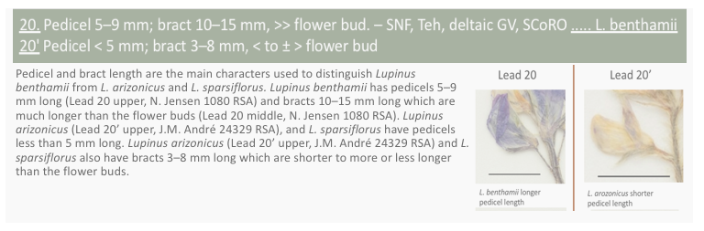A.E. Fisher 2021. Making an Illustrated Key of California Plants

Objectives
Students completing this activity will be able to:
- Use dichotomous plant identification keys such as the Jepson Manual of California Plants or The Flora of North America.
- Use technical terms to describe and summarize differences between plant species.
- Access specimen images from digital data repositories such as the Consortium of California Herbaria 2 or GBIF.
- Create digital images that have scale bars and cite original sources.
Introduction
Identification and description of plants are two of the main goals of plant systematists. Correct identification is important to understand plant diversity, animal-plant interactions, for rare plant conservation, to monitor invasive plants, and for many other purposes. There are now several apps like iNaturalist and PlantNet to identify plants based on photographs, but some features need to be carefully examined so identify a plant to the correct taxon. Botanists primarily use dichotomous keys to identify plants to species.

Dichotomous keys are a series of questions about the plant you are trying to identify. Each question is called a couplet. For each couplet there are only two possible choices called leads. Other kinds of keys (polyclave keys) can have more than two choices, but the most common types of identification key you'll find are dichotomous keys. In each couplet the most important information for telling apart the leads is listed first and information in the leads is parallel.

Here is an example of two couplets from the dichotomous key for the Pentagramma ferns from the Jepson eFlora:

1 Stem dark brown to more or less black, with white exudate from the leaf blade. Northern California... Pentagramma pallida
1' Stem brown to red-brown, generally smooth (without an exudate). Wide distribution
2 Leaf blade upper surface smooth, lower surface yellow to cream exudate.... Pentagramma triangularis
2' Leaf blade upper surface glandular, sticky, or with exudate, lower surface with white exudate
(Key authored by Carl J. Rothfels, Ruth E.B. Kirkpatrick, Alan R. Smith, Thomas Lemieux & Edward Alverson)

Use the key by reading lead 1 and then lead 1'. The most important character to decide which lead to take is the stem color. The leads have parallel information about the stem color, the exudate, and distribution.

If your fern is a better match for lead 1 then it is identified as Pentagramma pallida. If your fern is a better match for lead 1' then you go on to couplet 2. When you have chosen the lead that fits, look to the right of the lead and read off either a taxon name or another number. If you get a number, then find the pair of leads for that couplet and continue until you reach an identification.

If there is a word in your key you aren’t familiar with, look it up in the key glossary or a botany dictionary. Botany terms are so specific that sometimes an online search can give you a really strange definition! When you have keyed out your plant, verify your identification by looking up the plant in the Jepson eFlora or the species description in the key. Does the written description match your plant? Does the distribution overlap with where you found the plant? Does the illustration look like your plant? These are all ways to check that you've arrived at the correct identification.

Optional
Feeling lost? Watch this video on dichotomous keys (2:37)
https://youtu.be/3x7tuIZd4Sw

Activity 1 Using a Dichotomous Key

We are fortunate in California to have an excellent key to the vascular plants. The Jepson eFlora is produced by the Jepson Herbarium at the University of California Berkeley and includes native, naturalized, and invasive vascular plants of California. This is not a good key to identify plants from your garden or cultivated plants! For those, I recommend using Bailey's Manual of Cultivated Plants
https://www.google.com/books/edition/Manual_of_Cultivated_Plants_a_Flora_for/3Xc5AAAAMAAJ?hl=en&gbpv=1&dq=liberty%20hyde%20bailey%20manual%20of%20cultivated%20plants&pg=PA1&printsec=frontcover

Please navigate to the Family Key in the Jepson eFlora and answer the following questions.
https://ucjeps.berkeley.edu/IJM_keys/IJM_fam_key.html

1. What is the term for 1' in this key?

2. In the Jepson eFlora family key what is the character being compared in couplet 1?

3. In the Jepson eFlora family key what is the definition of "tree"? You can hover over any underlined word to see the glossary definition (see lead 5').

4. In couplet 12 of the Jepson eFlora family key what is the most important character to distinguish between 12 and 12'?

Activity 2 Making an Illustrated Key

We have been investigating plant morphological characters at the level of family, but to make fine-scale comparisons we will compare differences between plant species. This project will give you the chance to do an in-depth study of the morphological characteristics of a group of plants. In some plant groups the distinctions between closely-related species can be difficult to describe or only apparent after comparing the species. It can be much easier to use a dichotomous key with illustrations or photographs of the characteristics being compared in the couplet.

We will create illustrated keys using images of museum specimens of the plants. These images come from herbaria or collections of preserved plant specimens. We will use herbarium specimens instead of random online images for several reasons. Each herbarium specimen has information about who collected the plant, where it was collected, and when. The plants are pressed so that their important characteristics are visible. The specimen image includes a ruler so we know the scale of the plant. Additionally, herbarium specimens are likely to be identified correctly and studied by experts of the plant group.

Example of an Illustrated Key

Here is an example of an illustrated key to the California members of the genus Rhus (Anacardiaceae). Explanations of how to prepare the key and references follow this example.

Slide 1 The first slide is a title slide that says the genus and family. Please put your name on this slide.
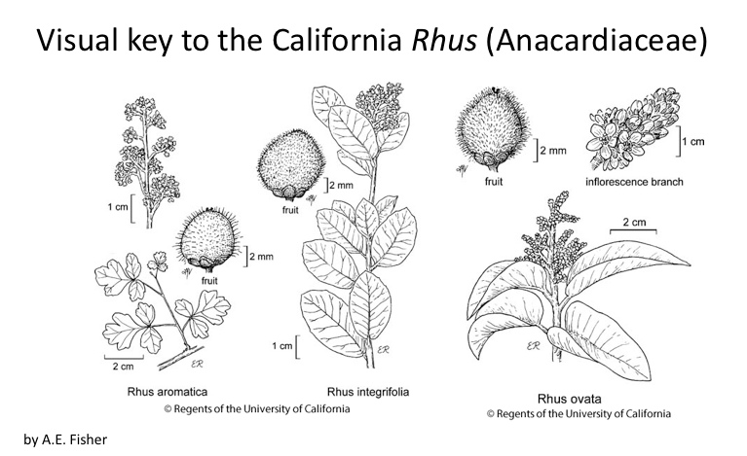

Slide 2 The second slide lists the California species in the genus and the basic characteristics of the genus. This information is from the Jepson eFlora Rhus genus page. The authors of the Jepson eFlora Rhus key are cited. There is also an attribution for the source of the images in the slides.
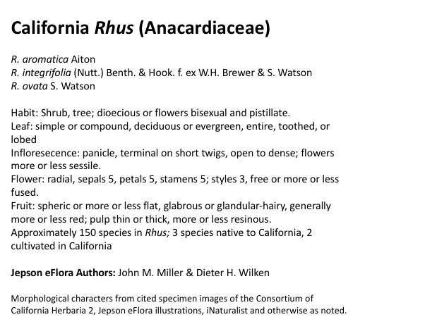

Slide 3 The third slide shows the Rhus key and cites the Jepson eFlora authors.

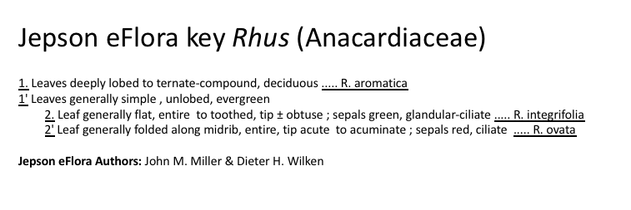
Slide 4 The fourth slide illustrates the leaf character in couplet 1. The couplet is at the top of the slide in gray. Lead 1 leads to R. aromatica and lead 1' leads to couplet 2, which leads to R. integrifolia and R. ovata. Images under Lead 1 show R. aromatica leaves from a CCH2 specimen voucher. It is important that you use specimen vouchers to illustrate these characters. Images under Lead 1' show a leaf from one of the two species under Lead 1' (in this case R. ovata) to illustrate the alternative character state. Each image has a scale bar and is also attributed to the original source (the specimen voucher) in the figure captions using a standardized citation format.

The figure caption explains differences between Lead 1 and 1' including any terms that need to be defined. There are comments on what the most common form is if the key mentions there can be multiple states. The most common state was found by looking at images of 10-20 specimens in the Consortium of California Herbaria 2 (CCH2).

The second character in the couplet is if the leaves are deciduous (senesce approximately once a year) or if the leaves are evergreen. This is difficult to illustrate and instead it is described in the caption. There is an attributed image (from iNaturalist) of the habit of R. aromatica that briefly describes where the photo was taken and what it is showing (the habit and leaf shape). The image of the living plant from iNaturalist does not need an herbarium specimen equivalent because it is showing the habit. There is also no scale bar needed on the iNaturalist image. There is a brief caption that describes where R. aromatica is found in California, its typical habitat, and elevation (from the Jepson eFlora).
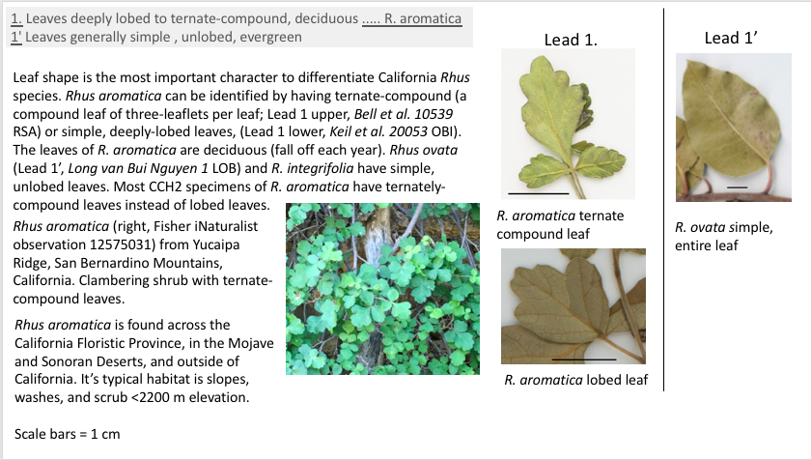

Slide 5 The fifth slide illustrates the leaf and sepal characters in couplet 2. The couplet is at the top of the slide in gray. This couplet differentiates between R. integrifolia and R. ovata. Lead 2 leads to R. integrifolia and lead 2' leads to R. ovata. The five characters in this couplet are leaf position, leaf margin, leaf apex, sepal color, and sepal vestiture. The upper images show the leaf position and margin and have scale bars. The middle images show leaf margin and apex. The lower images show sepal color on herbarium specimens. There are arrows pointing to the sepals so they are easier to see. Sepal vestiture has to be viewed under a microscope and so is not visible on these images. Each image is attributed to the original source in the figure captions. I commented that the Jepson key could be revised to state the the R. integrifolia sepals are often white instead of green. I found this by looking at several specimen images on CCH2.
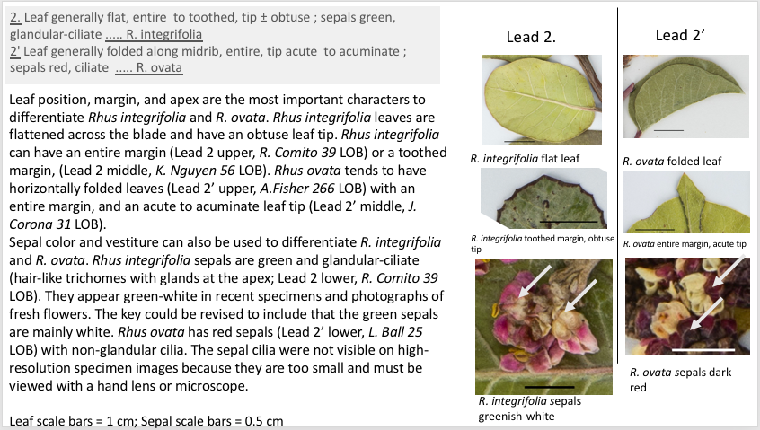

Slide 6 The sixth slide illustrates the habit of R. integrifolia and R. ovata. There are attributed images (from iNaturalist) of the habit of R. integrifolia and R. ovata that briefly describe where the photos were taken and what it is showing (the habit and leaf shape). The images of the living plants from iNaturalist do not need an herbarium specimen equivalent because they are just showing the habit. There is also no scale bar needed on these images. There is a caption that describes where R. integrifolia and R. ovata are found in California, their typical habitats, and elevation (from the Jepson eFlora).
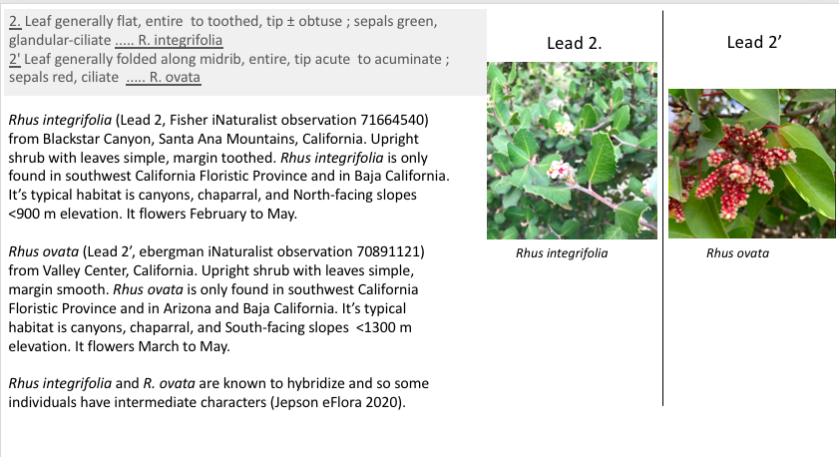

A template of this Powerpoint file is available.

Choose a genus

It is time for you to choose a genus to study for your illustrated key. Find a species key in the Jepson eFlora or Flora of North America with at least five species.

Jepson eFlora https://ucjeps.berkeley.edu/eflora/
Flora of North America http://floranorthamerica.org/Main_Page

Each person in the class must study different species. If there is a genus with many species you can work on a section of the key. You can also work on several small genera. Please ask for the Instructor's permission to do this.
Additional resources to choose a genus or section of a genus:
- Explore iNaturalist https://www.inaturalist.org/ to find species in your area
- Local field guides available in the classroom or online, such as Allen & Roberts' "Guide to Wildflowers of Orange County"
- Ask the Instructor for help

Once you have an idea for a genus please look at the genus key.
Are there at least five species?
What are the characters used in the key? Will you be able to see them on a specimen? Some keys will use microscopic characters like pollen that will be difficult for us to illustrate. If you see this in your key then choose a different group of species to work on!
Lab Group Discussion Questions
Please discuss these questions with your lab group
- Were there any couplets in the key that roughly divided the species in half? What were the characters for each lead of that couplet?
- Are there any terms that you need to look up? Please define those terms in the figure caption.
- Were there any characters that you think may be especially difficult or even impossible to see on specimens? Why would they be difficult to see?
- Were there any couplets that were confusing? How could you rephrase the key so that it was more intuitive? This is something I want you to keep in the back of your mind and may become apparent as your develop your visual key.
Instructor Approval for your Genus
Type in the genus name that you would like to work on next to your name in the lab group file by the due date. You will earn five points if you have an idea for your Illustrated Key project genus on the spreadsheet by that time. The Instructor will approve your choice or suggest another genus on the spreadsheet.
Steps to Begin Your Illustrated Key
Once you have Instructor approval you can begin to work on your key.
1. Who were the authors of the dichotomous key?
If you are using the Jepson eFlora the authors are listed on the genus page. Please cite the key authors on the second and third slides of your visual key.

2. List all of the species in the genus or the section of the key you are using with their species name and authority. Remember to italicize species names, but not the authority. The genus name is capitalized and the specific epithet is lowercase.

3. Place the key for your genus or section into a slide.

4. Create a slide for each couplet.

5. Read through the key and look up definitions for any technical terms.

The Jepson eFlora glossary or a textbook are your best references for definitions. I do not recommend using a Google Search for technical botany terms.

6. For each of the leads in the key, find specimen images from a species that is under that lead that shows at least one of the traits mentioned in the lead.

You must use images from specimens from the Consortium of California Herbaria 2, iDigBio, or GBIF to illustrate the key. If the key has characters that are not visible on the specimen (such as color or three-dimensional shape) then you can use a photograph with attribution to the photographer, but you must also show the same structure from a specimen image. If you can not see a character (such as vestiture or anther shape, etc.) then you may use a drawing from a flora or describe the character state in the figure caption.

Please cite the original sources all of your images in the figure captions.

Using digital data repositories to find specimen images that illustrate characters in the key

These instructions are to find images from specimens in the Consortium of California Herbaria 2: http://www.cch2.org/
Alternative sources for plant voucher images are iDigBio and GBIF.
- Choose the “Browse images” tab in CCH2 and search for your species name.
- Click on the image that you’d like to look at and then choose “Open Large Image” (lower red arrow in the image below). Clicking directly on the image opens a low-resolution image. The "Open Large Image" opens a high-resolution image that you can magnify.
- Check- Does the image show the character and trait that is mentioned in the key lead? If not, choose a different specimen image of this species from CCH2 and see if the trait is visible on that specimen. Ask the Instructor if you need help.

Choose which magnification to use and take a screen shot of the character. Then scroll up and using the same magnification take a screen shot of the 1 cm part of the ruler on the specimen image. We will use this to make a scale bar.

*Data Management- It's a good idea to put these pairs of screen shots in a folder system named for the species and the collector name and number (upper red arrow in the image above) and herbarium code (red circle in the image above).

Citing Voucher Specimens
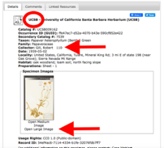

Cite the specimens you use for images in the following format:

Species name, Collector name, collection number (herbarium code)
Example of two specimens used to illustrate the species Arctostaphylos glauca.
Arctostaphylos glauca A. Fisher 612 (LOB), K. Pitzer s.n. (CAS)

The collector name, collection number, and herbarium code is on the specimen record that pops up with the specimen images.
Please list the specimens used for images in the figure caption on each slide.

Scale bars

It's important to know the size of what is pictured in each image and so we need a scale bar.
- Take a screen shot of the 1 cm scale bar from the specimen image at the same magnification.
- Bring both the character and scale bar images into Powerpoint or some other program without changing their size.
- Use Powerpoint line tool to draw a 1 cm line on the scale bar.
- I recommend using 1 cm or 0.5 cm scale bars.
- Next, move the line to the image of the character in Powerpoint. Take a screenshot of the character image with the scale bar on it. Now you have a 1 cm scale bar on your image!

Put the image with a scale bar in your illustrated key. Be sure to include the measurement for the scale bar in your caption.
You do not need to put scale bars on images of living plants.

Annotations
Use Powerpoint to add arrows or ovals to emphasize the traits on images where it would be helpful. There are usually a few images in each illustrated key that benefit from arrows and ovals!

Organizing Your Slides
I recommend organizing your slides by couplet. You can use more than one slide per couplet if there are many characters in the couplet.
If you are working with a large genus and there is a couplet that divides the key into two large groups of species then it can be helpful to have a slide where the species are listed under each lead.
Figure images should be high-quality with no text overlapping and shapes aligned.

Figure captions
Add figure captions to your illustrated key to explain the characters used in each couplet. Be sure that your figure captions explain what the images are showing. What character is shown and how does it differ in the two leads? Note if some character states are difficult to tell apart or if you would rephrase a couplet in the key. When a lead identifies a species please include a photograph of the habit of the living plant (iNaturalist or CalFlora are good resources for these). Be sure to acknowledge the photographer if you use a photo that is not your own! Also include information on the species distribution, typical habitat, and elevation. Please see the Rhus example for how you can succinctly include this information so it will fit nicely on the slide.

Submitting your Visual Key Project
Turn in your visual key as one set of slides through BeachBoard Dropbox as .pptx or .pdf files (Apple apps can save as pdf). If the file is very large, in Powerpoint try File<Compress Pictures to screen or email view.
The file name should be your last name_GenusName_VisualKey_Date.
Example: Fisher_Rhus_VisualKey_2021April24

Rubric
Scoring of 100 points possible
Illustrated Key /15
Interpretation of Key /35
Aesthetics /25
Organization and writing /25

 | Outstanding (100%) | Effective (80%) | Adequate (60%) | Ineffective (40%)
1. Illustrated Key (15 pts) | 1. Key with every lead accompanied with images from species under that lead to illustrate the choices in the couplet | 1. Key with every lead accompanied with images from species under that lead, with a couple mistakes of species or character identification to illustrate the choices in the couplet. | 1. Key with almost all leads accompanied with images from species under that lead, with several mistakes in species or character identification to illustrate the choices in the couplet. | 3. Key with several leads lacking images or with many mistakes in species or character identification to illustrate the choices in the couplet.
2. Interpretation of Key (35 pts) | 1. Information in project handout thoroughly and correctly answered in figure captions.  2. Correct interpretation of the key as a series of choices with only two leads for each couplet  3. Characters for each lead illustrated with images and differences accurately described in figure captions  4. If images of living plants are used then an image of the same character on an herbarium specimen is also shown.  5. Images have accurate scale bars and the image source is attributed.  6. Incorporating background information from Jepson eFlora about the species to interpret the key  7. Mention ways the key could be improved or difficulties in interpreting the couplets. | 1 Information in project handout correctly answered in figure captions  2. Mostly correct interpretation of the key as a series of choices with only two leads for each couplet  3. Characters for each lead illustrated with images and differences described with a few errors in figure captions  4. If images of living plants are used then an image of the same character on an herbarium specimen is also shown with few exceptions.  5. Images mostly have scale bars or there are some that are inaccurate scale and most image sources are attributed.  6. Some incorporation of background information from Jepson eFlora about the species to interpret the key  7. Little to no mention of ways your study could be improved or caveats to results of your study. | 1 Information in project handout mostly correctly answered in figure captions  2. Some incorrect interpretation of the key as a series of choices with only two leads for each couplet  3. Characters for most leads illustrated with images and most differences described with several errors in figure captions  4. If images of living plants are used then image of the same character on an herbarium specimen is seldom shown.  5. Images mostly lacking scale bars or scale bars are inaccurate. Many image sources are not attributed.  6. Little incorporation of background information from Jepson eFlora about the species to interpret the key  7. No mention of ways your study could be improved or caveats to results of your study. | 1 Information in project handout mostly incorrectly or not answered in figure captions  2. Mostly incorrect interpretation of the key that shows lack of understanding that it is a series of choices or that there are only two leads for each couplet.  3. Characters for most leads not illustrated with images and many differences not described with many errors in figure captions  4. If images of living plants are used then image of the same character on an herbarium specimen is missing.  5. Images almost all lacking scale bars or scale bars are inaccurate. No image sources are attributed.  6. No incorporation of background information from Jepson eFlora about the species to interpret the key  7. No mention of ways your study could be improved or caveats to results of your study.
3. Aesthetics (25 pts) | 1. Overall high quality images. Cropped specimen images and illustrations are high resolution and neatly cropped.  2. Images clearly and accurately demonstrate characteristics used to differentiate species with arrows and labels.  3. Images are aligned and organized well on each slide | 1. Effective images. Cropped specimen images and illustrations are fair quality. Some look low resolution or are not cropped well.  2. Images accurately demonstrate characteristics used to differentiate species and some have arrows and labels.  3. Images are mostly aligned and mostly organized well on each slide | 1. Adequate images. Cropped specimen images and illustrations are fair quality.  2. Images accurately demonstrate some characteristics used to differentiate species but some do not.  3. Many Images are not aligned or not organized well on each slide | 1. Poor quality images or lacking images. Specimen images and illustrations are poor quality or missing.  2. Images inaccurate or do not demonstrate characteristics used to differentiate species.  3. Most Images are not aligned or not organized well on each slide
4. Organization and Writing Mechanics (25 pts) | 1. Slides are thoughtfully organized. Caption concisely and accurately describes contents of the slide.  2. Entire text written in appropriate academic writing style  3. Accurate and relevant descriptions of the slide in the caption.  4. English mechanics (grammar, spelling) are perfect with no typos.  5. Specimen citations in the figure caption that support description of the plant characteristics. | 1. Slides are organized – Caption concise and describes contents of the slide.  2. Text – mostly in appropriate academic writing style, with some mistakes  3. Minor inaccuracies and some irrelevant descriptions in caption  4. Grammar and spelling near-perfect with only a few typos  5. Some specimen citations that support description of the plant characteristics. | 1. Slides could use re- organization – difficult to follow the information, but possible  2. Text – significant amounts of text not in appropriate academic writing style, but maintains formality  3. Some serious inaccuracies and irrelevant descriptions  4. Frequent grammar and spelling mistakes  5. Few specimen citations that support description of the plant characteristics | 1. Poster is poorly organized – few sub-headings, difficult to follow the information  2. Text – significant amounts of text not in appropriate academic writing style, and language is informal or inappropriate to academic style  3. Lack of description or clearly wrong  4. Consistent grammar and spelling mistakes throughout  5. No specimen citations.

