Georeferencing Specimens in a Collaborative Georeferencing (CoGe) Community
Last updated by Katie Pearson on January 18, 2020
This protocol explains how to georeference specimens in GEOLocate as part of a Collaborative Georeferencing (CoGe) community. The protocol consists of three parts. Part I explains how to set up an account in CoGe. Part II describes the protocol for georeferencing using the GEOLocate interface. Part III is a user guide for GEOLocate that explains GEOLocate features. Some essential information in Part III is duplicated in Part II for ease of use.

I. Account Setup (for first time use)
- In a browser, navigate to the CoGe website (https://coge.geo-locate.org/) and click the Sign Up button.
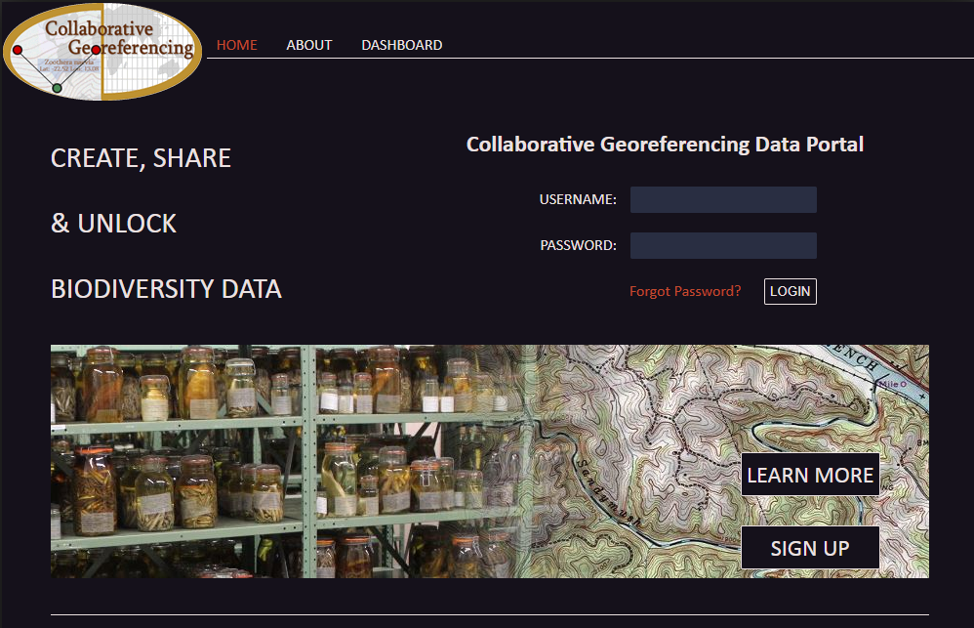
- Fill in the required information, indicated by red stars. Where it asks for your Organization, enter “California Phenology Network” (or your organization). Then click the CREATE ACCOUNT button.
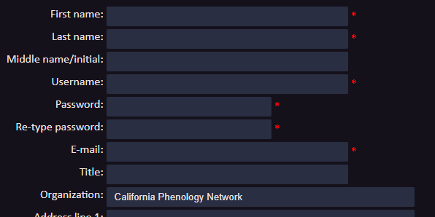
- Once you receive an email from CoGe that indicates you have been authorized as a CoGe user, email Katie Pearson (kdpearso@calpoly.edu) to be assigned to our project. Once she has confirmed your registration, proceed to Georeferencing in GEOLocate.

II. Georeferencing in GEOLocate
- In a browser, navigate to the Geo-Locate client: http://www.geo-locate.org/web/WebComGeoref.aspx
- Enter your CoGe username and password into the Username and Password fields and the click Login button.
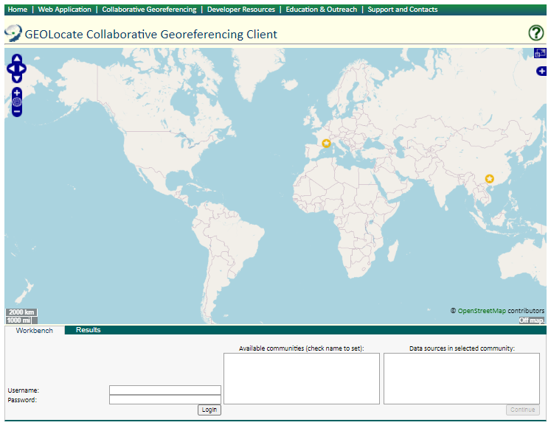
- In the “Available communities” box, click the radio button next to the name of the community you will be working on. If you don’t see any communities in this box, contact Katie or your supervisor. Then click the Continue button.
- Click the Next Record button to view your first specimen record.
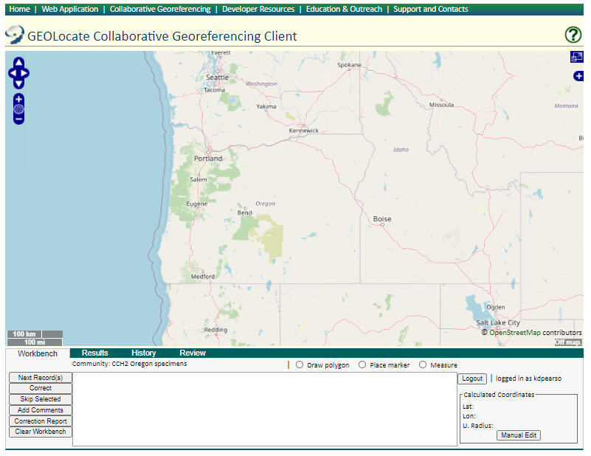
- You should now see your first specimen’s locality description on your GEOLocate “workbench” (notice the Workbench tab on the far left).
  - The locality that you are georeferencing will be highlighted.
  - Any records that have a similar locality description will be compiled in the “Similar Records” and/or “Identical Records” options just below your target locality. The number of similar or identical records is indicated in the parentheses.
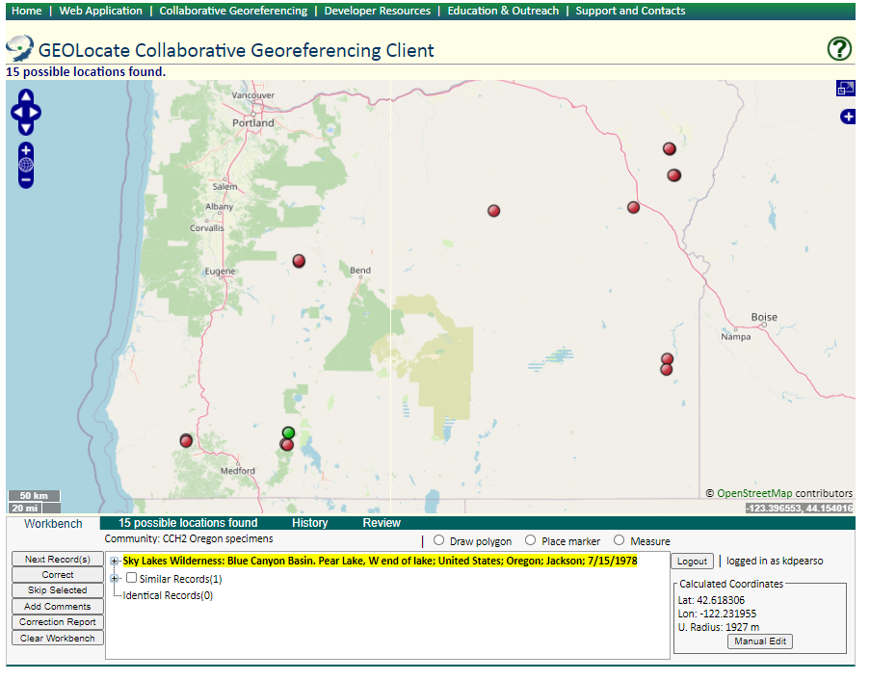
Checking Similar and Identical Records
- If there is a Similar Record to your locality, click the plus sign next to Similar Records (circled in screenshot above). On each similar record, compare the locality descriptions to assess whether the similar specimen should be georeferenced along with your target (highlighted) specimen. Ask yourself: do they indicate the same exact place? For example, the “similar record” listed below is found in the same wilderness area, but not near the same lake as the target specimen. So we would NOT choose to georeference these specimens together
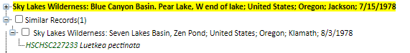
  - If the specimens should be georeferenced together, check the box next to the similar specimen record (it will turn blue).
  - If the specimens should NOT be georeferenced together, do NOT check the box next to the similar specimen record.
- If there is an Identical Record to your locality:
  - Click the plus sign next to the highlighted locality, then click the green catalog number of the record to open the specimen’s details in a new tab or window.
  - Click the plus sign next to the Identical Record, then right click the catalog number of the record and select “Open in New Tab” to open up the individual specimen’s details in a new tab.
  - Compare the habitat field of the potentially identical record to the habitat field of your highlighted record to determine whether they should be georeferenced together. If one of the specimens could be pinpointed to a more specific degree due to the habitat information, then you would not want to georeference both specimens together. For example:
    - If the location is “E side of Soda Lake”, your target specimen’s habitat is “bank of lake”, and your identical specimen’s habitat is “in streamlet leading to lake”, you would NOT want to georeference these specimens together.
    - If the location is “E side of Soda Lake”, your target specimen’s habitat is “open forest”, and your identical specimen’s habitat is “meadow”, you could georeference these specimens together because open forest and meadow are not likely to be distinguished from one another during the georeferencing process.
  - If the specimens should be georeferenced together, check the box next to the identical specimen record (it will turn blue).
  - If the specimens should NOT be georeferenced together, do NOT check the box next to the identical specimen record.
- Once you have assessed any similar or identical records, move on to step 9.
Finding a specimen’s locality
- GEOLocate will attempt to georeference your specimen by comparing key phrases in your locality description with information stored in its gazetteers (i.e., internal list of places).
  - The green point is GEOLocate’s best guess for the locality of the specimen. You may also see red points, which are alternative guesses.
  - To view the reasons why GEOLocate selected these points, click the “# possible locations found” tab to the right of the Workbench tab.
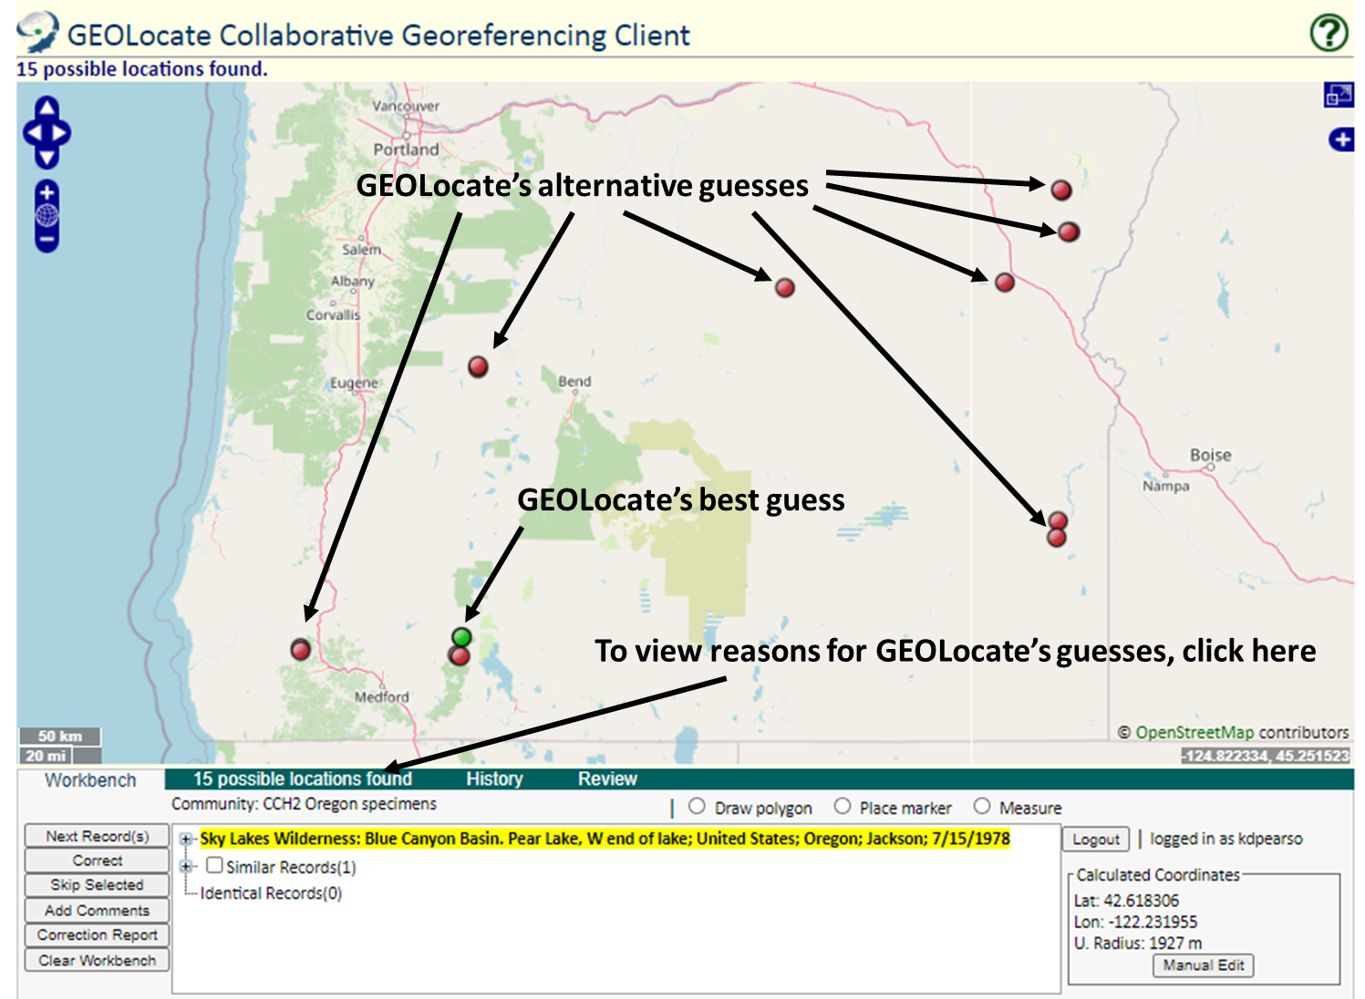
- If there are points on the map, click on the “# possible locations found” tab to investigate whether any of them could be a good starting point for your georeferencing by comparing the points’ locations on the map to the highlighted locality description.
  - The information in ALL CAPS after “pattern” indicates which phrase was used to place the point. For example, when we used the following locality:

GEOLocate gave us the following results.

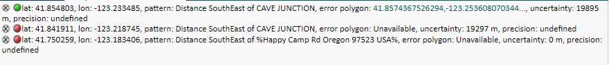
For the green (first) point, it measured the “Distance SouthEast” of a location called “Cave Junction,” as described in the locality description. Depending on where this Cave Junction is, this might be a good place to start with our georeferencing.
  - When deciding whether to use one of the GEOLocate points, make sure to check that the state and county where the point has been placed matches the state and county indicated by the record.
  - It is possible that none of the points indicate the correct locality. In this case, ignore GEOLocate’s points and search for the location on your own (e.g., using a Google search, map, or other resource such as those available here: https://www.capturingcaliforniasflowers.org/georeferencing-protocols-and-guides.html)
- Either starting with a GEOLocate point or from scratch, use the highlighted locality description to determine an approximate collection location of the specimen. This will likely require searching other references (e.g., Google maps) for location and feature names. Some helpful tips about GEOLocate:
  - To use a point from GEOLocate, click on that point so it turns green. You can then drag this point to the desired location.
- You can change the base layer (i.e., the type of map shown in the GEOLocate window) by clicking the plus symbol in the upper right corner of the window (see screenshot on next page).
- To measure a distance on the map, click the button next to “Measure” and click on a starting point on the map. You can then move your cursor anywhere on the map and a line will be measured between those two points. The length of the line will be shown in green next to the line. To measure between more than one point, click again to anchor another point. To stop measuring, double click on the ending point of your measurement.
- To manually change the latitude, longitude, or error radius, click the Manual Edit button on the bottom right side of the workbench. This is where you can paste coordinates that you copied from another source such as Google maps.
- If you have seen a similar locality in the past and you want to use the coordinates that you previously used, see the Using the History Tab section of this protocol (page 8).
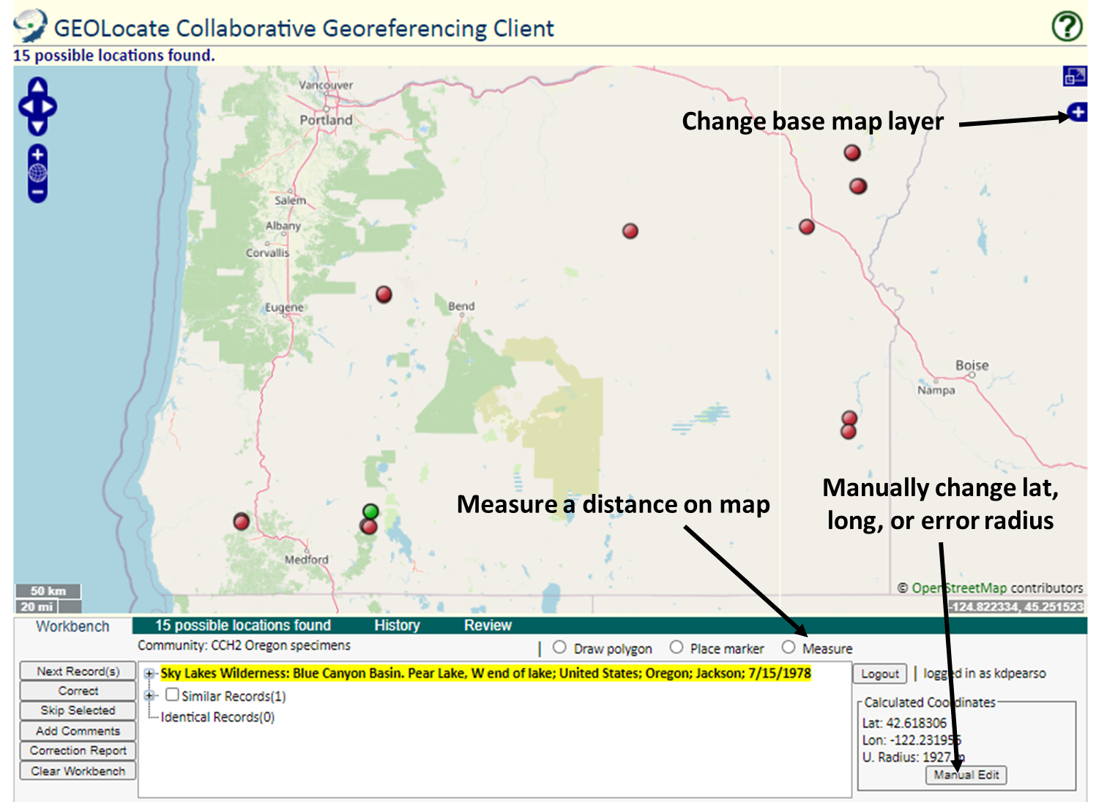
- Once you have found an approximate location for the specimen record, click the button next to “Place Marker” and click on the map where you want to place the GEOLocate point (if you have not already placed the point). Follow the guidelines provided in Table 1 when deciding where to place the point.
- If there is not enough information in the locality description to assign an approximate point, click the plus sign to the left of the description, then click the catalog number of the specimen. This will take you to the specimen record. Look for more information on the specimen record (e.g., the “habitat” field) for any information that might help you georeference the specimen.
- If you are still not able to assign an approximate point from this information but you think someone else may be able to georeference this record in the future, click the Clear Workbench button followed by the Next Record(s) button.
- If you think the specimen data are insufficient for anyone (even an expert) to georeference the specimen, click the Skip Selected button and type “cannot georeference” with a brief explanation of your reasoning in the pop-up window.
    - If only a county is provided, enter “locality imprecise; cannot georeference” in the Georeference Remarks field.
- Set the error radius and/or create an error polygon to indicate the uncertainty of the specimen’s locality. Follow the guidelines provided in Table 1 when deciding how large of an error radius to use for a given point and whether you should use an error polygon.
- To edit the size of the error radius, click the green point on the map and select “Edit Uncertainty” in the pop-up box. Click and drag the grey arrowhead that will appear on the outer rim of the error circle to resize the error radius.
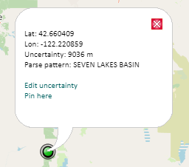
- To create an error polygon, click the button next to “Create polygon” and click on the map where you want to begin drawing the polygon. A corner of the polygon will be created time you click on the map. To finish the polygon, double click. Once you have completed the polygon, click the green point again and select “Resize uncertainty to polygon.”
    - To redo a polygon, click the “Clear Polygon” button to the right of the “Options” button.
- Click the Add Comments button on the bottom left side of the workbench. Explain your reasoning for placing the point and setting the error radius in the pop-up field. You do not need to explain that you followed the protocol, but you should explain any assumptions you made during the process. Some examples of useful comments are shown below:
  - “measured distance SE of Hampton, error radius halfway to Sneads”
  - “point placed halfway between Newport and Florence, error radius half the distance to both”
- When you are confident in your GEOLocate point and error radius, and you have added comments to the Add Comments field, click the “Correct” button on the bottom left side of the workbench to save your work.
- Return to step 4 to start on a new record.

Using the History Tab
The History Tab is used primarily for two purposes: (1) to fix a record that you previously georeferenced, or (2) to import coordinates from a specimen that you already georeferenced into a different specimen’s record. Both uses are described below:
- Click the History tab.
- To search for a specific locality that you previously georeferenced, click “history filter” below the “get history” button.
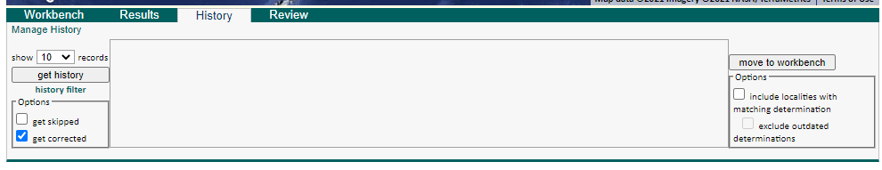
- In the new window, check the box next to the filter that you would like to use. You can either filter by records that were georeferenced to somewhere within the map area or you can filter by records that contain a certain keyword in the locality description. (You can also search by both of these filters at once by checking both boxes).

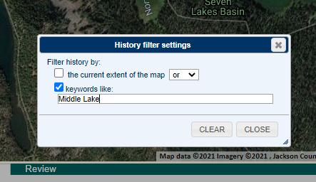
- Click the Close button, then the “get history” button on the left side of the History tab. You will then be shown a list of records that you previously georeferenced and that match your search criteria.
  - Records in light blue are those that you changed previously, while records in dark blue are the currently accepted georeferences for the particular specimen(s).

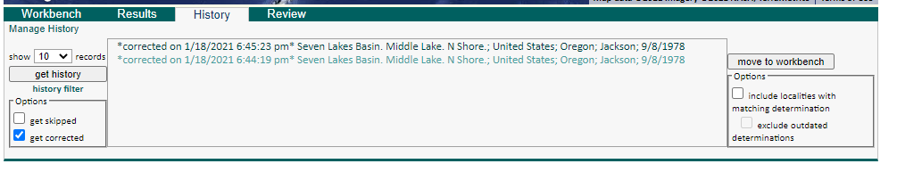
- If you want to fix a record that you previously georeferenced, click on the record that you would like to fix and then click the “move to workbench” button. This will move the specimen back to your Workbench, and you can georeference it using the regular georeferencing protocol. Click the Correct button, as usual, once you have georeferenced the specimen.
- If you want to import coordinates from an old record into a new record, click on the record from the list that has the coordinates you would like to import. A gold point should show up on the map. (Hint: sometimes the gold point can be obscured by a green or red point. You may have to move points around to find it).
  - Click the gold point (it will turn green).
  - Click the Workbench tab to move back to your workbench.
  - Continue georeferencing as before (but the values that you start with in the Calculated Coordinates will be those that you imported).

Table 1: Guidelines for georeferencing from different types of locality information. Adapted from Wieczorek et al. 2012 “Georeferencing Quick Reference Guide” (https://www.idigbio.org/wiki/images/1/1e/GeoreferencingQuickReferenceGuide.pdf) and Zermoglio et al. 2020 Georeference Quick Reference Guide [Community review draft] version b5a20n5
Locality type | Example | How to place coordinates | How to measure error radius/polygon
Bounded area: locality refers to a geographic feature with discernible spatial boundaries | “Las Vegas”  “Puerto Madryn”  “San Fernando” | Estimate the geographic center of the boundaries of the area. If the center of the area does not fall within the boundaries of the area (e.g., the area is moon-shaped or otherwise curved) find the smallest enclosing circle that contains the entire feature, but has its center on the boundary of the feature. | Measure the distance from the center of the area to the border of the area furthest from the center.
Undefined area: locality refers to a geographic feature that does not have a clear spatial boundary | “Hoosier Pass”  “Hills south of Los Osos” | Determine the coordinates for the geographic center of the area as well as possible using visual evidence (e.g., appearance of houses, changes in elevation, mountains) near the label for the area on the map. | Use half the measured distance from the selected coordinates to the center of the nearest feature (e.g., next town or geologic feature). Selecting the nearest feature can be tricky, and you should select a feature that is at a distance that indicates an appropriate level of uncertainty for your point (e.g., far away if you are uncertain, fairly close if you are rather certain in your geolocated point).  Make note of the feature that you measured to in the “Georeference Remarks” field.
Street address | “1 Orchard Lane, Berkeley, CA”  “319 Stadium Dr., Tallahassee, FL” | Locate the address on, e.g., Google maps, and find this location on the map in GEOLocate. | Use half the measured distance from the selected coordinates to the location of an address on either side of the given address. If the next address is too difficult to determine, use half the distance from the coordinates of the address to the further end of the block on which it sits.
Locality type | Example | How to place coordinates | How to measure error radius/polygon
Junction, intersection, crossing | “junction of Coora Rd. and E Siparia Rd.”, “bridge over Willamette River”, “interscn of CA 166 and 399” | Use the coordinates of the center of the intersection. | Use satellite or aerial images to find the extent of the intersection by measuring the distance from the center to the furthest part of it. If this is not possible, use the number of lanes of the larger of the two roads and multiply by 4 meters.
River, stream, road, path | “Sacramento River”, “Los Osos Valley Road”, “Rio Parana” | Make a straight line between the two points on the geographic feature that are most removed from each other, yet still within the administrative boundaries (e.g., county) specified in the locality description. Choose the point on the feature nearest to the midpoint of the line. | Use one half of the straight line that you made between the two points on the geographic feature that are most removed from each other, yet still within the specified administrative boundaries.
Mouth or headwaters of a river, confluence of waterways, trailhead | “headwaters of the Missouri River”, “Triangle Lake trailhead” | For a river mouth or confluence of waterways, select the midpoint of the line connecting the opposite shores where the waterways meet. For a river source, select the point of highest elevation on the river or create a boundary around the multiple streams contributing to the river and find the geographic center of that bounded area. For a trailhead, select the point where the trail begins. | For a river mouth or confluence of waterways, use the distance from the chosen point to the shore. For a single river source or trailhead, use 10 m.
Near a named place | “vicinity of Mt. Hood”, “near the Hoover Dam” | Determine the coordinates as either a Bounded area or Undefined area, as appropriate. | Determine the distance as either a Bounded area or Undefined area, as appropriate, and add additional uncertainty if you can do so without encompassing another major feature (e.g., another prominent town).
Between two places | “between Atascadero and San Luis Obispo” | Use the midpoint between the centers of the two named places. | Use half the distance between the centers of both named places.
Locality type | Example | How to place coordinates | How to measure error radius/polygon
Direction only, no distance | “N of Berkeley”, “SW of Gainesville” | Use the midpoint between the centers of the specified named place and the nearest feature (e.g., town or mountain range), where the nearest feature to use is in the specified direction. The nearest feature should be, for the first example, the nearest named place somewhere between NW and NE of Berkeley. | Use half the distance between the centers of both named places.
Specified distance in unnamed direction | “5 km outside Calgary”, “2 miles from Morro Bay” | Determine the coordinates as either a Bounded Area or Undefined Area, as appropriate. | The length of the radius should be the same as the distance given in the locality description.
Specified distance in a direction, no path given | “50 miles W of Las Vegas”, “30 km E of Sacramento” | Find the center of the feature (e.g., town) and measure the provided distance in the direction provided in the locality description. | Use half the measured distance from the selected coordinates to the center of the nearest feature.  Make note of the feature that you measured to in the “Georeference Remarks” field.
Specified distance in a direction, path given | “7.9 mi N Beatty, on US 95”, “7 mi. W Santa Barbara on 101”, “left bank of Mississippi River, 16 mi downstream from Paris” | Find the geographic center of the named place as either a Bounded area or Undefined area, as appropriate. Use the measuring tool to follow the specified route for the given distance. Use the end point as the coordinates. | Use half the measured distance from the selected coordinates to the center of the nearest feature.  Make note of the feature that you measured to in the “Georeference Remarks” field.

III. GEOLocate User Guide

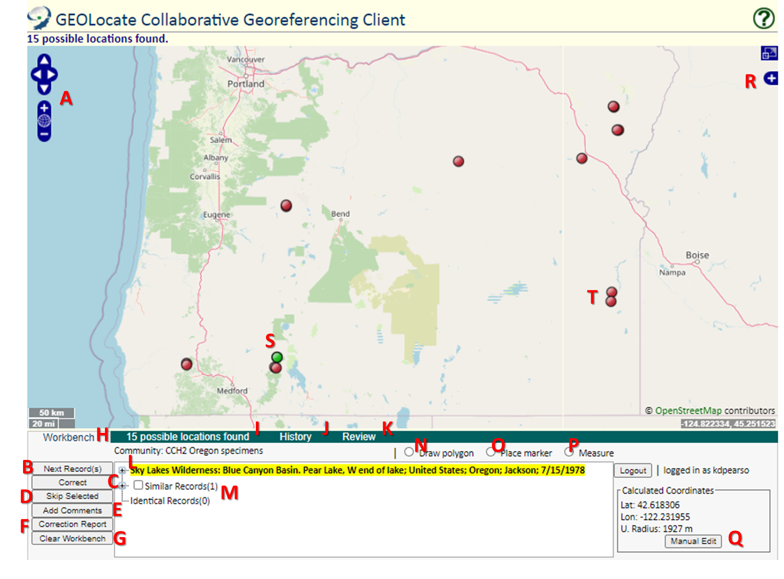

- Zoom and pan around the map using these buttons. The arrows will move the map, the plus sign will zoom in on the map, and the minus sign will zoom out on the map.
- Once you have georeferenced a record (and clicked Correct), you can load a new record by clicking this Next Record(s) button. Note that if there is already a record in your workbench, you will not be able to navigate to a new record until you click the Clear Workbench button.
- Click this button once you have georeferenced your specimen and added comments.
- Click this button if you are not able to georeference a specimen. You will be prompted to describe your reason for skipping the specimen. If you just don’t feel like doing a specific specimen, do NOT click Skip Selected. Instead, click Clear Workbench followed by Next Record(s).
- Click this button to add comments or a description of your georeferencing assumptions.
- Click this button to see a count of how many records you georeferenced (i.e., “corrected”), how many you have skipped, and how many are left to be georeferenced in the community.
- Click this button to refresh your workbench or to skip a record that you don’t feel like georeferencing.
- This tab will show you the locality you are currently georeferencing.
- This tab will show you the reasoning that GEOLocate used to place its green and red points. The text after the word “pattern” is the description. In some cases, this involves measuring a distance away from a landmark or town that is named in the description. Some examples and their translations are shown below.
GEOLocate placed the point at a location called “Summit” (perhaps a town or landmark).

GEOLocate placed the point on the approximate center of the Rogue River.

GEOLocate placed the point southeast of a landmark named Cave Junction at the distance specified by the locality description.
- This tab can be used to view specimens you have already georeferenced. See the section “Using the History Tab” on page XX.
- If you are an administrator, you will see this tab. It can be used to review records that have been georeferenced by other users.
- The highlighted text is the locality description from the specimen you are currently attempting to transcribe. It will also include the country, state, county, and collection date of the specimen, when available.
- GEOLocate automatically lumps similar and identical locality descriptions together. In the workbench under Similar Records and Identical Records, you can view these records and decide whether to include them in your current georeferencing effort. See the section labeled Checking Similar and Identical Records for how to use this function of the workbench.
- This tool can be used to draw an error polygon rather than an error radius. This should be used only in cases in which the described feature is not sufficiently represented by an error radius, such as a river, road, or other oddly-shaped feature.
- Click this button, then somewhere on the map, to place a fresh green point.
- You can use this tool to measure a distance on the map. Single click to place a vertex of the line (if you want the path to consist of more than one straight line). Double click to end the measurement. The measurement is shown in meters/kilometers on top and feet/miles on the bottom in green text.
- You can manually edit the latitude, longitude, and error radius of a georeferenced point by clicking the Manual Edit button and entering the values in the pop up window. Click the Ok button to save your edits.
- Click this tool to change the base map. This can be particularly helpful when elevation or topographical information is provided in the locality description. The list of currently available map layers is shown below (subject to change).
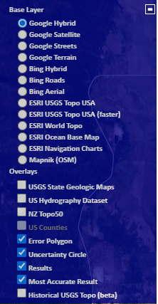
- The green point is GEOLocate’s best guess at where the specimen was collected, based on a comparison of the locality description to GEOLocate’s background list of locations. The reason for the placement of this point can be viewed in the Results tab (see letter I).
- The red points are GEOLocate’s alternative guesses at where the specimen was collected. The reason for the placement of these points can also be viewed in the Results tab (see letter I).

