General Imaging Station Setup

Last updated July 31, 2020
A simplified diagram of the general imaging station setup is shown below. Camera setting recommendations for the Nikon D800E with AF-S 50 mm f/1.8D lens are also provided.

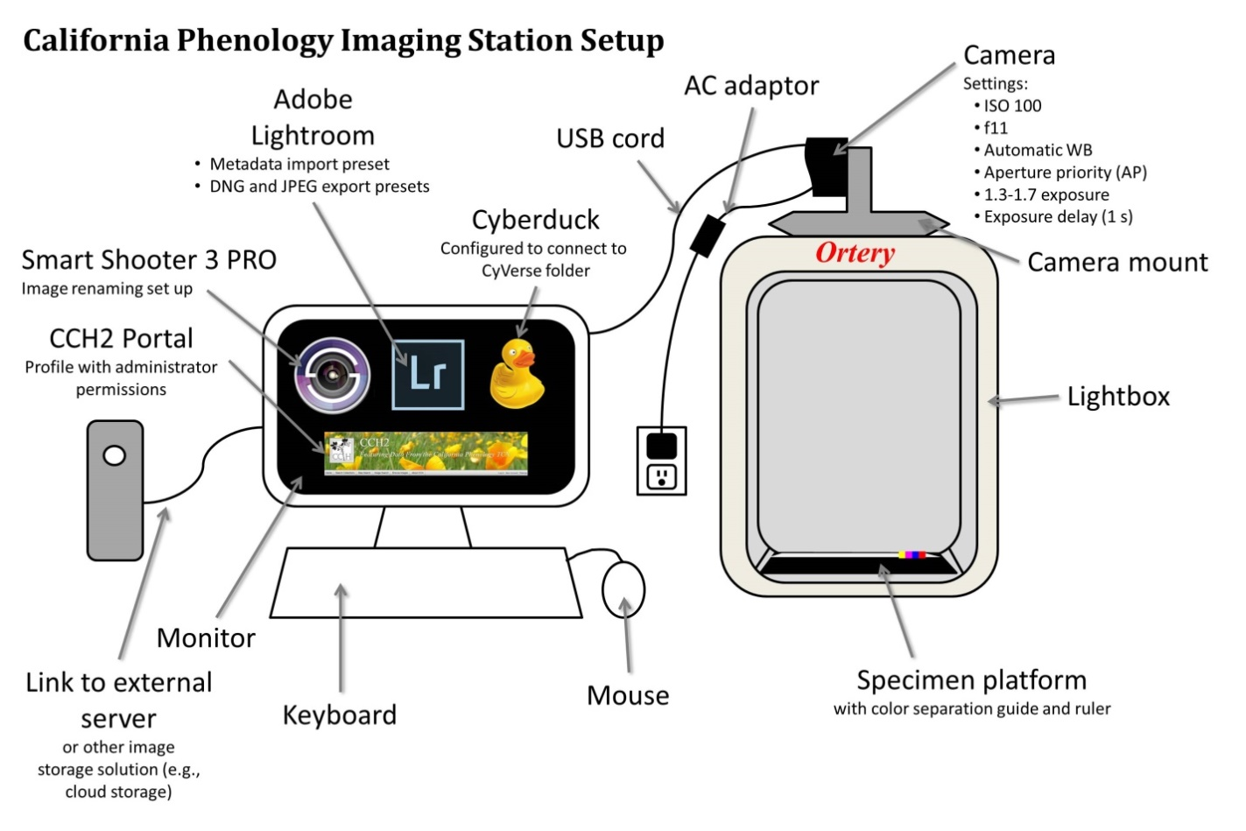

Equipment Recommendations
The following equipment was recommended for institutions that did not already have imaging stations at the start of the project. Many institutions were able to use preexisting equipment.
Item | Expected price | Source(s)
Nikon D800E 36.3 MP CMOS FX-Format Digital SLR Camera  (if you cannot find this model, a D800 or D810 would also work) | $1000-1500 | Amazon, etc. (note that this model is no longer supplied by Nikon, you will need to purchase from a third party)
Nikon AF-S FX NIKKOR 50mm f/1.8D Lens | $200 | Best Buy, Amazon, etc.
Nikon EP-5B Power Supply Connector | $48 | Amazon, etc.
Nikon EH-5b AC Adapter  Note: it is possible to purchase off brand Nikon power supplies for much cheaper; however, there are some reports that these have caused the camera to malfunction; buy at your own risk | $100 | Amazon, etc.
Ortery Photosimile 50 lightbox | $2,100 + 300 shipping | Email Grant Grzecka <Ggrzecka@ortery.com>. Say you are with Cal Poly and copy Katie so he knows you’re with us. Grant will need your billing and shipping address as well as how you would like to pay. They accept credit card, bank wire transfer, or check.
Symbol LS2208 General Purpose Barcode Scanner | $40-60 | Amazon, etc.
Goose neck stand for Symbol Scanner LS2208 | $10-30 | Amazon, etc.
Tiffen Q-13 Color Separation Guide (Small) | $32 | B&H Photo, Amazon, etc.
Imaging computer with 4+ GB of RAM and 500+ GB of internal storage, preferably with a solid state drive (SSD), reasonable graphics card, more than three USB ports (USB 3.0 preferred); Mac or PC OK | up to $1200 | Best Buy, Costco, Amazon, etc.  Examples: Lenovo IdeaCentre 510A, other Lenovo, Apple iMac
(If desktop computer) Good quality computer monitor
(If desktop computer) Mouse and keyboard
Ethernet cable | $5 (likely available for free through IT department)
Smart Shooter 3 PRO | $195 | Smart Shooter 3 website
Adobe Lightroom 6 or Adobe Lightroom Classic CC | $150 | Adobe website or institutional license (check with your institution to see whether this is already available to you)
Camera Mount System (see Section 5) | ~$60* | *Manufactured at Cal Poly and provided to partner institutions free of charge
Specimen Backdrop (see Section 5) | ~$7 | Craft store or other source
Barcodes | see Section 6

Custom Imaging Equipment
Institutions using the Ortery Photosimile 50 will need a camera mount system and specimen backdrop. The Cal Poly machine shop designed and manufactured camera mount systems for institutions that needed them at the beginning of the grant. The specifications and installation of this camera mount system are provided here. Each institution should manufacture a specimen backdrop (instructions provided).

Camera Mount System
The camera mount shown below was constructed for each institution that purchased an Ortery lightbox.
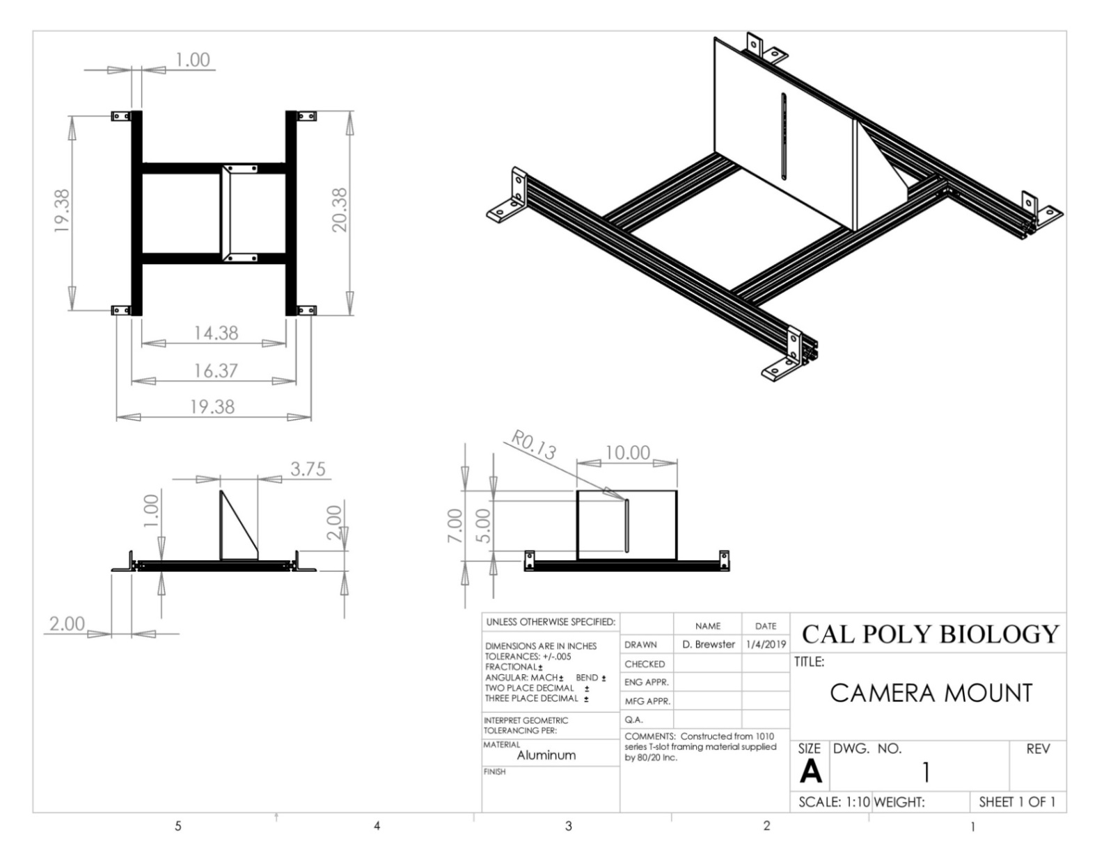

Installing the Camera Mount System
- Unscrew the four white knobs from the top four corners of the lightbox.
- Place the camera mount on the lightbox with the black rubber pad of the flat, upright piece facing left (see image below).
- Use the black knobs to fasten the four corners of the mount to the lightbox (circled in Figure 5.1).
- Mount the camera on the flat, upright piece by placing the bottom of the camera along the black rubber strip, fitting a black screw through the slot, and tightening it into place
- Adjust the positioning of the camera to be able to fit an entire specimen and the color bar into the camera’s field of view. You can accomplish this by:
  - moving the camera up or down in the camera mount slot,
  - using a 4 mm Allen wrench to loosen and tighten the black screws (see arrows on Figure 5.1) that hold the flat, upright piece to the aluminum bars
  - and using a 2.5 mm Allen wrench to loosen and tighten small hex-head screws in the gussets (L-shaped connectors) that connect the aluminum bars to one another (see arrows on Figure 5.2).
- Once you have tightened all the screws, double-check the field of view. Even slight adjustments can change the angle of the camera lens and greatly affect the resulting field of view.

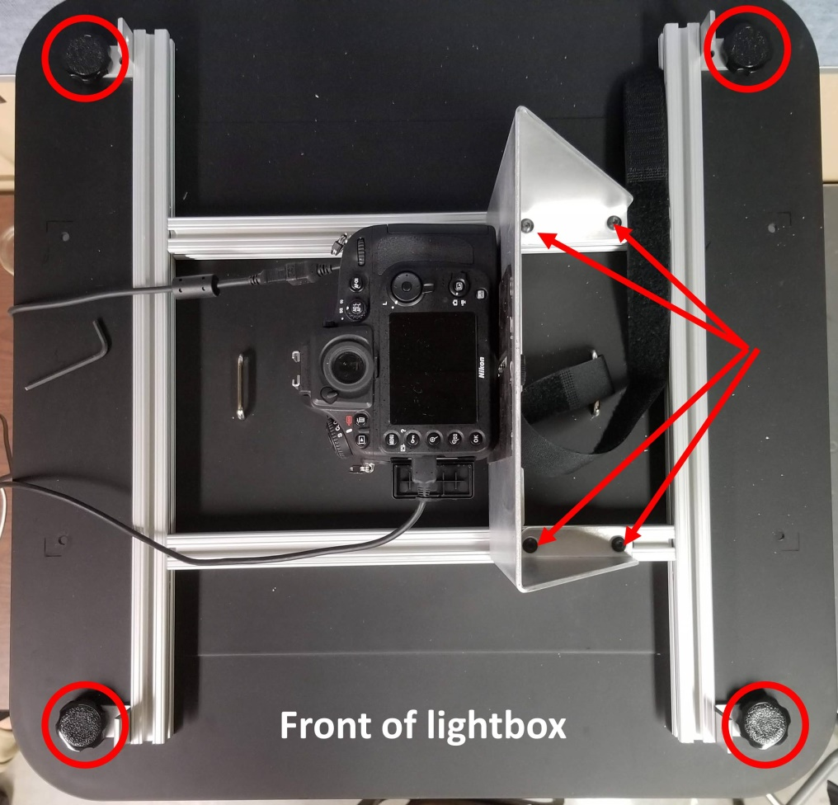
Figure 5.1 Top view of lightbox with installed camera mount. The knobs that secure the mount to the lightbox are circled in red, and the arrows indicate screws that can be tightened or loosened with a 4 mm Allen wrench to move the camera left or right.

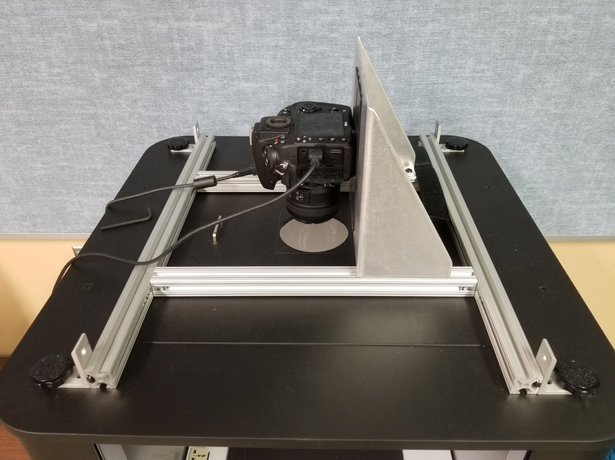
Figure 5.2 Angled view of top of lightbox with installed camera mount. The arrows indicate screws that can be tightened or loosened with a 2.5 mm Allen wrench to move the camera away from or toward the door of the lightbox.

Specimen Backdrop
(Adapted from Legler 2010, Assembling the Custom Components for Specimen Imaging, Consortium of Pacific Northwest Herbaria)

Supplies
- Black foamboard or fiberboard (approximately 1/8” thick) CLEANLY cut into the following pieces
  - 15” x 20”
  - 15” x 1.5”
  - 18.5” x 1.75”
- Double-sided tape or glue
- Razor blade or X-acto knife
- Metal ruler or other straight-edge for cutting
- Tiffen Q-13 color separation guide (see Section 4.1) or other color guide
- Color printout of your institution’s logo, no taller than 2.5 centimeters

Assembly and Installation
- Cut the foamboard into the necessary sizes, making sure that cuts are clean and straight. Use outside edges whenever possible, which are already straight.
- Use double-sided tape to attach the 15” x 1.5” strip to one of the 15” ends of the large (15” x 20”) sheet. Carefully align the outside edges of the strip with the outside edges of the large sheet. The edge will form the top of the holder.
- Use double-sided tape to attach the 18.5” by 1.75” strip to the left side of the sheet and under the 15” strip at the top. The strip should tightly abut the previously attached strip, and its outside edge should align with the outside edge of the uncut sheet.
- Cut the Tiffen color separation guide such that it will completely fit on the 1.5” strip at the top of the specimen backdrop. This will mean cutting off the text of the color control patch (see dashed line below). Do not discard either piece of the color control patch.

- Cut the ruler at the top of the Tiffen color separation guide down to about 13 centimeters.
- Use double-sided tape to affix the colored strip, the printout of your institution’s logo, and the shortened ruler to the top 1.5” strip, as seen in the photo below.
- Lay the specimen platform in the lightbox such that the raised strips are to the top and left. The color bar and ruler should be furthest away from the lightbox opening.
- Before affixing the specimen platform to the lightbox floor with double-sided tape, install the camera mount system. You may need to adjust the position of the specimen platform as you adjust the camera mount so that your images are properly aligned.

