Georeferencing Individual Specimens in CCH2
Last updated by Katie Pearson on September 30, 2020

For a video introduction to GeoLocate, see: https://vimeo.com/showcase/2163673/video/65222791

- Log in to your account in the CCH2 portal, click “My Profile,” navigate to the “Specimen Management” tab, and click the name of the institution for which you will be georeferencing.
- In the Data Editor Control Panel, click “Edit Existing Occurrence Records.”
- In the Record Search Form, specify your search to include the specimens that you are interested in georeferencing and have not already been georeferenced. For example, if you wanted to georeference all the Eschscholzia californica in San Luis Obispo county, your record search form should look like this:
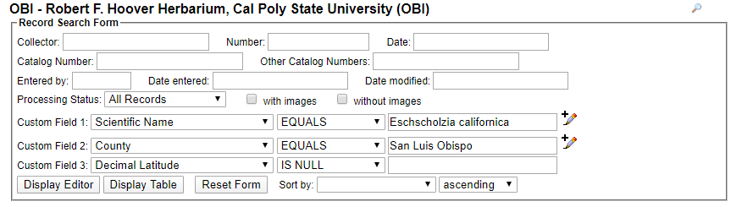
Notice that we specify “Decimal Latitude” IS NULL because we are specifically searching for specimens that have not already been georeferenced.
- Click either Display Editor (to see one specimen at a time) or Display Table (to see a table of all the specimens).
- Select the specimen you wish to georeference (if it is not already open) and click the Dupes? button at the top right hand corner of the page (circled below).
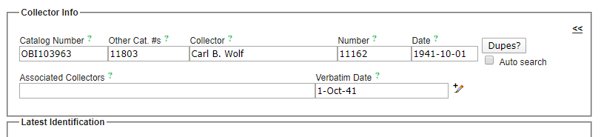
- If you see a No Dupes message, proceed to step 7. If a window pops up (make sure you do not have a pop-up blocker activated) that says Possible EXACT Duplicates or Potential Duplicate EVENTS, do the following:
  - In the search results, look for any records that have latitude/longitude coordinates (see example window below). If none of the potential duplicates have latitude/longitude coordinates, close the pop-up window and proceed to step 7.
  - Compare the location information on your specimen record (in the Locality field) to the location information for the potential duplicate record(s) that has latitude/longitude coordinates. If both location descriptions indicate the exact same place, click Transfer to Empty Fields Only. If none of the location descriptions for the potential duplicates match the location description of your specimen, close the pop-up window and proceed to step 7.
  - If you transferred information into the specimen record, double check ALL blue highlighted fields to make sure that the data match your specimen record. Delete any data that was imported into fields that are not in the Locality box.

The example below shows an instance when you would NOT “transfer to empty fields only” because the locations are not the same. Although the SD specimen has latitude/longitude, the locality description (“East end of El Monte Road, El Capitan...”) does not match the original record’s locality description (“Near hwy 101 in SLO”).

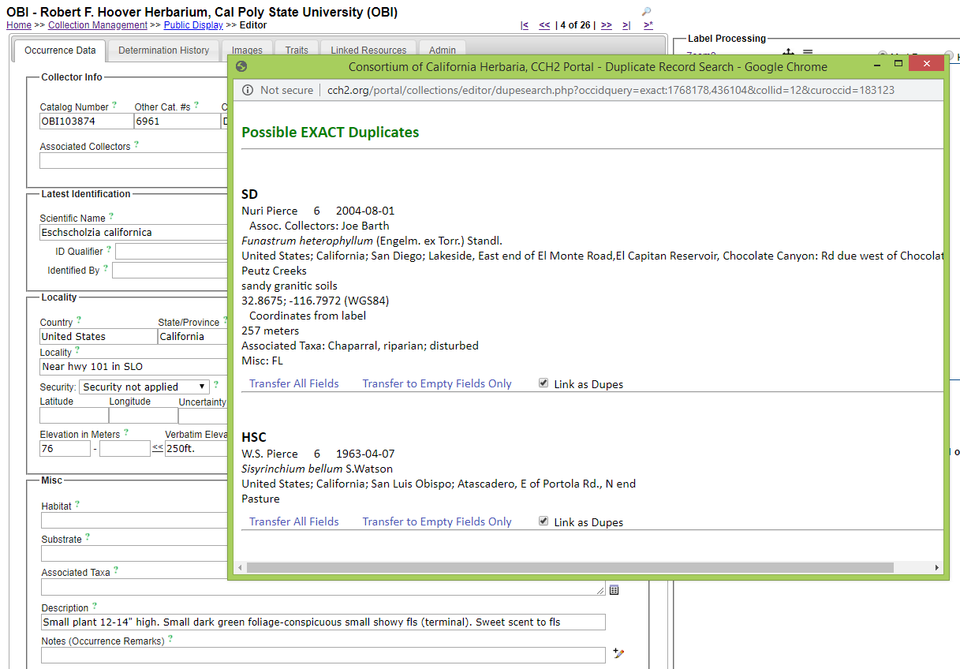
- Click the C button to the left of the latitude and longitude fields in the Locality box. In the pop-up window (make sure your pop-up blocker is disabled for CCH2), select the Contains radio button and click Search. If you see the message “Search failed to return specimen matches”, proceed to step 8. If otherwise, do the following:
  - View the potentially matching localities in the resulting map (see next page). If any of them seem to match the location of your specimen (judging from the location description on your specimen), click that coordinate and click Use Coordinates.
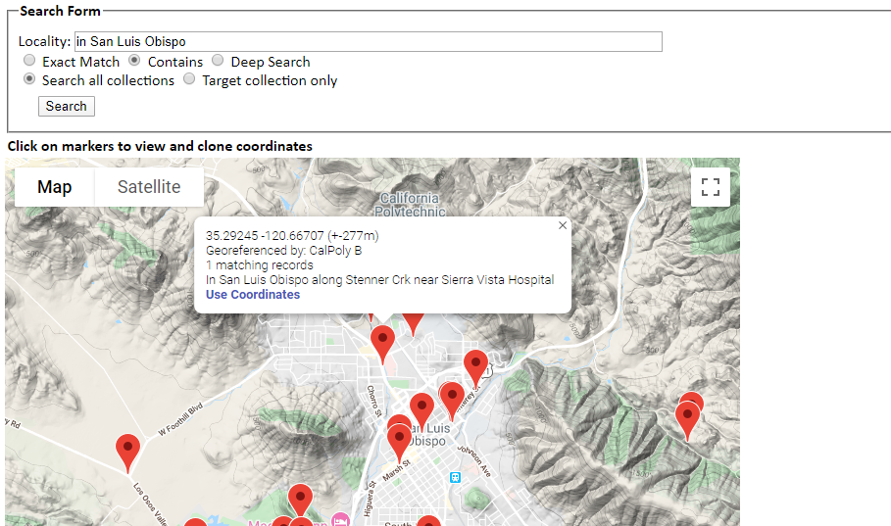
  - Click the globe icon to the right of the uncertainty field. In the resulting window, adjust the point and the uncertainty radius according to the point-radius method (read through the remainder of the protocol for instructions on how to do this accurately).
- Click the Geolocate () icon to the right of the latitude, longitude, and uncertainty fields. This will open a new GeoLocate window (see screenshot below) displaying a map and, in some cases, possible location(s) for the specimen that GeoLocate inferred from the text.
  - The green dot is GeoLocate’s best guess for the locality of the specimen. You may also see red dots, which are alternative guesses.
  - To view the reasons why GeoLocate selected these dots, click the “# possible locations found” tab to the right of the Workbench tab. The words in all caps are those that GeoLocate used to infer a location.
- Click the “Options” button on the bottom left of the GeoLocate window and ensure the “Do Uncertainty” box is checked. Close the Georeferencing options window.
- Make sure that all of the boxes (latitude, longitude, uncertainty, and error polygon) near the bottom right of the window are checked.
- If there are dots on the map, investigate whether any of them could be a good starting point for your georeferencing by comparing the dots’ locations on the map to the text in the Locality String (see dashed box in screenshot above). It is possible that none of the dots indicate the correct locality. If this is the case, you can ignore the dots or remove them by clicking the “# possible locations found” tab and clicking the circled ‘x’ to the left of each rejected entry (see below).
  - When deciding whether to use one of the GeoLocate dots, make sure to check that the state and county where the dot has been placed matches the state and county indicated by the record.
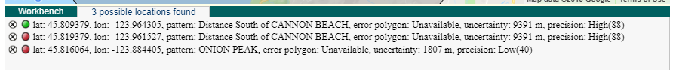
- Either starting with a GeoLocate dot, if appropriate, or from scratch, use the Locality String to determine an approximate location for the specimen. This will likely require searching other references (e.g., Google maps) for location and feature names.
  - You can change the base layer (i.e., the type of map shown in the GeoLocate window) by clicking the plus symbol in the upper right corner of the window (see screenshot on next page).
  - To measure a distance on the map, click the button next to “Measure” and click on a starting point on the map. You can then move your cursor anywhere on the map and a line will be measured between those two points. The length of the line will be shown in green next to the line. To measure between more than one point, click again to anchor another point. To stop measuring, double click on the ending point of your measurement.
  - If there is not enough information in the Locality String to assign an approximate point, look back at the specimen record to see whether there is more locality information in another data field (e.g., habitat) or on the specimen image (if available).
    - If you are still not able to assign an approximate point from this information and you think someone else may be able to georeference this record in the future, move on to another record. If you think the specimen data are insufficient for anyone (even an expert) to georeference the specimen, add a note in the Georeference Remarks field (click the pencil at the bottom right corner of the Locality box) that begins with “cannot georeference.”
      - If only a county is provided, enter “locality imprecise; cannot georeference” in the Georeference Remarks field.
- Once you have found an approximate location for the specimen record, click the button next to “Place Marker” and click on the map where you want to place the GeoLocate dot. Follow the guidelines provided in Table 1 when deciding where to place the dot.
- Set the error radius and/or create an error polygon to indicate the uncertainty of the specimen’s locality. Follow the guidelines provided in Table 1 when deciding how large of an error radius to use for a given point and whether you should use an error polygon.
  - To edit the size of the error radius, click the green dot on the map and select “Edit Uncertainty” in the pop-up box. Click and drag the grey arrowhead that will appear on the outer rim of the error circle to resize the error radius.
  - To create an error polygon, click the button next to “Create polygon” and click on the map where you want to begin drawing the polygon. A corner of the polygon will be created time you click on the map. To finish the polygon, double click. Once you have completed the polygon, click the green dot again and select “Resize uncertainty to polygon.”
    - To redo a polygon, click the “Clear Polygon” button to the right of the “Options” button.
- When you are confident in your GeoLocate point and error radius, click the “Save To Your Application” button at the bottom of the GeoLocate window. You will be taken back to the specimen record page.
  - The coordinates and error will now show up below the search results in the appropriate Latitude, Longitude, Uncertainty fields, and Georeference Remarks. If you created an error polygon, its coordinates will be listed in the Footprint Polygon field.
- Explain your reasoning for setting the error radius in the Georeference Remarks field (indicated by the arrow below). For example, if you were georeferencing a named place that did not have clear boundaries, explain how you determined a suitable error radius.
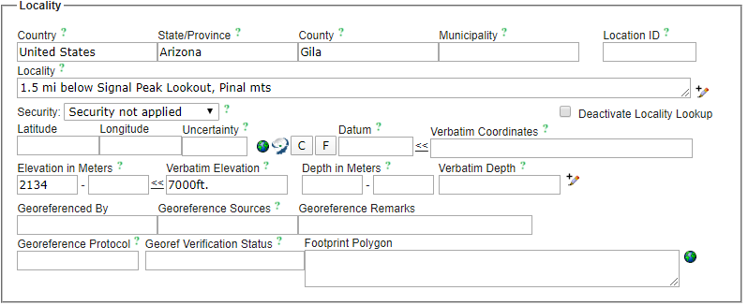
- Add your CCH2 username to the Georeferenced By field.
- Click the Save Edits button at the bottom of the page.

Helpful resources:

For georeferencing videos:
https://vimeo.com/showcase/2163673

For USGS topo maps (including old locations):
https://store.usgs.gov/map-locator

For historical maps
https://www.oldmapsonline.org/

For georeferencing township, range, section (TRS) coordinates
http://www.earthpoint.us/TownshipsSearchByDescription.aspx

Table 1: Guidelines for georeferencing from different types of locality information. Adapted from Wieczorek et al. 2012 “Georeferencing Quick Reference Guide” (https://www.idigbio.org/wiki/images/1/1e/GeoreferencingQuickReferenceGuide.pdf) and Zermoglio et al. 2020 Georeference Quick Reference Guie [Community review draft] version b5a20n5
Locality type | Example | How to place coordinates | How to measure error radius/polygon
Bounded area: locality refers to a geographic feature with discernible spatial boundaries | “Las Vegas”  “Puerto Madryn”  “San Fernando” | Estimate the geographic center of the boundaries of the area. If the center of the area does not fall within the boundaries of the area (e.g., the area is moon-shaped or otherwise curved) find the smallest enclosing circle that contains the entire feature, but has its center on the boundary of the feature. | Measure the distance from the center of the area to the border of the area furthest from the center.
Undefined area: locality refers to a geographic feature that does not have a clear spatial boundary | “Hoosier Pass”  “Hills south of Los Osos” | Determine the coordinates for the geographic center of the area as well as possible using visual evidence (e.g., appearance of houses, changes in elevation, mountains) near the label for the area on the map. | Use half the measured distance from the selected coordinates to the center of the nearest feature (e.g., next town or geologic feature). Selecting the nearest feature can be tricky, and you should select a feature that is at a distance that indicates an appropriate level of uncertainty for your point (e.g., far away if you are uncertain, fairly close if you are rather certain in your geolocated point).  Make note of the feature that you measured to in the “Georeference Remarks” field.
Street address | “1 Orchard Lane, Berkeley, CA”  “319 Stadium Dr., Tallahassee, FL” | Locate the address on, e.g., Google maps, and find this location on the map in GeoLocate. | Use half the measured distance from the selected coordinates to the location of an address on either side of the given address. If the next address is too difficult to determine, use half the distance from the coordinates of the address to the further end of the block on which it sits.
Locality type | Example | How to place coordinates | How to measure error radius/polygon
Junction, intersection, crossing | “junction of Coora Rd. and E Siparia Rd.”, “bridge over Willamette River”, “interscn of CA 166 and 399” | Use the coordinates of the center of the intersection. | Use satellite or aerial images to find the extent of the intersection by measuring the distance from the center to the furthest part of it. If this is not possible, use the number of lanes of the larger of the two roads and multiply by 4 meters.
River, stream, road, path | “Sacramento River”, “Los Osos Valley Road”, “Rio Parana” | Make a straight line between the two points on the geographic feature that are most removed from each other, yet still within the administrative boundaries (e.g., county) specified in the locality description. Choose the point on the feature nearest to the midpoint of the line. | Use one half of the straight line that you made between the two points on the geographic feature that are most removed from each other, yet still within the specified administrative boundaries.
Mouth or headwaters of a river, confluence of waterways, trailhead | “headwaters of the Missouri River”, “Triangle Lake trailhead” | For a river mouth or confluence of waterways, select the midpoint of the line connecting the opposite shores where the waterways meet. For a river source, select the point of highest elevation on the river or create a boundary around the multiple streams contributing to the river and find the geographic center of that bounded area. For a trailhead, select the point where the trail begins. | For a river mouth or confluence of waterways, use the distance from the chosen point to the shore. For a single river source or trailhead, use 10 m.
Near a named place | “vicinity of Mt. Hood”, “near the Hoover Dam” | Determine the coordinates as either a Bounded area or Undefined area, as appropriate. | Determine the distance as either a Bounded area or Undefined area, as appropriate, and add additional uncertainty if you can do so without encompassing another major feature (e.g., another prominent town).
Between two places | “between Atascadero and San Luis Obispo” | Use the midpoint between the centers of the two named places. | Use half the distance between the centers of both named places.
Locality type | Example | How to place coordinates | How to measure error radius/polygon
Direction only, no distance | “N of Berkeley”, “SW of Gainesville” | Use the midpoint between the centers of the specified named place and the nearest feature (e.g., town or mountain range), where the nearest feature to use is in the specified direction. The nearest feature should be, for the first example, the nearest named place somewhere between NW and NE of Berkeley. | Use half the distance between the centers of both named places.
Specified distance in unnamed direction | “5 km outside Calgary”, “2 miles from Morro Bay” | Determine the coordinates as either a Bounded Area or Undefined Area, as appropriate. | The length of the radius should be the same as the distance given in the locality description.
Specified distance in a direction, no path given | “50 miles W of Las Vegas”, “30 km E of Sacramento” | Find the center of the feature (e.g., town) and measure the provided distance in the direction provided in the locality description. | Use half the measured distance from the selected coordinates to the center of the nearest feature.  Make note of the feature that you measured to in the “Georeference Remarks” field.
Specified distance in a direction, path given | “7.9 mi N Beatty, on US 95”, “7 mi. W Santa Barbara on 101”, “left bank of Mississippi River, 16 mi downstream from Paris” | Find the geographic center of the named place as either a Bounded area or Undefined area, as appropriate. Use the measuring tool to follow the specified route for the given distance. Use the end point as the coordinates. | Use half the measured distance from the selected coordinates to the center of the nearest feature.  Make note of the feature that you measured to in the “Georeference Remarks” field.

