Course Syllabus

Exploring Plant Phenology Using Herbarium Specimens
Pearson KD, Love NR, Ramirez Parada T, and Yost J
version 1, last updated 28 July 2020

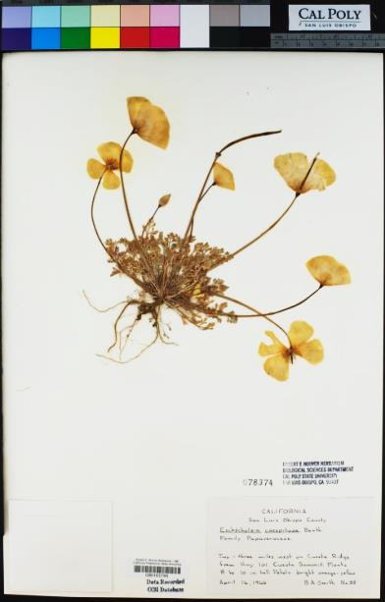
Instructors and office hours

Key terms
- Digitization – creation of digital data from once analog-only data; this includes taking pictures of specimens and transcribing label data
- Herbarium specimen – dried, pressed plant and associated data stored in a natural history collection like the Cal Poly Hoover Herbarium (see photo above)
- Phenology – the timing of growth and reproduction, for example, flowering and fruiting for angiosperms

Course description
Volumes of data on plant diversity are becoming available with the digitization of herbarium specimens. Images of herbarium specimens provide a rich resource that can be harvested for data on plant form and phenology. In this course, students will design and conduct original research that examines the effect of climate on plant phenological events (e.g., flowering) using herbarium specimen data. Students will augment existing specimen records with phenological and georeference data in the CCH2 data portal. They will then visualize, clean, and analyze herbarium specimen data and climate data using Excel and R code (through RStudio). Each student will present their research as a scientific report, poster, and/or a lightning talk (5 minute oral presentation). During weekly class meetings, important topics and guidance regarding the research process will be discussed.

Learning objectives
The overarching goal of this course is to provide opportunities to learn and practice scientific research skills through developing and conducting an original research study. By engaging in the research process, students will learn to:
- Read and evaluate scientific literature
- Identify and generate scientific questions and hypotheses
- Design experiments or analyses to describe trends and/or test hypotheses
- Evaluate the limitations of a data sources and design analyses that effectively take these limitations into account
- Gather and vet data from disparate sources
- Use R code (in RStudio) and Microsoft Excel to clean and analyze data
- Produce visualizations of data analyses in RStudio
- Write an academic report or assemble a scientific poster in a clear, concise, scientific tone
- Speak knowledgeably and concisely on conducted research
- Seek, evaluate, and incorporate feedback on work

Grading
This course will be graded as Pass/Fail. To receive a passing grade, you must complete the following before the end of the course:
- Regularly attend and actively participate in class
- Complete and turn in all assignments

Course Requirements

Required texts and material
You will need a laptop computer with Microsoft Office and RStudio installed. Students should already be familiar with basic use of Microsoft Excel.
Students will need to download R and RStudio (free software) onto their work computer/laptop. Instructions will be provided. Previous experience with R code is helpful, but not required.
Required readings will be available via the course website or via email.

Attendance and engagement
Attendance is required for successful completion of this course. More than one unexcused absence will result in a failing grade. Students are expected to participate in class discussions in a manner that is respectful of each fellow student and the instructors.

Late or missed assignments
All assignments must be finished and turned in / checked off to complete the course. To avoid getting behind in the course, assignments should be turned in according to the due date listed in the syllabus.

Quality of work
Although this is a pass/fail course, students are expected to put effort into their work as if the content were letter-graded. The more effort you put in to a scientific project, the more you will learn from it.

Disability accommodations
If you have a documented disability and wish to discuss academic accommodations, please contact one of the instructors as soon as possible.

Draft weekly schedule
Assignments designated in the “Assignment(s) due” column are due by class time during the week indicated on the left.
*Schedule of topics may change without prior notice. Any changes in due dates will be announced.
Week | In-class topic(s) | Assignment(s) due
Week 1 | - Course introduction and background  - Scientific questions  - Independent and dependent variables  - Reading scientific literature | - Assignment 1: Course introduction readings
Week 2 | - Refining your research question  - Sources of data and their limitations  - Collecting phenological data | - Assignment 2: Dependent and independent variables
Week 3 | - Methods and assumptions in data analysis  - Linear models in RStudio | - RStudio installed on computer and new project created (see protocol 2)  - Assignment 3: Phenological scoring guide (see also protocol 3)
Week 4 | - R questions | - Assignment 4: Preparing and analyzing data in R
Week 5 | - Writing a scientific paper / creating a research poster  - Data collection & troubleshooting | - Half of target dataset phenologically scored  - Read Turbek et al. 2016
Week 6 | - Data cleaning | - Entire dataset phenologically scored  - Annotated bibliography (8 sources)
Week 7 | - Describing results  - Designing additional analyses | - Preliminary results with cleaned data  - Introduction section of poster
Week 8 | - Interpreting results (discussion and conclusion) | - Methods and results sections of poster
Week 9 | - Giving and receiving feedback | - Draft of final poster/paper
Finals week | - Poster presentations | - Final poster/paper  - Course evaluation

List of Course Materials

Assignments
- Assignment 1: Course Introduction Readings
- Assignment 2: Independent and Dependent Variables Research
- Assignment 3: Phenological Scoring Guide
- Assignment 4: Preparing and Analyzing Data
- Annotated Bibliography Assignment
- Peer Review
- Final Poster / Final Report

Guides/Protocols
- Protocol 1: Using the CCH2 data portal
- Protocol 2: Preparing to use RStudio
- Protocol 3: Using the phenological scoring tools in CCH2
- Discussion and conclusions checklist

Slides and In-class Activities
- Class 1 slides: Welcome and introduction
- Class 2 slides: Refining your research question
- In-class activity 3: Reading methods sections of papers
- Class 3 slides: Linear regression in R
- Class 5 slides: Creating a research poster / research report
- Class 6 slides: Data cleaning
- Class 7 slides: Results
- Class 8 slides: Discussion and conclusions
- Class 9 slides: Giving and receiving feedback
- Course assessment

R Scripts and datasets
- Class 3 code: Demonstrating linear regression in R
- Class 3 dataset: Gamochaeta data
- Assignment 4 code
- Assignment 4 dataset: Nemophila data
- Class 6 code: Data cleaning and final analyses

