Protocol 2: Preparing to Use RStudio
Pearson KD, Mazer SJ, Yost JM. September 30, 2020
Exploring the Effects of Climate on Plant Phenology Using Herbarium Specimens course

Part 1: Complete the Following Tutorials
- Setting up R and RStudio:
https://datacarpentry.org/R-ecology-lesson/index.html#Setup_instructions

- Setting up and Working Directory:
https://datacarpentry.org/R-ecology-lesson/00-before-we-start.html#Getting_set_up

- RStudio Projects and Working Directories:
https://www.r-bloggers.com/rstudio-projects-and-working-directories-a-beginners-guide/

- More on RStudio Projects:
https://support.rstudio.com/hc/en-us/articles/200526207-Using-Projects

Part 2: Install R and RStudio
First install the base program, R, by visiting the following website and selecting the appropriate version of R (Linux, Mac, or Windows) from the options available: https://cran.rstudio.com/
Next, install RStudio (a graphic user interface for R) by visiting the following website and selecting the appropriate version from the All Installers list. You will want to download RStudio Desktop, which is free. https://rstudio.com/products/rstudio/download/

Part 3: Set Up Folders
On the desktop of your computer, create a folder named PhenologyCourse. Within this folder, create two folders, one named Data and one named Scripts. Within the Data folder, create two folders, one named specimen_data and one named prism_data. Make sure that your names match the provided names exactly, including capitalization. Otherwise, you will have trouble loading and running scripts in the future. You should keep this folder and its contents on your desktop for the remainder of the course.

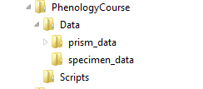

Part 4: Create a New Project
Open RStudio. Click File in the top left corner. Select New Project... from the dropdown list. Now you will want to decide where you will keep all the files associated with this course (or at least the first assignment). Select Existing Directory from the pop-up window. Click the Browse button and select the PhenologyCourse folder that you created in part 2. Click the Open button, then Create Project.

Part 5: Install Packages
In one of the windows of RStudio (usually the bottom right), you will see a window that has multiple tabs: Files, Plots, Packages, Help, and Viewer. Click on the Packages tab. Click the Install button in the top left corner (circled below).

In the pop-up window, make sure the Install from: field is filled with Repository (CRAN) and that the Install to Library field is set to the default directory (it will say [default]). In the Packages field, enter each of the following package names, separated by a space. Make sure that you enter them exactly as shown below (without capitalization).

car, broom, leaflet, raster, sp, tidyverse, tidyselect, visreg

You may also cut and paste this list into the Packages field, as shown below:

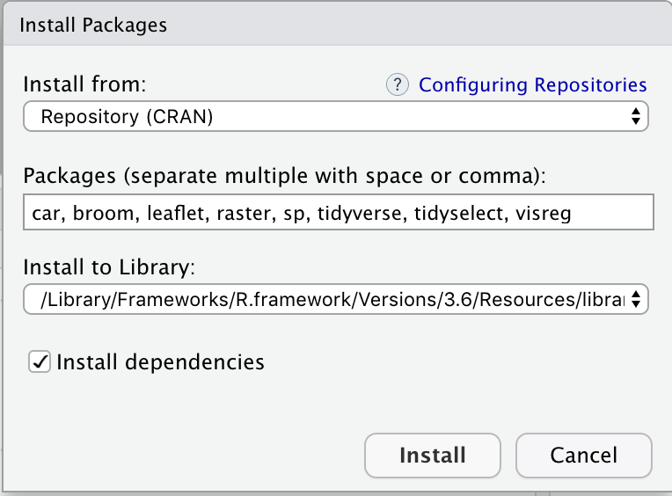

Then, click the “Install” button.

Allow the packages to install (it might take a little while). You may see some error messages, but don’t be alarmed. Unless you see something like “failure to install”, you should be fine.

