Protocol 3: Guide to Phenological Scoring Tools in the CCH2 Portal
Pearson KD, Mazer SJ, Yost JM. September 30, 2020
Exploring the Effects of Climate on Plant Phenology Using Herbarium Specimens course

I. Scoring phenology from images (using trait coding tool)
This is the most efficient method of scoring phenology from images. To access and use this tool:
- Log in to your account in CCH2 (cch2.org).
- Click My Profile.
- Click the Specimen Management tab.
- Click the name of the collection for which you will score specimens for phenology (there will likely only be one).
- In the Data Editor Control Panel, click Occurrence Trait Coding Tools.
- Select “Trait Coding from Images” from the two provided options.
- In the Filter box, select Angiosperm Phenological Traits from the Trait dropdown menu.
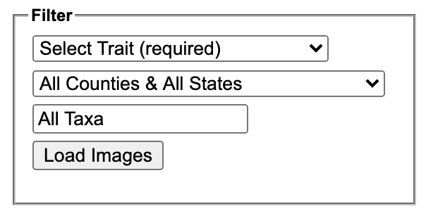
- Type the name of the taxon for which you wish to score phenological traits in the All Taxa box. A dropdown list will appear, and you should select the appropriate taxon from that list. You can also refine your search by using the All Source Types and All Counties & All States dropdown lists (see descriptions below).
  - All Source Types: this field allows you to view and re-score specimens that have already been scored using another method (e.g., text mining). Leave this as is unless you are specifically working on re-annotating specimens.
  - All Countries & All States: this field provides a dropdown menu of all countries and U.S. states that are indexed in CCH2. If you select one of these geographic criteria, the tool will only show you specimens from that country/state.
- Click the Load Images button. On the next page, you will see an image of a specimen of the selected taxon on the left, and an Action Panel on the right (see screenshot on next page). Note that you can edit the contents of the Filter box as well.
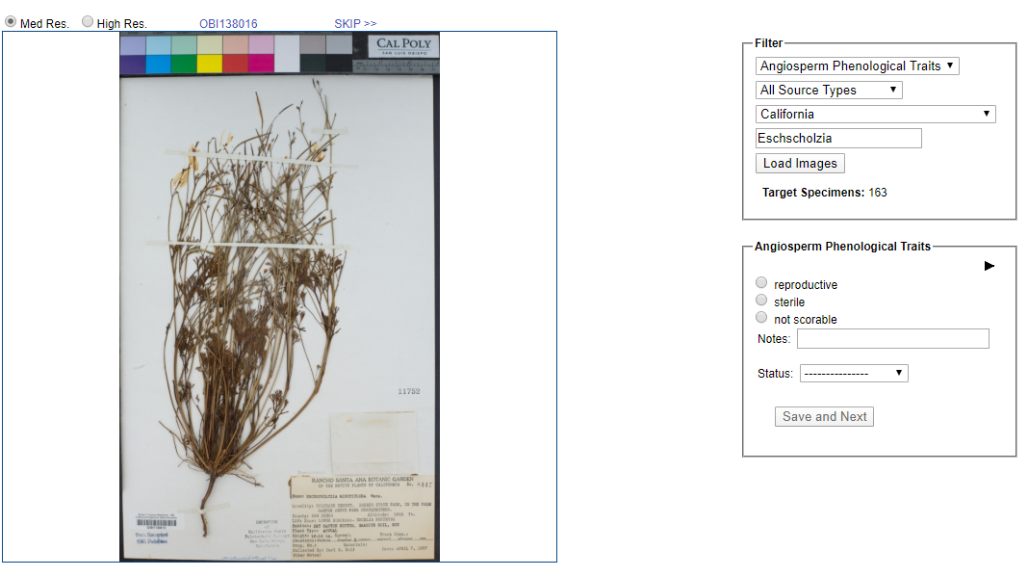
- If you wish to score the specimen with more detail than just “reproductive” or “sterile”, click the black triangle inside the Action Panel to show the finer-scale phenological scoring options (circled above).
- From this list, select which reproductive structures are present or absent on the specimen. If you are not sure about the presence or absence of a structure, leave the radio buttons for that structure unfilled.
  - If the image cannot be scored (e.g., the majority of plant is obscured or damaged), select “not scorable.”
  - If you are unsure about your scoring, write a note about your uncertainty in the Notes field and change the Status to Expert Needed. Click Save and Next. Alternatively, you can skip the image by clicking SKIP >> at the top right of the image.
- Once you are satisfied with your scoring, click Save and Next.

II. Scoring phenology from images (using occurrence editor)
You can also score the phenology of a specimen from that specimen’s occurrence editor page by clicking the Traits tab (circled below).
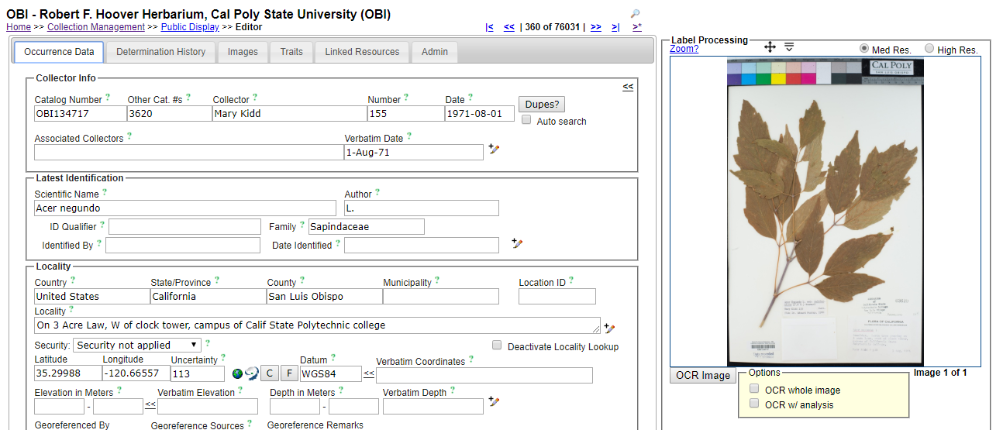
If you wish to score the specimen with more detail than just “reproductive” or “sterile”, click the black triangle inside the Action Panel to show the finer-scale phenological scoring options.
From this list, select which reproductive structures are present or absent on the specimen. If you are not sure about the presence or absence of a structure, leave the radio buttons for that structure unfilled.
- If the image cannot be scored (e.g., the majority of plant is obscured or damaged), select “not scorable.”
- If you are unsure about your scoring, write a note about your uncertainty in the Notes field and change the Status to Expert Needed.
- If you need to redo your scoring, press the Delete Coding button.
Click the Save Edits button when you are satisfied with your scoring.
  - If you need to redo your scoring, press the Reset Form button

