Protocol 4: Downloading Phenological Data
Pearson KD, Mazer SJ, Yost JM. October 1, 2020
Exploring the Effects of Climate on Plant Phenology Using Herbarium Specimens course

To download your specimen data with phenological data, start on the Search Collections tab on the CCH2 homepage. Select the collections from which you want to download specimen data. You might just start with all collections at this point, in case there are specimens that already have phenological and geographical data that you can use.
Enter your search criteria (likely your taxon name and potentially a state or county) and click the Table Display button.
On the resulting page, click the download button:

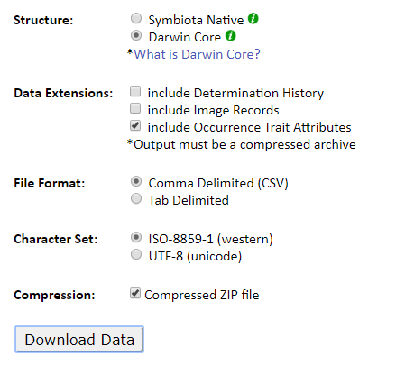
The resulting data file will contain an occurrences file (with the specimen records) and a measurementOrFact file (with the phenological data). You will merge these using the Data Cleaning code that will be discussed in class.

