Collections being managed as “live datasets” within the Symbiota portal can often immediately publish to GBIF and iDigBio without issues.
Collections that make use of an in-house management system (e.g. Specify, Ke-Emu, etc.) and only publish a snapshot of their data within a Symbiota instance may also use the portal to publish their data to GBIF, but only if:
- they are not publishing their data through another means (e.g. IPT installation, VertNet, etc.) and
- an occurrenceID GUID is included in the data being pushed from their in-house database to the Symbiota dataset. If the collection is using the Symbiota publishing tool built into Specify, the occurrenceID GUID will be automatically included in the data upload from Specify.

Publishing a Collection Dataset from Symbiota Portal
Collection managers first need to set up an institutional account with GBIF so that there is a direct publishing agreement established between GBIF and the institution. The institutional account will be used to list multiple collection datasets associated with that institution (e.g. https://www.gbif.org/publisher/4c0e9f60-c489-11d8-bf60-b8a03c50a862), and thus the collection manager should coordinate with other collections within their institution. Note that the different datasets listed under a single institution can be imported using different publishing sources. For instance, the zoological collections could import their data from VertNet (http://ipt.vertnet.org), vascular plant data from CCH2 (http://cch2.org/portal/), and lichens from Consortium of North American Lichen Herbaria (http://lichenportal.org).
- Use the GBIF Endorsement Request page (https://www.gbif.org/become-a-publisher) to register your institution. Use the organization lookup on that page to make sure your institution is not already registered.
  - If you are sure your institution is not yet registered, complete the registration form and follow the instructions provided by GBIF.
  - If your institution is already registered, review the GBIF metadata for your organization and existing datasets and contact GBIF to make any necessary changes. Be sure that none of the existing datasets contain the same data you are trying to publish. If they do, make the appropriate arrangements with GBIF so that the old dataset can be archived BEFORE re-publishing the new dataset.
- Login to CCH2 and navigate to the Collection Management menu by doing the following: click My Profile, click on the Specimen Management tab, and then click your collection name.
- Click on “Edit Metadata and Contact Information” link in the Administration Control Panel.
- Verify that your collection name and description are correct. These will be used within the GBIF page.
- Check the GBIF box to the right of “Publish to Aggregators”, and click the “Save Edits” button.
- Return to the Collections Management menu and click on the “Darwin Core Archive Publishing” link in the Administration Control Panel.
- Click “Create/Refresh Darwin Core Archive” button to package up your data within a Darwin Core Archive data package.
- Open a new browser tab or window and navigate to https://www.gbif.org/. Click on Publishers above the search bar.
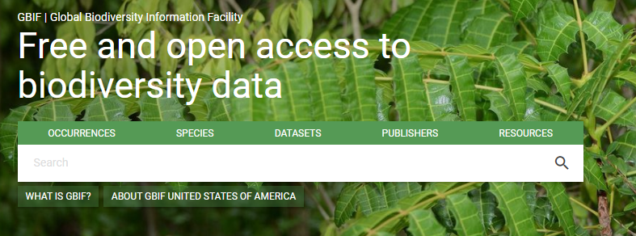

- In the resulting page, enter the name of your institution (or a couple key words from your institution name) in the search bar to the left. Click on the correct result as it appears on the right.
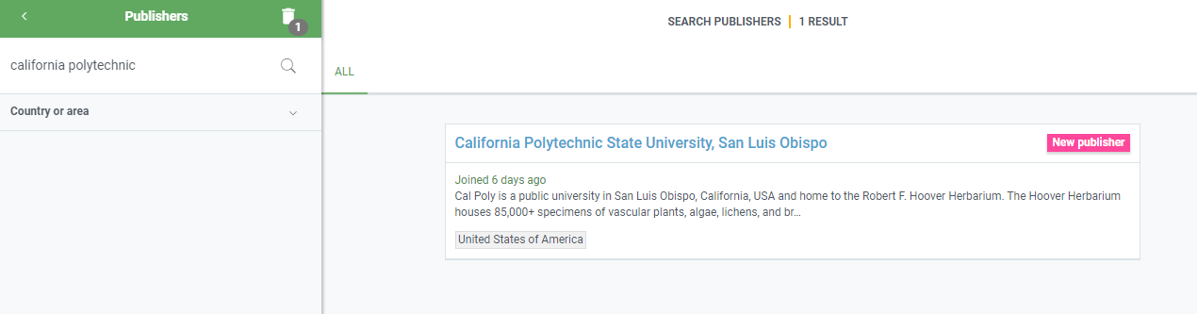

- Once you the publisher page for your institution has loaded, look at the URL at the top of the page (see below). Copy the 36-character string that follows https://www.gbif.org/publisher/. This string of numbers and letters is called your GBIF Organization Key. The GBIF Organization Key should have the following format: xxxxxxxx-xxxx-xxxx-xxxx-xxxxxxxxxxxx (e.g. 4c0e9f60-c489-11d8-bf60-b8a03c50a872).
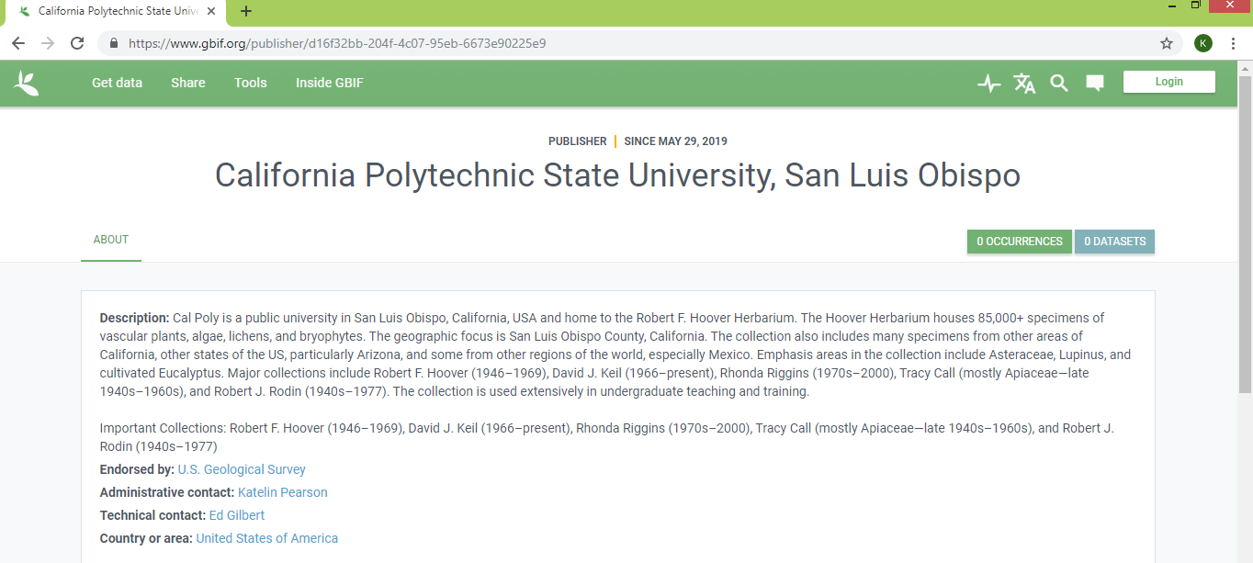
- Return to the Darwin Core Archive Publishing page in the CCH2 portal. Paste the 20-digit GBIF Organization Key that you just copied into the GBIF Key field of the Publishing Information box. Click the Validate Key button. If your key validates, more instructions will be displayed along with a Submit Data button.
- Before you can submit data, you will need to contact GBIF help desk (helpdesk@gbif.org) and request for the portal’s GBIF user account to be given permission to create and update datasets within your institution’s publishing instance. The GBIF username associated with the Symbiota portal installation is displayed in paragraph above the Submit Data button. Click on the GBIF email address to automatically generate a message within your email client or click on the link to open a draft email to send to helpdesk@gbif.org.
- Once you hear back from GBIF affirming that the portal has permission to submit data to your publisher, return to the Darwin Core Archive Publishing page in the CCH2 portal and click the Submit Data button. A link to your GBIF dataset will be immediately displayed, though it may take an hour or so for your data to be loaded, indexed, and available.

