Creating Research Checklists in CCH2
Assembled by Katie Pearson, 22 November 2019 – Some content adapted from the Symbiota website: http://symbiota.org/docs/creating-research-checklists-in-symbiota/

1. Creating a checklist 1
2. Adding taxa to a checklist 2
2.1 Adding individual taxa 2
2.2 Batch uploading taxa 3
3. Adding voucher specimens to a checklist 5
3.1 Adding individual specimens from your own collection 5
3.2 Adding specimens from any collection (Manage Linked Voucher tool) 7
4. Other checklist tools 10
4.1 Voucher conflicts tab 10
4.2 Reports tab 10

A research checklist is a list of taxa for a certain region. Checklists are documented by voucher specimens, which may be in several different herbaria. The checklist tool enables linking to voucher specimens, if they are available online, or simply listing their catalog number if not. The voucher tool also enables tracking new potential voucher specimens and re-identification of existing vouchers.

1. Creating a checklist
A video tutorial of this process (on a general Symbiota site) is available here: http://symbiota7.acis.ufl.edu/temp/2-checklists_create.mp4
- Login to CCH2 (http://www.cch2.org).
- Click on “My profile”
- Under the “Species Checklists” tab, click on the green plus sign:
- Fill out the “Create New Checklist” box with the desired information.
  - Most checklists will be a General Checklist. Alternatively, you can another list type from the Checklist Type dropdown menu. A Species Exclusion List is used to curate a subset of taxa that are purposely excluded from another list, and a Rare, threatened, protected species list is used to compile a state-level list of rare, threatened, and protected taxa for which locality data will be redacted for specimens in that state.
  - To indicate that this checklist is a subset within a larger checklist, select the “parent” (larger) checklist from the More Inclusive Reference Checklist dropdown menu.
  - You can define the area included in the checklist by describing it in the Locality and Abstract fields, including Latitude and Longitude coordinates, and/or you can define the boundaries of that area geographically by setting a “footprint polygon”. To define a “footprint polygon”:
    - Click the globe icon ( ) inside the Polygon Footprint box. A Google map will appear a new window.
    - Drag the map until it shows the region covered by your checklist, then zoom in until you can see the boundaries of the area.
    - Click the polygon icon in the top center of the window ( ), then click around the boundaries of your area.
    - When you get back to the point where you started, double click the starting point. This will lock the coordinates into the text box at the bottom of the window. Your defined area will shaded in.
    - If you are dissatisfied with your polygon, you can delete or redraw it by clicking the appropriate button on the bottom right. When you are satisifed with your polygon, click the Save Polygon button.
  - You can decide whether you want to keep this checklist private, or if you want it to be available to the public by selecting Private or Public from the Access dropdown menu.

2. Adding taxa to a checklist
There are two ways to add taxa to a checklist, either individually (the default process) or via batch upload. You may want to start by adding them individually so you can become familiar with the information that can be uploaded and the care one needs to take in doing so.

2.1 Adding individual taxa
A video tutorial of this process (on a general Symbiota site) is available here, beginning at minute 7:15: http://symbiota7.acis.ufl.edu/temp/2-checklists_create.mp4
- On the checklist page, click the rightmost pencil icon (labeled spp.) at the top right of the page. This will bring up a panel on the lower right side of the screen.
- Add the name of a taxon you wish to add. Do NOT include the authorship of the taxon. You can start typing, and a dropdown list will allow you to select the taxon from available options.
  - You cannot add a name that is not present in the taxonomic thesaurus (it will tell you if this is the case). If you find that the taxon you wish to add is not present:
    - Check that your spelling is correct. Use Tropicos (http://tropicos.org) or IPNI (http://www.ipni.org/) to check.
    - If your spelling is correct, contact your portal manager with the name, authorship, and a reference or link to that name in another taxonomic database, and it will be added for you.
- Fill in the other fields if desired. All of these fields can be left blank:
  - Family Override: If you enter the family name here, you will override the family provided by the taxonomic thesaurus. It is advised not to enter anything in this field.
  - Habitat: If the taxon is usually found in a particular habitat in the area circumscribed by the checklist, you can include this information here.
  - Abundance: Here you can note how frequently/abundantly this taxon is found in the area circumscribed by the checklist. For example, you can use terms like “common,” “frequent,” or “rare.”
  - Notes: Any other comments about this taxon pertaining to your checklist area can be put here, for example: “Cultivated ornamental” or “favored by honeybees”
  - Internal notes: This field, unlike the others, will be visible only to people authorized to edit the checklist. You might make a note “need to check the species” or “no picture available” for example.
  - Source: This field is more likely to be used for research and teaching checklists. For such checklists, it is useful to know whether the information came from a flora, some other publication, or a report by some
- Click the “Add species to List” button.

2.2 Batch uploading taxa
A video tutorial of this process (on a general Symbiota site) is available here: http://symbiota7.acis.ufl.edu/temp/3-checklists_batch_load.mp4
If you have several taxa to add at one time, you can upload them in a CSV (comma separated value) file. The easiest way to create the desired listing is to use Microsoft Excel or OpenOffice Calc and then save the file as a CSV file.
In your CSV file, one column in the file should be labeled sciname. This should contain the scientific name of the taxon WITHOUT the authorship included. In this CSV file, you must be very careful to spell the scientific names correctly. If you have an error in your spelling, you will not be able to load that name into your checklist.
You can also include “family”, “habitat”, “abundance”, and “notes” (see section 2.1 for description of contents of these fields) columns in this file. An example is shown below.
Sciname | Habitat | Abundance | Notes
Asystasia gangetica | Middle of the field | Rare | Demonstration; correct spelling
Asystasia gangetca | Middle of the field | Unknown | Demonstration; wrong spelling
Below is a screenshot of uploading the previous example “file”. Note that only one name, the one that was correctly spelled, was uploaded.
To return to the Checklist, click “Return to Checklist” at the top left of the page (circled below).
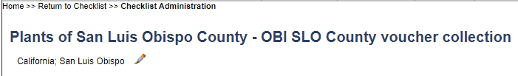
You can then view the taxa that were added to the checklist.

3. Adding voucher specimens to a checklist
There are two main ways to add voucher specimens to a research checklist. You can add specific, individual specimens from your own collection to the checklist through the occurrence editor (the page of the specimen record) or add specimens from any collection through the Manage Linked Voucher tool on the checklist page.

3.1 Adding individual specimens from your own collection
- Look up a specific specimen in your own collection (e.g., by clicking Edit Existing Occurrence Records in your Data Editor Control Panel and searching by a specific catalog number or by using other search terms; see example below).
- On the resulting page, click the Linked Resources tab (circled below).
- In the Checklist Voucher Linkages box (see screenshot below), select the desired Checklist from the dropdown menu and click Link to Checklist as Voucher. A new window will likely pop up as a result, but you can ignore this window and close the editor. The specimen has been successfully linked as a voucher to the desired checklist.
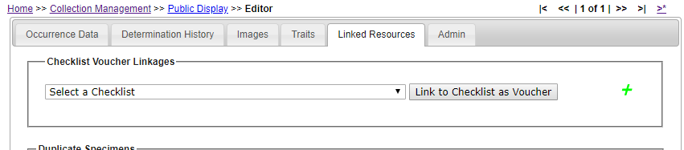

3.2 Adding specimens from any collection (Manage Linked Voucher tool)
A video tutorial of this process (on a general Symbiota site) is available here: http://symbiota7.acis.ufl.edu/temp/4-checklist_voucher.mp4
- Navigate to the homepage of your checklist.
- Click the pencil icon that has a V next to it (the center icon in the top right corner of the page, circled below).
- If this is the first time you have used this tool, you will be asked to first define the search statement (i.e., search parameters) that will be used to find the specimens that might pertain to your checklist. You can use a variety of fields to define your search, as described below.

NOTE: you will be able to change the search statement in the future, so you are not necessarily defining the bounds in perpetuity.
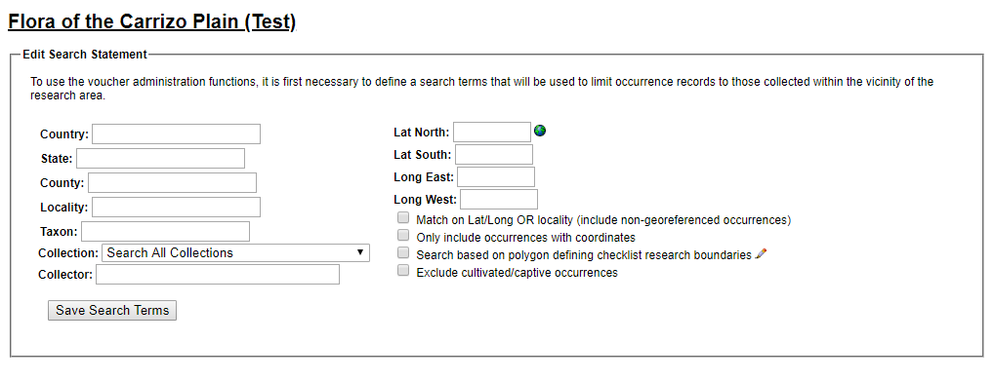

  - You can enter search terms for a number of fields on the left side of the form.
  - You can use the polygon footprint that you defined when creating the checklist (see Section 1, step 3c) to search for specimen records by checking the “Search based on polygon defining checklist research boundaries” box. If you did not define a polygon previously, you can also do so from here by clicking the pencil icon to the right of this option and following the steps outlined in Section 1, step 3c.
  - You can define a specific bounding box by entering the latitude and longitude values that delimit the box, or by defining the lat/long values on a map. To do the latter:
    - Click the globe icon to the right of the Lat North field
    - In the pop-up window, pan and zoom to the location where you want to place the bounding box.
    - Click on the approximate center where you want the bounding box to be located.
    - Adjust the location and size of the bounding box as desired by clicking and dragging inside the box (to move the box) or clicking and dragging one of the circles on the sides or corners of the box (to resize the box).
    - To save the bounding box, click the tiny grey rectangle to the right of the lat/long coordinate fields (circled below)
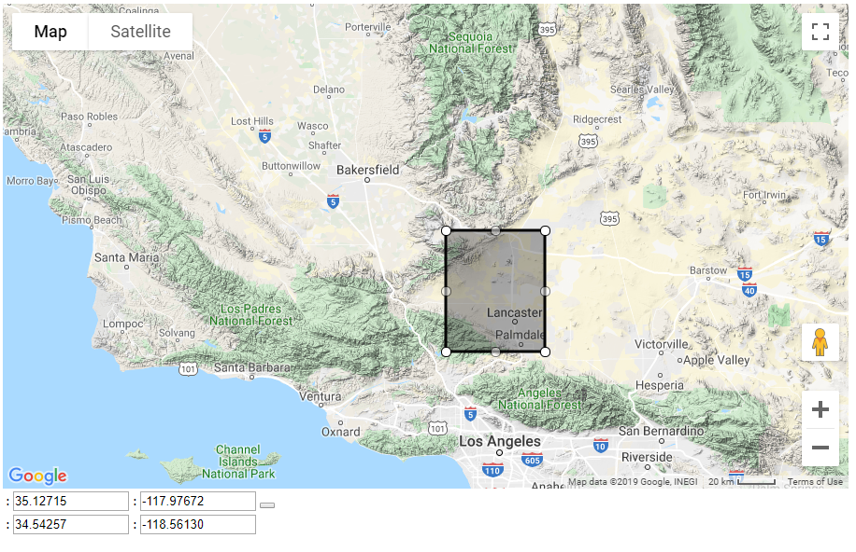
  - There are a number of important checkboxes below the Lat/Long fields that you can use to refine your search. For example, you can allow the search to return specimens with the desired search terms OR within certain latitude and longitude coordinates.
  - You can use any combination of the above options to search for voucher specimens.
- Once you have entered the desired search terms, click the Save Search Terms button.
- There are a number of ways to add voucher specimens from this point.
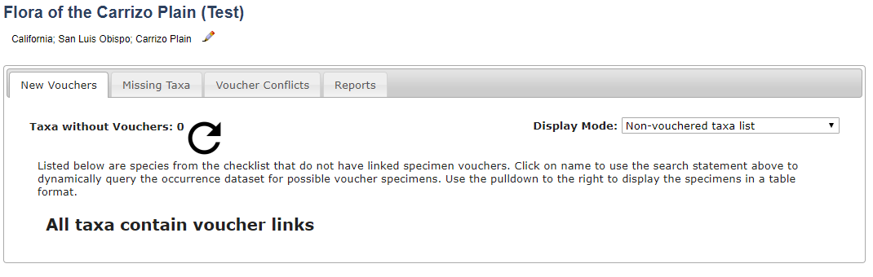
  - If you have already defined a taxon list (see Section 2) for your checklist, you can add voucher specimens from the New Vouchers tab. From this tab, you can:
    - View taxa that do not currently have voucher specimens in your checklist (select Non-vouchered taxa list from the Display Mode dropdown list).
    - View specimen records that match your search criteria and are one of the taxa defined in your taxon list that is NOT currently vouchered (select Occurrences for non-vouchered taxa from the Display Mode dropdown list).
      - To add voucher specimens from this list, click the box to the left of the specimen record(s) that you wish to add and click the Add Vouchers button.
    - View specimen records that match your search criteria and are one of the taxa defined in your taxon list, regardless of whether that taxon has been vouchered previously (select New occurrences for all taxa from the Display Mode dropdown list).
      - To add voucher specimens from this list, click the box to the left of the specimen record(s) that you wish to add and click the Add Vouchers button.
  - Regardless of whether you have previously defined a taxon list for your checklist, you can add voucher specimens through the Missing Taxa tab. From this tab, you can:
    - View the taxa that are not found in the checklist currently but are represented by one or more specimens that align with your search criteria (select Species List from the Display Mode dropdown list).
      - You can then view a list of the specimens associated with each taxon by clicking the page and chain icon ( ). From there, you can link the desired specimens individually by clicking the add voucher icon ( ) to the right of the specimen record in the list.
    - View the specimens that are not yet added as voucher specimens for your checklist but do align with your search criteria (select Batch Linking from the Display Mode dropdown menu).
      - To add voucher specimens from this list, click the box to the left of the specimen record(s) that you wish to add and click the Add Vouchers button.
    - View specimen records that align with your search criteria, but have scientific names that are not linked to a particular name in the taxonomic thesaurus (select Problem Taxa from the Display Mode dropdown menu).
      - To add voucher specimens from this list, enter the name of the taxon to which this specimen belongs into the text box to the right of the specimen’s scientific name. Note that the name you enter in this box must already be found in the list of taxa in your checklist. Click the Link Voucher button.

4. Other checklist tools

4.1 Voucher conflicts tab
In the Manage Linked Vouchers tool (see section 3.2), you can view a list of specimen vouchers for which their current identifications do not match how they were originally added as part of the checklist. This is generally due to recent annotations.
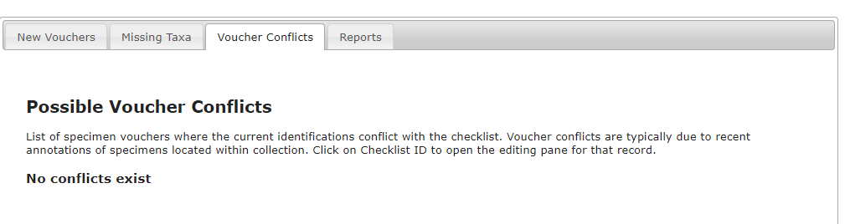

4.2 Reports tab
You can generate a number of useful reports using the Reports tab in the Manage Linked Vouchers tool (see section 3.2), as shown in the menu below.
